University of Central Florida

Department of Electrical & Computer Engineering

EEL 4914

Senior Design I



Slate

Multi-Input Wireless Macro Keypad

Final Project Documentation

*Group 8 Team Members: Project Coordi**nators:*  
Diego Agudelo, CpE Dr. Lei Wei  
Andhres Bolano-Melendez, CpE Dr. Samuel Richie  
Samuel Chodur, EE   
Jacob Goodman, CpE

August 3, 2021



Table of Contents

1 Executive Summary 1

1.1 Team Member Introduction 1

1.2 Problem Description 1

1.3 Problem Solution 1

2 Project Description 2

2.1 Motivation 2

2.2 Project Background 2

2.3 Goals/Objectives 2

2.4 Market Analysis 3

2.4.1 Elgato Stream Deck 3

2.4.2 Loupedeck Live 4

2.4.3 DIY Macro Key-switch Keypad 4

2.4.4 Market Analysis Summary 4

2.5 Requirements Specification 5

2.5.1 Features and Functions of Slate 5

2.5.2 Visual Representation of Slate 5

2.5.3 House of Quality 7

2.5.4 Engineering Requirement Categories 7

2.5.5 Slate’s Engineering Requirements 9

2.5.6 Project Constraints 10

2.6 Block Diagram Overview 11

2.6.1 Hardware Block Diagram 11

2.6.2 Power Management Block Diagram 12

2.6.3 Software Block Diagram 13

2.6.4 Software Use Case Diagram 14

3 Engineering Standards 15

3.1 Relevant Standards 15

3.1.1 IEEE 802-2014 Standard for LAN / MAN 16

3.1.2 IEEE 828 Standard for Configuration Management 17

4 Component Investigation 18

4.1 Relevant Technologies 18

4.1.1 Single Cell Lithium-Ion / Lithium-Polymer Batteries 18

4.1.2 Dynamic Power-Path Management (DPPM) 18

4.1.3 Field Programmable Gate Arrays (FPGAs) 19

4.1.4 Microcontrollers 19

4.1.5 Universal Serial Bus (USB) 20

4.1.6 Bluetooth (BT) Communication 23

4.1.7 Touch Screen 25

4.2 Printed Circuit Board 27

4.2.1 PCB composition 28

4.2.2 Design Recommendations 29

4.2.3 PCB Design Software 31

4.2.4 Eagle Design 31

4.2.5 Design Constraints for PCB 32

4.2.6 PCB Manufacturers 32

4.3 Keyboard Switches Considerations 33

4.3.1 Mechanical Switches 33

4.3.2 Switch Considerations 36

4.4 3D Printer Filament Considerations 39

4.4.1 PLA 41

4.4.2 ABS 41

4.4.3 Flexible 41

4.4.4 High impact polystyrene (HIPS) 41

4.4.5 PETG 42

4.4.6 Nylon 42

4.4.7 Carbon Fiber 42

4.4.8 ASA 42

4.4.9 Polycarbonate 43

4.4.10 Polypropylene 43

4.4.11 Metal Filled 43

4.4.12 Wood Filled 43

4.4.13 PVA 44

4.4.14 3D Filament Summary 44

4.5 Controller Considerations 44

4.5.1 Espressif ESP32 Series 45

4.5.2 Atmel ATmega32U4 46

4.5.3 Nordic Semiconductor nRF52840 46

4.6 Screen Considerations 47

4.6.1 Adafruit TFT FeatherWing 48

4.6.2 4D System uLCD-43PT 48

4.6.3 EastRising TFT LCD touchscreen 48

4.6.4 Focus LCD’s TFT E35RG73248LW6M250-C 49

4.6.5 Focus LCD’s TFT E35RG13248LW2M450-CA 49

4.7 Battery Management IC Considerations 49

4.7.1 Texas Instruments BQ24179 50

4.7.2 Maxim Integrated MAX77757 52

4.7.3 Linear Technology LTC4085 53

4.7.4 Microchip MCP73831/2 54

4.8 Software Considerations 55

4.8.1 QMK 55

4.8.2 ZMK 55

4.8.3 CircuitPython 55

4.8.4 KMK 56

4.9 Battery Considerations 56

4.9.1 18650 Lithium-ion Cell Battery 56

4.9.2 Lithium-Polymer (Li-Po) Battery with JST-connector 56

4.9.3 “AA” Alkaline Non-Rechargeable Battery 57

4.10 Rotary Encoder Considerations 57

4.10.1 Small Rotary Encoder – 12.5mm Shaft Height, 6mm Shaft Diameter 57

4.10.2 Medium Rotary Encoder – 14.3mm Shaft Height, 6mm Shaft Diameter 58

4.10.3 Large Rotary Encoder – 20mm Shaft Height, 6mm Shaft Diameter 58

4.11 Joystick Considerations 58

4.11.1 “PS2”-Style Joystick 58

4.11.2 “PSP”-Style Joystick 59

4.11.3 “Switch”-Style Joystick 59

4.12 Strategic Components and Part Selections 59

4.12.1 PCB Design Software Selection 59

4.12.2 Battery Management IC Comparison and Selection 59

4.12.3 Battery Selection 60

4.12.4 Microcontroller Selection 61

4.12.5 Software Selection 62

4.12.6 Touchscreen Selection 62

4.12.7 Switch Selection 63

4.12.8 Rotary Encoder Selection 64

4.12.9 Joystick Selection 65

4.12.10 3D Printing Filament 66

4.13 Possible Designs and Related Diagrams 66

4.14 Parts Selection Overview 68

5 Hardware Design Details 69

5.1 Power and Filtering 69

5.2 LIPO Charging and Monitoring 71

5.3 MCU/BT Module, Debugging, and Flash Memory 72

5.4 Decoupling Capacitors 73

5.5 Screen Headers 74

5.6 MX Switches 75

5.7 Rotary Encoder 75

5.8 Joystick 76

5.9 PCB Bill of Materials (BOM) 76

6 Software Design Details 77

6.1 Software Functionality and Block Diagrams 77

6.2 Software Tools 79

6.2.1 Documentation and Communication 79

6.2.2 Development Tools 80

6.3 Software Development 81

6.3.1 GUI Tools 81

6.3.2 “Touch Deck” Demo Code Analysis 82

7 Prototyping 83

7.1.1 Prototype Progression 83

7.1.2 PCB 93

7.1.3 Prototype Expectations 98

7.1.4 Parts Acquisition and Bill of Materials 100

8 Integration & Testing 102

8.1 Prototype Testing 102

8.1.1 Enclosure Testing 102

8.2 Power Testing 103

8.2.1 Initial Calculations 103

8.2.2 Battery Analysis 104

8.3 Hardware Testing 104

8.3.1 Component Testing 105

8.3.2 Microcontroller Testing 106

8.3.3 Touchscreen Testing 107

8.4 Software Testing 107

9 Project Operation 108

9.1 Safety Precautions 108

9.2 General Information 108

9.2.1 Using Slate 108

9.3 Troubleshooting Tips 109

10 Administrative Content 110

10.1 Milestones 110

10.2 Budget Analysis 111

10.2.1 Development Budget 111

10.2.2 Single Unit Bill of Materials (BOM) 111

10.2.3 Budget Analysis Summary 112

10.3 Project Design Problems 112

11 Project Summary and Conclusion 114

12 References 115

Figures and Tables

Table 2‑1: Market Analysis Summary 4

Figure 2‑1: Three products from (a) Elgato, (b) Loupedeck, and (c) a DIY solution 4

Figure 2‑2: Initial 3D renderings of Slate 6

Figure 2‑3: Slate's House of Quality 7

Table 2‑2: Engineering requirement categories 8

Table 2‑3: Initial engineering requirements for Slate 9

Table 2‑4: Initial engineering constraints identified for Slate. 10

Figure 2‑4: High level hardware block diagram 11

Figure 2‑5: Slate's power management block diagram 12

Figure 2‑6: Slate’s high level software block diagram 13

Figure 2‑7: Slate configuration use case Diagram 14

Table 3‑1: Engineering standards related to Slate. 15

Figure 3‑1: IEEE 802 reference model 16

Table 3‑2: Core CM processes and their purpose 17

Figure 4‑1: Lithium-Ion battery operation 18

Figure 4‑2: DPPM IC internal operation 19

Table 4‑1: Summary of USB architecture components 20

Figure 4‑3: USB Power Delivery communications stack 21

Table 4‑2: USB interconnect key concepts 22

Table 4‑3: Focus areas for USB implementation 22

Figure 4‑4: Layers and entities of simple USB communication 23

Table 4‑4: Summary of BR and LE BT systems 24

Figure 4‑5: Three example Bluetooth configurations 24

Figure 4‑6: Operation of a resistive touch screen. 25

Figure 4‑7: Operation of a capacitive touchscreen 26

Table 4‑5: Resistive screen advantages and disadvantages 27

Table 4‑6: Capacitive screen advantages and disadvantages 27

Figure 4‑8: Materials used in a PCB 28

Table 4‑7: PCB design techniques and rules 29

Table 4‑7: PCB design techniques and rules 30

Table 4‑8: Overview of PCB software 31

Table 4‑9: Summary of PCB manufacturers 33

Figure 4‑9: Components of a mechanical keyboard switch 34

Table 4‑10: Descriptions of the components of a keyboard switch 34

Table 4‑11: Characteristics of mechanical switches 35

Table 4‑12: Summary of key switch types 36

Figure 4‑10: Visualization of several keyboard switches 36

Figure 4‑11: Low-profile key switch visualization 38

Figure 4‑12: 3D Printer example 39

Figure 4‑13: Examples of 3D printer filaments 40

Table 4‑13: Summary of 3D filaments 44

Figure 4‑14: Stock images of MCU options 45

Figure 4‑15: Stock photos of screens considered 47

Figure 4‑16: Power path flowchart used for power management IC considerations. 50

Figure 4‑17: Texas Instruments BQ24179 example schematic 51

Figure 4‑18: Maxim Integrated MAX77757 block diagram 52

Table 4‑14: MAX77757 key characteristics 53

Figure 4‑19: LTC4085 typical application 53

Table 4‑15: LTC4085 key characteristics 54

Figure 4‑20: MCP73831 typical application 54

Table 4‑16: MCP7381 key characteristics 54

Figure 4‑21: Types of batteries considered for Slate 56

Figure 4‑22: Rotary encoders considered for use with Slate 57

Figure 4‑23: Types of joysticks being considered for use with Slate 58

Table 4‑17: Key considerations for battery management IC selection 60

Table 4‑18: Key considerations for battery selection 60

Table 4‑19: Key considerations for microcontroller selection 61

Table 4‑20: Qualitative considerations for microcontroller selection 61

Table 4‑21: Specifications and features comparison for displays 63

Table 4‑22: Key switch feature and trait comparison 64

Table 4‑23: Key features of encoders used for final selection 65

Table 4‑24: Key features of joysticks used for final selection 65

Table 4‑25: Key 3D printer filament features used for final selection 66

Figure 4‑24:Pinout for Slate prototype 67

Table 4‑26: Initial prototype part selection overview 68

Figure 5‑1: Slate’s power and filtering circuit 69

Figure 5‑2: USB and JST connector schematic design 70

Figure 5‑3: LIPO charging and schematic design 71

Figure 5‑4: MCU/BT module schematic design 72

Figure 5‑5: SWD debugger and flash memory schematic designs 73

Figure 5‑6: Schematic design of the decoupling capacitors 73

Figure 5‑7: Schematic design of the screen headers 74

Figure 5‑8: Schematic design of the MX switches 75

Figure 5‑9: Rotary encoder schematic design 75

Figure 5‑10: Schematic design for the PS style joystick 76

Table 5‑1: Limited BOM for Slate’s PCB design 76

Figure 6‑1: Slate’s software block diagram 77

Figure 6‑2:Slate’s desktop configurator software block diagram 78

Table 6‑1: List of software tools utilized for development 80

Figure 6‑3: Listing of pins available via CircuitPython 80

Figure 6‑4: Image of Slate’s code repository on GitHub 81

Figure 7‑1:Initial condition of prototype components 83

Figure 7‑2: The initial booting of the Feather Express prototype component 84

Figure 7‑3: Header pins attached to the prototype breakout board 85

Figure 7‑4: Attachment of Feather and FeatherWing 86

Figure 7‑5: Error upon initial running of test code for prototype screen 86

Figure 7‑6: Expected output for CircuitPython screen libraries 87

Figure 7‑7: Mock layout for initial Slate prototype 88

Figure 7‑8: Mock layout on two 7x9cm perfboards 89

Figure 7‑9: Modular key switch breakout with pins attached 89

Figure 7‑10: Eight modular switches mounted to perfboard 90

Figure 7‑11: Soldering progress of switch headers on new protoboard 90

Figure 7‑12: Soldering progress of remaining component headers 91

Figure 7‑13: Wiring assembly for screen 91

Figure 7‑14: Power-on test after wiring screen 92

Figure 7‑15: Custom cut 10x16cm MDF base 92

Figure 7‑16: Final prototype assembly 93

Figure 7‑17: Trace and wiring examples 94

Figure 7‑18: Reflow time & temperature profile chart 96

Figure 7‑19: PCB Schematic 97

Table 7‑1: Potential hardware issues 99

Table 7‑2: Potential software issues 99

Table 7‑3: Parts acquisition table 101

Table 7‑4: Bill of materials 101

Table 8‑1: Enclosure testing steps 102

Figure 8‑1: Render mockup for case design reference 103

Table 8‑2: General component testing steps 105

Table 8‑3: Microcontroller testing steps 106

Table 8‑4: Touchscreen testing steps 107

Table 9‑1: Slate troubleshooting tips 109

Figure 10‑1: Gantt chart for expected milestones 110

Table 10‑1: Initial development budget for Slate 111

Table 10‑2: Predicted single unit bill of materials for Slate. 112

Table 10‑3: Project design problems 113

# Executive Summary

## Team Member Introduction

The Slate project is made up of four team members, each with a unique and diverse set of background and skills. Diego Agudelo is seeking his BSCpE in the Comprehensive Track besides school he is furthering his business in custom automotive lighting and is interested in finding employment related to hardware design. Andhres Bolano-Melendez is seeking his BSCpE in the Comprehensive Track with the goal of finding employment in software development for one of the FAANG companies. Samuel Chodur is seeking his BSEE in the Communication and Signal Processing Track. Samuel is currently employed as a Data Analyst but is interested in finding employment related to embedded software design. Jacob Goodman is seeking his BSCpE in the Comprehensive Track. Jacob is an incoming hire to SK Hynix as a Technical Marketing Engineer in 2022. Currently there are no customers, sponsors, or significant contributors to the project.

## Problem Description

Multi-tasking during device use is being more and more prevalent. A single user may be expected to accomplish the same amount of work that was accomplished by a multiple member team. As an example, production of a live television broadcast could be made up of the on-screen personality, a camera operator, and an audio engineer. With the increase in popularity of live streaming of events, being able to accomplish all these job descriptions as a single person is sometimes necessary or desired. There are many other such examples when it comes to creating quality artistic productions with minimal time and team members and the market for products that aim to solve these problems is growing at a high rate.

## Problem Solution

A solution to the time and personnel problem is providing the essential functions of multiple disciplines at the user’s fingertips. There is currently a niche market made up of a few companies that aim to provide live streamers, content creators and other artistic disciplines a solution to their problems. We decided to target this rapidly expanding market with a new device solution that provides customizability and portability while still being able to interface with a wide variety of software.

We will now provide a more detailed description of the project to include our market analysis, our product’s requirement specifications, and a high-level overview of both our hardware and software design.

# Project Description

Throughout this section, we will discuss the motivation for our project along with its background, goals, objectives, and finally the engineering requirements. This information will be the basis for identifying relevant standards and design constraints.

## Motivation

Some may argue that the most valuable resource on earth is a person’s time. Saving a few seconds over a lifetime can lead to more goals being achieved, more unique opportunities being experienced, and an overall more relaxing lifestyle. Any moment that can be made more productive compounds and results in a life filled with satisfaction. *Slate* is meant to enhance productivity and efficiency during our user’s creative workflows.

## Project Background

Before this idea was brought up we all were heavy computer users who depended on keyboard short cuts for example the most common copy (Control+C) and paste (Control+V) to get tasks done. In addition, some of us were familiar with using creative applications like Adobe software, where there are often common sequences of commands or actions performed to get a desired outcome, in addition to the many unique key-binds that perform predefined tasks or tools. Knowing that many users would prefer a visual reminder of the action a button or macro performs rather than memorizing all the available key-binds, we recognized a device that could function complimentary to your standard keyboard would be a great option.

## Goals/Objectives

The goal of this project is to have a fully functioning customizable multi-input wireless macro keypad that combines a touch-display with multiple physical inputs to provide macro functionality to the user in a compact and robust form-factor. Slate would allow for the user to configure key data to be displayed back on the built-in display. These features allow for the user to navigate their device in a more efficient way and monitor important aspects of their work without information being lost on their main output device.

The design of Slate will be a mixture between portability and functionality, while still maintaining an aesthetic that easily blends into the desktop of most users. We want the users of Slate to be proud of their device. It should be a device that catches the eye of all types of computer users when perusing the shelves or scanning digital advertisements and reviews. Slate aims to give users additional customization, choice, and flexibility they did not know they could benefit from.

The intuitiveness of the device must be clear from the first use. We hope to avoid a steep learning curve by making the most basic and useful functions immediately apparent whilst still providing the customizability sought after by the power user. Ideally, Slate becomes as important of a peripheral to the power user as their mouse and keyboard. The ultimate goal is for every user of Slate to wonder how they ever got along without it.

After brainstorming and investigating products like Slate, the main features and functions of Slate were identified. The results of this investigation are listed below:

* Includes a user interface via touch screen, physical keys and rotary encoders.
* The entire system should be portable.
* Provides user-programmable macros.
* Uses standard, user-serviceable switches for physical keys.
* Interfaces wirelessly with accompanying device.
* USB or Battery can power the device.
* USB connection can charge device and provide data transmission to PC.
* Programmable via mobile application with Bluetooth connection.
* Programmable RGB LEDs for physical keys to denote function.
* Haptic feedback for touchscreen input.
* Onboard speaker to provide audio feedback.
* User can select from multiple macro functions at any given time.
* User can program the macro keypad using complementary software.

## Market Analysis

There are several products in the market that attempt to offer similar solutions as Slate. We feel that Slate can offer a better level of choice, flexibility, and/or affordability compared to these other products. Three products of differing brands were specifically investigated to help identify any engineering requirements and constraints that need to be associated with our project. These three products are the Elgato Stream Deck, the Loupedeck Live, the DIY Macro Keypad. All three of these products can be visualized in the figure below and will be discussed further in subsequent sections.

### Elgato Stream Deck

The Elgato Stream Deck is a computer peripheral connected over USB that provides multiple dedicated, user customizable keys that are incorporated into the touch screen device and was the main inspiration for Slate. The Stream Deck give the user buttons with customizable screens that denote their function and allow for multiple profiles. The Stream Deck does not provide any additional physical inputs and only operates while wired via USB.

Stream Deck was the main inspiration behind this project. The Stream Deck brings micro keys to the user by expanding the number of keys by adding lcd screens underneath the key to display different commands. Based on the product’s website, the Stream Deck’s primary customers are video game streamers and other live content creators. The physical dimensions of the product are 4.6”x3.3”x0.8” with a weight of 6.7oz (190g). The cost of the base model version of the product is $150.

### Loupedeck Live

Loupedeck Live offers content creation, editing and streaming with ease. The Loupedeck Live provides a blend of physical and digital inputs but comes at a high price. Based on the product’s website, the Loupedeck Live’s primary customers are content creators and video game streamers.

After investigating the Loupedeck website, we found the physical dimensions of the product to be 5.9”x4.3”x1.2” with a weight of 8.1oz (230g). The product cost of the Live model is $150. The supported operating systems are Windows 10 and macOS.

### DIY Macro Key-switch Keypad

This is a do-it-yourself (DIY) solution that offers customizable controls over USB within arm’s reach. It allows for users to control their favorite applications and media easily and instantly. The physical dimensions of the product are approximately 4.0”x3.0”x1.0” with a weight of approximately 5.0oz (142g). The price for all required parts is approximately $100. Technical knowledge for assembly and programming is required to produce a usable product.

### Market Analysis Summary

The key features for each of the three options available in the current market are summarized in Table 2-1 below.

|  |  |  |  |
| --- | --- | --- | --- |
|  | Elgato Stream Deck | Loupedeck Live | DIY Solution |
| Length (inches) | 4.6 | 5.9 | 4.0 |
| Width (inches) | 3.3 | 4.3 | 3.0 |
| Height (inches) | 0.8 | 1.2 | 1.0 |
| Weight (oz) | 6.7 | 8.1 | 5.0 |
| Price (USD) | $150 | $150 | $100 |
| Target Customer | Live Streamers | Live Streamers | Power Users |
| Supported OS | Windows, macOS | Windows, macOS | Windows, macOS, Linux |

Table 2‑1: Market Analysis Summary

Stock photographs of the three products investigated are shown in Figure 2-1 below.

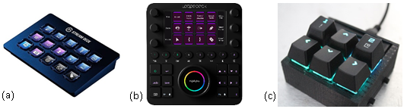

Figure 2‑1: Three products from (a) Elgato, (b) Loupedeck, and (c) a DIY solution

The investigation of the several products already in the market provided Slate’s team with what should be the minimal expectations for our product design. We were able to identify key features and engineering standards with the help of our market analysis.

We feel the Loupedeck products are the most like our vision for Slate as it provides a good blend of physical and digital inputs. The downside of all these products is the high price, which we feel shows there is space for more competitors in this market. Based on our market research, we plan to focus on a compact, wireless-capable macro keypad that blends both highly customizable digital inputs and traditional physical inputs to give the user as much choice as possible.

## Requirements Specification

### Features and Functions of Slate

The function of this project is to assist the user with an additional interface of “one-push” macros. The device is a mixture of a programmable touchscreen, physical switches, and rotary encoders. The programmable touchscreen would provide mainly application-specific macros, with the user able to select from multiple pages and profiles of digital “buttons” that execute a programmed macro or routine function. Physical switches can be customized in functionality but ideally remain the same between applications, serving as generalized macros across the OS. Rotary encoders assist the user in level, timeline, and scaling-based tasks, such as adjusting volume, scrolling the video timeline in editing software, or zooming in and out on a photo.

### Visual Representation of Slate

Figure 2-2 on the next page, which is subject to change, is a rough rendering of what our product will look like. The main idea behind this rendering is to make the device as user friendly as possible, the closest to the user is the touchscreen which allows for customizable commands/programs that can be added. Then above follows a joystick and two nobs. At the top of the device there will be a total of 10 buttons that will also be customizable by the user.

The enclosure that holds all the components will be 3D printed. For the purpose of Slate, we will consider using PLA filament. The cost of building will be provided by a member of the Slate as this member has a 3D printer at their disposal. If by any means the team member cannot print out the enclosure, we will use the 3D printer supplied in the TI Innovation Lab at UCF. As far as which type of filament we are currently leaning towards PLA instead of ABS, PETG, TPU, and PC. We will further explain why we chose PLA in *Section 4.4*.

The render in Figure 2-2 was designed using the software tool *SketchUp*. The design was then rendered with the help of the program *V-Ray*. This render provided the team with a common goal for engineering requirements and design. As more aspects of the design are investigated, this initial device housing and components may change.

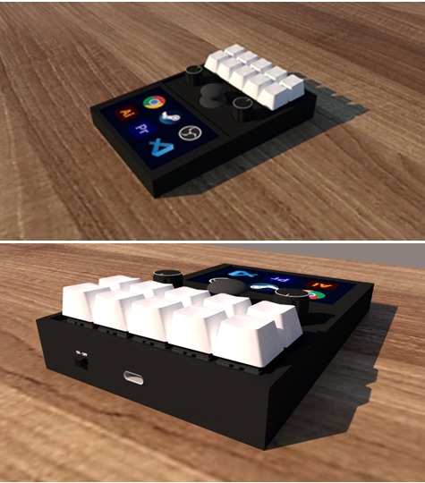

Figure 2‑2: Initial 3D renderings of Slate

### House of Quality

To better show the interrelationships between our target engineering specifications and the market features of the Slate we created a House of Quality (HOQ). The HOQ is a primary tool used during the quality function deployment (QFD). This QFD encompasses marketing, design, and manufacturing which is represented as a series of matrices that resembles a house. These matrices relate our marketing goals with our engineering requirements by showing us important tradeoffs when adding features to Slate.

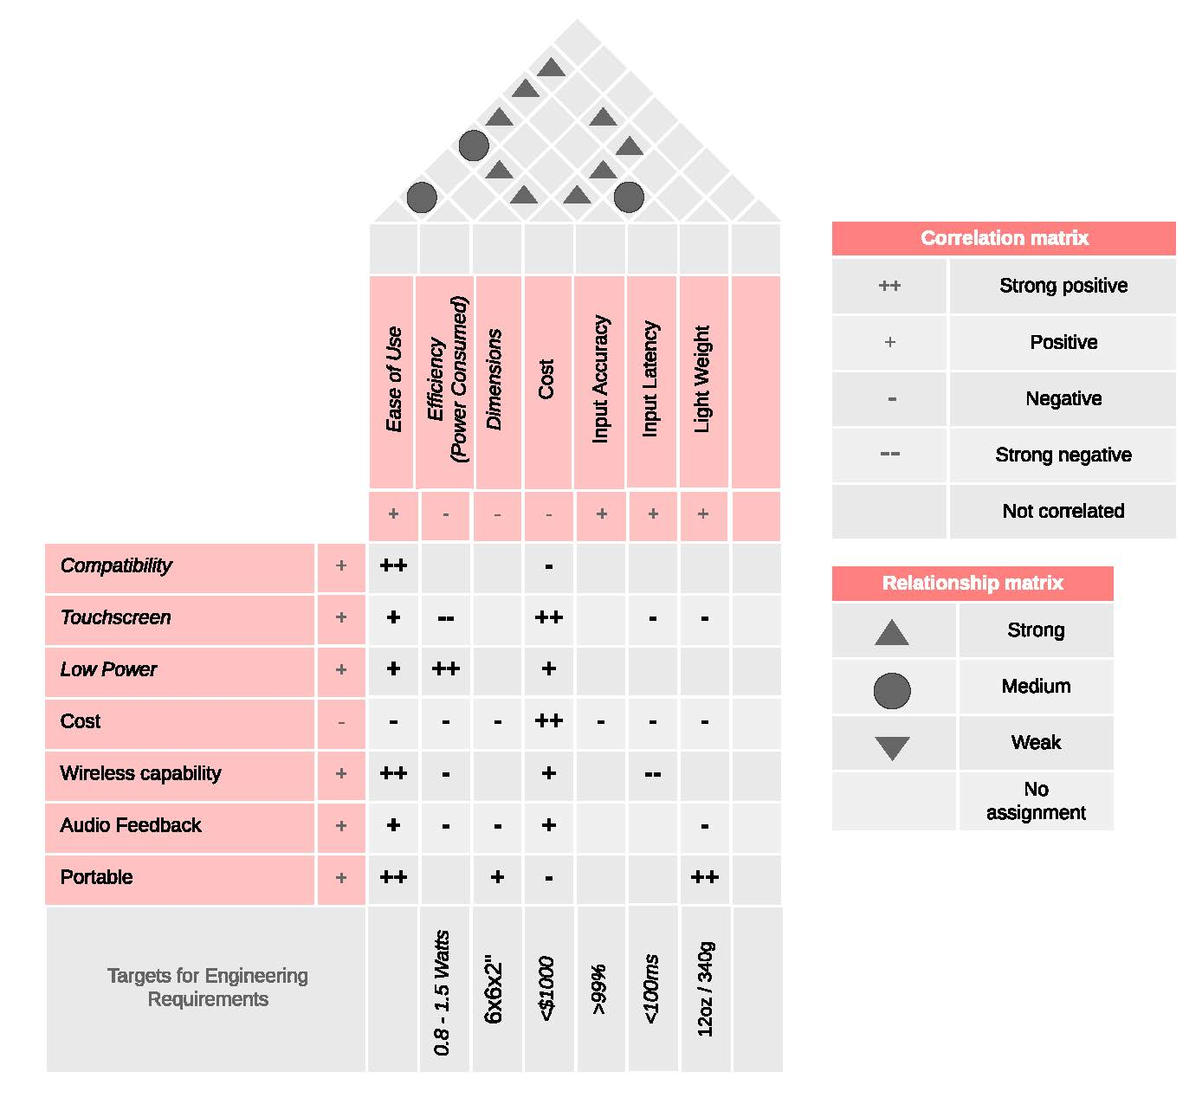

Figure 2‑3: Slate's House of Quality

### Engineering Requirement Categories

There are a variety of design requirements that must be acknowledged and understood during the design phase any project. ABET, which was incorporated as The Accreditation Board for Engineering and Technology, Inc. states that students should attain the ability to design either a system, component or a process that meet several realistic design requirements.

Several categories of these realistic design requirements are identified in UCF’s EEL4914 class textbook [1]. Table 2-2 on the next page lists and briefly describes each of these realistic design requirements. It should be noted that normally these requirements are listed with those affecting performance and functionality first, followed by an alphabetized list, as performance and functionality are the most critical to the design of any type of project.

The requirement category list was used by members of the Slate team to develop their own set of requirements. This ensured we were following current standards in regard to requirement categories, and following standard market practices for their importance.

|  |  |
| --- | --- |
| Requirement Category | Description |
| Performance | Reflect a critical aspect of performance of the system or device. |
| Functionality | Describe the type of functions that a system should perform. |
| Economic | Include costs associated with development and sale; this may include economic impact of final system. |
| Energy | The amount of power that a product may consume; may be specified in terms of maximum, minimum or average values. |
| Environmental | Address the impact of the design on the earth’s environment and resources. |
| Health and Safety | Anyone that may be affected by the completed project should be an especially important concern. |
| Legal | Any existing patents, copyrights, and trademarks should not be infringed up, especially if there is an intention to sell the product. |
| Maintainability | Maintenance of the system being developed and its compatibility with other systems. |
| Manufacturability | The manufacturing aspect of product development should be considered. These requirements are usually identified as constraints. |
| Operational | Address the physical environment the product will operate in. |
| Political | The effect of the product on political, governmental, or union organizations. |
| Reliability and Availability | An estimation of the expected period of proper operation. |
| Social and Cultural | Benefits, risks, and acceptance of the product by the intended user or society. |
| Usability | Identifies how easy the system is to use, which can be difficult to verify. |

Table 2‑2: Engineering requirement categories

### Slate’s Engineering Requirements

The engineering requirements specify the technical and budgetary needs of the design. The performance requirements are arguably the most important requirements and are often characterized by time, accuracy, throughput, or percentage error. The functionality requirements describe the type of functions the system should perform. The requirements identified for Slate are shown in Table 2-3 below:

|  |  |
| --- | --- |
| **Engineering Requirement** | **Justification** |
| 1. Slate’s touch screen input shall have an input response time less than 100ms. | Input response time of the touch screen is an important factor for users of macro-keyboard devices. |
| 1. Slate’s physical keys shall have an input response time less than 100ms. | Input response time of physical keys is expected to be imperceivable for most products on the market today. |
| 1. Slate’s touch screen will have input accuracy greater than 90%. | Users of similar devices expect their inputs to be read accurately. |
| 1. Slate shall operate wirelessly for at least 10 hours at idle (ready) state starting with a fully charged battery. | Based upon current products in the market. |
| 1. Slate shall provide at least six programmable macro functions. | This allows for a suitable number of functions while not requiring an exuberant amount of memory. |
| 1. Slate shall maintain all performance and functionality requirements when connected via Bluetooth. | Users will expect all functionality to remain the same no matter the host connection type. |
| 1. Slate shall maintain performance and functionality requirements no matter the power source. | Users will expect all functionality to remain the same no matter the power source. |
| 1. Slate’s battery shall charge from 0% to 50% in less than 4 hours when connected to a USB power source. | A rechargeable battery is something that is expected in any portable device in today’s market. |
| 1. Slate shall provide at least three profiles for selection by the user. | Multiple profiles allow for use cases related to different software. |
| 1. The total cost of developing the system should not exceed $1,000. | The group has a limited budget. |
| 1. The total for manufacturing cost and parts should not exceed $150. | To be considered competitive in the market space, the price of the final product must be affordable. |

Table 2‑3: Initial engineering requirements for Slate

### Project Constraints

The constraint requirements are created from limitations imposed by the environment or stakeholders. The previously listed engineering requirements are technically constraints as well, but the difference between these and the constraints that shall be identified for the Slate project are that they often are in violation of the abstractness property of engineering requirements. The abstractness property is defined for normal engineering requirements such that the requirement explains *what* the system will do, and not *how* it will do it.

A concrete example of this from our text is that of requiring to allow people to travel from one side of an obstacle to the other side. Specifying how this would be done (bridge, boat, etc.), violates the abstractness property, but with constraints this property is normally violated. In Table 2-4 below, the identified project constraints are listed for the Slate project.

|  |  |
| --- | --- |
| Engineering Constraint | Justification |
| 1. The size of the prototype should not exceed 6" x 6" x 2". | Slate should be easily transportable and blend in with most user setups. |
| 1. The weight should not exceed 12oz / 340g. | Slate should be easily transportable. |
| 1. The product should maintain operational between temperatures of 0° to 70°C | Slate should meet common commercial use standards for temperature. |
| 1. Slate shall meet all safety requirements specified in the ANSI C18.2M Part 2 standard. | Slate must not constitute a safety hazard regarding its power and charging system. |
| 1. All components of slate will meet or exceed standards defined in IEC standard 62680. | Following USB standards ensures compatibility with USB systems and components. |
| 1. Wireless communications conducted between Slate and host systems will follow the standards described in IEEE 802.15.1for Bluetooth. | Following Bluetooth standards ensures compatibility with all Bluetooth devices that also follow those described in the standards document. |
| 1. Slate shall be designed for use on Microsoft Windows operating systems. | Designing specifically for Microsoft operating systems will provide a greater chance of success for the initial prototype. |
| 1. The design of Slate shall utilize only components available for purchase from a variety of suppliers. | Designing Slate with only available components will allow for project timelines to be met. |

Table 2‑4: Initial engineering constraints identified for Slate.

## Block Diagram Overview

High-level block diagrams were created for hardware, power management and software designs during the initial stages of Slate’s design. These early block diagrams ensured all project members had a similar vision for what would be necessary to accomplish the realization of Slate. These block diagrams also guided the team’s identification of relevant technologies and standards. Lastly, the diagrams helped the team develop initial component comparisons.

### Hardware Block Diagram

A diagram representing the hardware system is shown in Figure 2-4 below. The hardware for the design of Slate will consist of four major components which include the power subsystem, the communication subsystem, the microcontroller unit, and the user interface. The responsibility legend identified below does not necessarily mean that the team member listed will fully realize the entirety of that hardware component, but they have been identified for the initial investigation into what will be necessary to fulfill that aspect of the design for Slate.

The user interface specified in the hardware components below only describes that which will be utilized on Slate itself. Another user interface that will be displayed on the computer host of Slate will be described by the User Application component in Figure 2-6 of section 2.6.3. It should also be noted that the user interface specified within the Hardware Components block diagram below includes physical inputs as well as inputs that will be interfaced through Slate’s display device with touch input capability.--

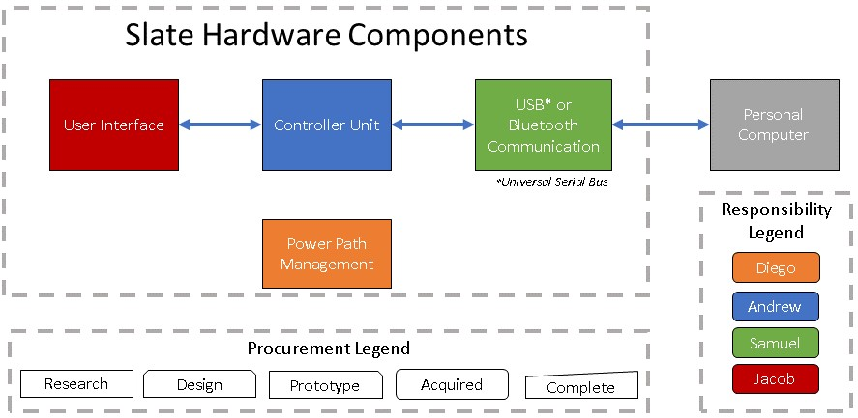

Figure 2‑4: High level hardware block diagram

### Power Management Block Diagram

Next, a high-level overview of the power system which will be utilized by Slate is discussed. The initial block diagram shown in Figure 2-5 was created prior to the technology investigation aspect this report. Its purpose was again to show a high-level look into what the power system would encompass for the Slate project so all team members could share the same vision for the technologies required to successfully design and realize Slate. The specific power management system design will be shown in the schematic diagrams of Section 5-1.

Power for Slate will be provided from USB when available and via an internal battery when USB is not available. A high-level view of this type of system is shown in the following figure. At this point in the design of Slate, the specific power rails that would be required is not known. The expected voltage and type of the internal battery is also unknown at this point of the design for Slate. Thus, only the 5V DC input provided by USB is displayed in the Power Path Management diagram of Figure 2-5.

Several options for the Power Path management IC will be explored in the technology investigation of Section 4.7 for the Battery Management IC.

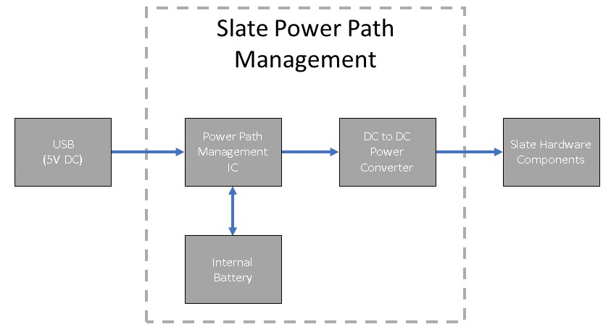

Figure 2‑5: Slate's power management block diagram

### Software Block Diagram

A diagram representing the software system is shown in the following figure. From this block diagram, the team was able to identify three key areas of Slate that will require software design and implementation. This also allowed for us to divide the software requirements of the Slate project into different sections for specific team members to concentrate on.

During this initial stage, the responsibility legend is mainly used to identify the team member responsible for the initial investigation of what will be required for each of these software components. The team member identified may not necessarily complete that aspect of Slate’s software components during the prototyping stage and software design stages.

Several aspects for all the major software components for identified in the high-level software block diagram will need to be investigated. To build the software required for the user interface on the Slate device itself, knowledge of the screen which will be used, and the controller unit selected will be required. The requirements to write the software for the controller unit itself will require knowledge from the datasheet for the controller unit, and all other aspects of the software components themselves as well. The same goes for the user space application software. This software will be how the user will manage the information stored on their Slate device.

In short, all the software components identified in Figure 2-6 below will require knowledge of one another and will not be realized fully by any one team member. Communication between the team during the software design will be of the upmost importance. That importance may not be reflected by the seeming simplicity of the high-level software component block diagram below but has been identified and will be remembered by all team members as we complete various phases of the project.

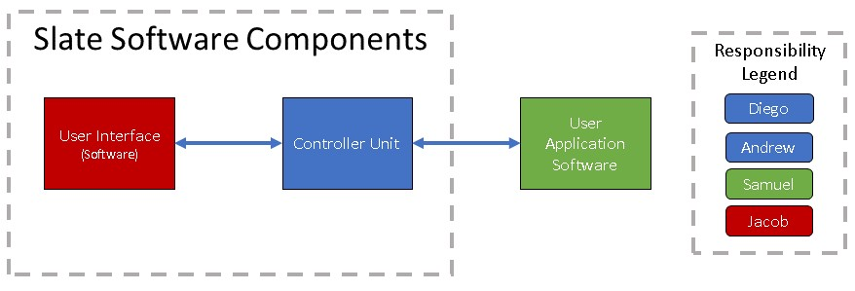

Figure 2‑6: Slate’s high level software block diagram

### Software Use Case Diagram

The key interactions the user will have with Slate and its configuration software are shown in the flowchart of Figure 2-7 below. This use case diagram is an essential step in the software design of Slate that will be used to configure how the device will interact with the host device.

One important aspect of the design that was identified to be investigated was how will the user modify their configuration. At this point of our realization, the Slate team realized that the best way to configure Slate was through an interface that will be displayed on the host computer, and not on the Slate device itself. Minimal configuration will be accomplished on Slate, but that interaction is not shown in the use case diagram of Figure 2-7.

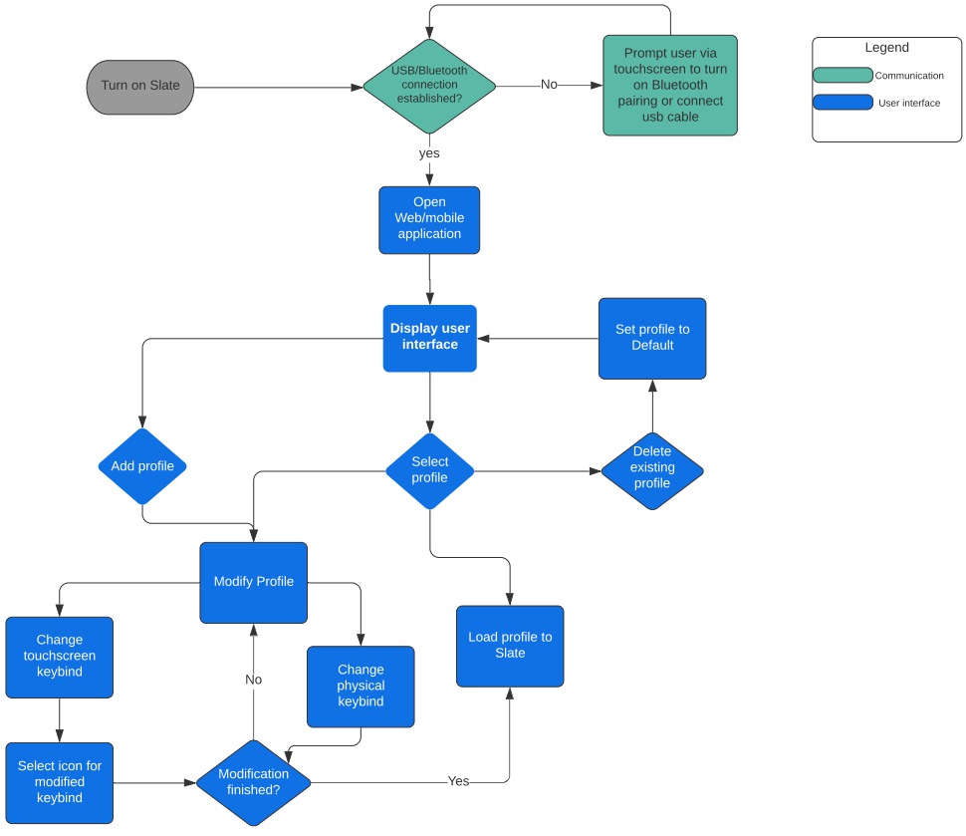

Figure 2‑7: Slate configuration use case Diagram

# Engineering Standards

Engineering standards are a set of guidelines that govern engineers, users and manufacturers. These standards are usually created via a consensus amongst interested parties on national or international levels. These standards provide a minimum quality that must be observed for a variety of reasons, the upmost important of these being safety. These standards are also in place to help ensure the reliability of not only products and materials, but services as well. Some examples of governing bodies for engineering standards are The Institute of Electrical and Electronics Engineers (IEEE) and The American National Standards Institute (ANSI). A thorough understanding of the standards applicable to any project is an essential part of the design process. The standards applicable to our project will now be discussed.

## Relevant Standards

Based on possible designs for the product, related standards were identified. A thorough understanding of the standards applicable to any project is an essential part of the design process. Some of the related standards that have been identified during are summarized in the following table and expounded upon in the subsequent sections.

|  |  |  |  |  |
| --- | --- | --- | --- | --- |
| Governing Body | Designator | Description | Last Updated | Availability |
| ANSI | C18.2M Part 2 | Portable Rechargeable Cells and Batteries - Safety Standard | 20 November, 2020 | No |
| IEEE | 828 | Configuration Management in Systems and Software Engineering | 6 February, 2012 | Yes |
| IEEE | 802-2014 | LAN / MAN: Overview and Architecture | 12 June, 2014 | Yes |
| IEEE | 802.15.1 | WPAN / Bluetooth | 14 June, 2005 | Yes |
| IEC | 62680 | USB interfaces for data and power | February 16, 2021 | No |
| ISO/IEC/IEEE | 29119 Series | Software Testing | September 2013 | No |

Table 3‑1: Engineering standards related to Slate.

### IEEE 802-2014 Standard for LAN / MAN

This standard is simply an overview of the rest of the standards related to frame-based networks. Frame based networks are those in which digital transmission occurs via units, called frames. The framing concept provides discernable pieces of information which are understandable between both receiver and sender. Although these framing concepts are mainly a concern of the physical (PHYs) and data link (DLLs) layers, the IEEE 802 standard’s scope is not limited to just these. The layers within the scope of this standard are shown in the IEEE 802 reference model below [2].

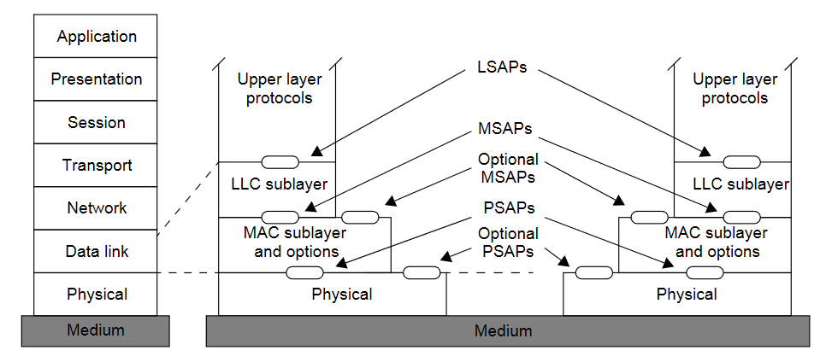

Figure 3‑1: IEEE 802 reference model

The Slate project plans to provide Bluetooth connectivity between participating networking stations. Within the IEEE 802 family of standards, this type of network is referred to as a personal area network (PAN) because these networks typically require little to no infrastructure and provide no connection with the outside world. Standards related to PANs are found within the IEEE 802.15.1 standard, which will be discussed in the next section.

#### IEEE 802.15.1 WPAN / Bluetooth

Within this standard, methods for communicating devices in PANs are discussed. Typically, PANs deal with the conveyance of information over short distances and are limited to a private group of participating devices. The standard is a formalization of Bluetooth wireless technology, which allows for short-range communication without the need for cable(s) or fixed electronic devices.

From this standard, we know that a general description of Bluetooth is that the radio frequency operates within an unlicensed band of 2.4 GHz and employs frequency hopping mechanisms to combat signal interference and fading. To minimize transceiver complexity, radio frequency operation utilizes a shaped, binary frequency modulation scheme.

### IEEE 828 Standard for Configuration Management

Configuration management is an important aspect of any engineering or software project. It is important to keep track of some of even the most miniscule of changes, because those small changes might be the reason why a hardware issue or software bug is present in the design of a product. Following at least the minimum requirements identified in IEEE Standard for Configuration Management in Systems and Software Engineering.

The minimum requirements that should be utilized in the processes for Configuration Management (CM) are established within this standard. It is known that establishing and maintaining the integrity of a product throughout its life cycle is not only desired but vital during development. From 828-2012, Annex A, a list of the core CM process models is identified. The following table summarizes these process models and provides their purpose.

|  |  |
| --- | --- |
| CM Process Name | Purpose |
| Planning | Produce and communicate CM plans that are effective and workable for a project |
| Management | Provide implementation, monitoring, controlling and improvement of CM services. |
| Configuration Identification | Determine schemes that will be used for naming configuration items, identify items that will be needed to be controlled. Also, physical, and functional characteristics of these items are developed. |
| Configuration Change Control | Maintain the integrity of the product throughout all states, starting with the requirements all the way through to a fully functional product, as modifications arise under both development and post-release stages. |
| Configuration Status Accounting | Record, retrieve and report critical information about assets under configuration control to the project team. |
| Configuration Auditing | Assess integrity in an objective manner from both functional and physical perspectives |
| Interface Control | Manage possible effects of interfacing hardware, system software and other project deliverables. |
| Release Management | Ensure the proper set of project deliverables are provided to the required parties. |

Table 3‑2: Core CM processes and their purpose

# Component Investigation

We will first provide an overview of the relevant technologies that must be understood prior to selecting components. Next, we show our analysis of several options for the main components required for Slate. We conclude this section with the components selected for the initial design of Slate.

## Relevant Technologies

### Single Cell Lithium-Ion / Lithium-Polymer Batteries

Single Cell Lithium-Ion (Li-Ion) and Lithium-Polymer (Li-Po) batteries are batteries that use a chemistry of a negative electrode, electrolyte, and positive electrode to charge and discharge lithium ions production energy. Batteries labelled as Li-Ion typically are using an aqueous or solid electrolyte, whereas Li-Po batteries use a polymer-gel-based electrolyte. Most common Li-Ion/Li-Po batteries are manufactured so their chemistry provides a nominal ~3.7V per cell. Since most small and embedded electronics operate on 3.3V or 5V, a single cell Li-Ion/Li-Po battery is often considered for wireless applications.

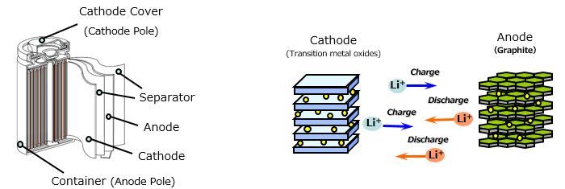

Figure 4‑1: Lithium-Ion battery operation

### Dynamic Power-Path Management (DPPM)

Dynamic Power-Path Management (DPPM) provides a constant and reliable power supply to a system if either an input supply or battery are available. DPPM normally resides within the charging circuit of a battery. DPPM utilizes power path, which separates the battery and the system. The power path circuit normally resides within the charger integrated circuit (IC) and allows for powering of a system and charging of a battery at the same time.

From Texas Instruments (TI), we know that DPPM manages current based on the system’s voltage. The battery charging current is reduced if the system voltage drops below a certain threshold to prevent the system from being under-powered. If the charge current for the battery drops to zero, then the battery can enter what is referred to as supplement mode which means the battery will supplement power to the system if the system’s voltage drops below a certain threshold. In the figure below from TI, we can see the internals of an IC that accomplishes DPPM [3].

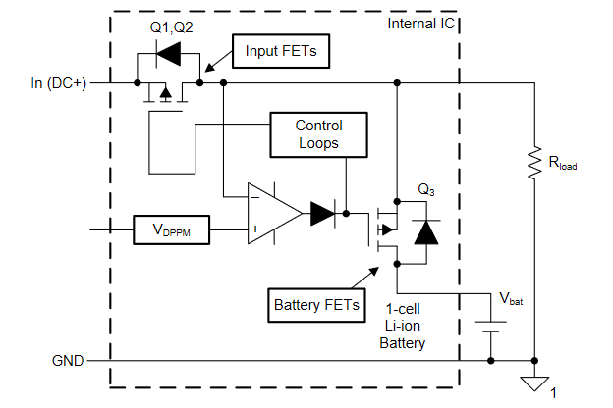

Figure 4‑2: DPPM IC internal operation

### Field Programmable Gate Arrays (FPGAs)

A Field Programmable Gate Arrays (FPGA) allows for dynamic programming of the controller’s hardware functionality. This results in high-performance HDL circuit design that performs the specific task/data-routing it was designed to do, without having to deal with the additional overhead or power consumption of a general CPU-based controller. FPGAs usual purpose is to prototype hardware-layout designs of a custom embedded circuit or processor without spending the exorbitant cost of having them developed, fabricated, and tested between design changes. The downside of using an FPGA is low-compatibility with open-source software. This software is usually written to be run on CPU-based controllers that can perform a wide variety of tasks since they provide circuitry for generalized I/O.

### Microcontrollers

Microcontrollers, also known as MCUs, are compact integrated circuits that govern specific operation in an embedded system. Most microcontrollers include a processor, memory, input/output peripherals, and additional features based on product family and manufacturer. They are designed to improve integration and combine features of specific processors and necessary components into an all-in-one package. Some additional features often added to microcontrollers are support for wireless communication such as Wi-Fi or Bluetooth, native USB support, onboard sensors, large flash memory, antenna designs, and heatsink/heatshield enclosure.

There are a few notable manufacturers of common microcontrollers. These include Nordic Semiconductor, Atmel, Espressif, Texas Instruments, STMicroelectronics, Microchip, and others. Another term often associated with microcontrollers is system-on-a-chip, or SoC. SoC’s are not as well defined as MCUs, but generally infer an even more flexible controller that integrates features beyond MCUs for more generalized operation, as opposed to the often specific and limited capability of an MCU.

### Universal Serial Bus (USB)

As USB is becoming a de facto norm for powering and charging of portable electronic devices, an investigation into both its power providing capabilities and its data transfer methods needed to be explored to complete a suitable design for the Slate project.

#### USB Power

Many devices used today get their power from USB ports contained in a variety of places including but not limited to laptops, personal automobiles, and airplanes. USB power has become the de facto standard power socket for many small personal electronics. The needs of users for both data transmission and power availability can thus be satisfied by USB.

The design of USB Power Delivery is such that pairs of attached ports negotiate voltage, current and/or direction of power flow over the USB cable while being directly attached to one another. There are several key components that make up the USB Power Delivery architecture. Descriptions of these key components are summarized in Table 4-1 below.

|  |  |
| --- | --- |
| Component | Description |
| Device Policy Manager | Exists in all devices, manages Power Delivery resources within devices |
| Policy Engine | Implements local policy for a Power Delivery port |
| Protocol Layer | Enables messages to be exchanged between source and sink ports |
| Physical Layer | Handles bit transmission and reception on wire along with data transmission |

Table 4‑1: Summary of USB architecture components

A visualization of the high-level USB Power Delivery communications stack is provided by the USB Power Delivery Specification Revision 3.1 and is shown in the following Figure 4-3 below .

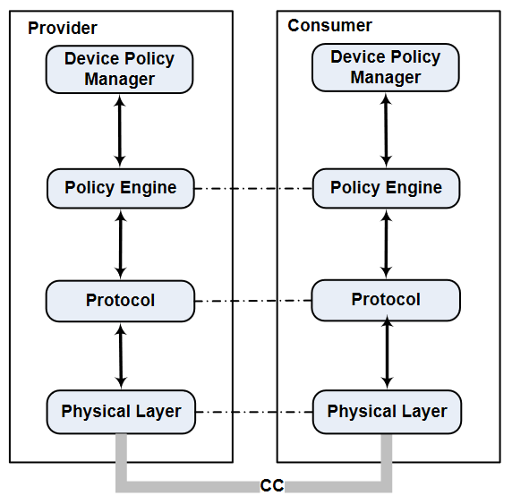

Figure 4‑3: USB Power Delivery communications stack

#### USB Data Transmission

Besides providing a power source, USB can also process a large amount of data. The upper limit for bandwidth provided by the USB 3.2 specification is 2GB/sec. The simplest description of USB is that it is a cable bus which supports the exchange of data between a wide range of simultaneously accessible peripherals and a host computer. These peripheral devices can be attached, detached, configured, used, etc., all while the host and other peripherals are operating.

A USB system can be described by three main areas: 1) USB interconnect, 2) USB devices, and 3) USB host. USB interconnect describes how USB devices are connected and communicate with the host. These key concepts involved with USB interconnect are summarized by the table below and were found in the USB Specification Revision 2.0 [5].

|  |  |
| --- | --- |
| Concept | Description |
| Bus Topology | The model for a connection between USB devices and the host |
| Inter-layer Relationships | USB tasks performed at each layer of the system in terms of a capability stack |
| Data Flow Models | How data moves in the system over the USB between producers and consumers |
| USB Schedule | Since USB provides a shared interconnect, access is scheduled to support isochronous data transfers and eliminate arbitration overhead |

Table 4‑2: USB interconnect key concepts

The simplest connection is that of a host to a single device, and this would require interactions between various layers and entities. There are four focus implementation areas of the simple USB system described and are summarized in the following table.

|  |  |
| --- | --- |
| Implementation Focus Area | Description |
| USB Physical Device | A piece of hardware at the termination points of a USB cable which performs a function useful for the user |
| Client Software | Client software that executes on the host device. It is usually supplied with an operating system or with a USB device |
| USB System Software | Supports USB in a particular operating system and is typically independent of particular USB devices or client software |
| USB Host Controller | Allows for USB devices to be attached to a host and is comprised of both hardware and software |

Table 4‑3: Focus areas for USB implementation

The interaction for the simplest of connections can be described by the physical/signaling/packet connectivity, which is provided with the USB Bus Interface layer. Next, the USB Device layer provides a view for the USB system software while performing generic USB operations with a device. Followed by the Function layer providing extra capabilities to the host device by an appropriately matched client software layer. Both the USB Device and Function layers have view into the logical communication within their respective layer that uses the Bus Interface layer to finally accomplish data transfer. This simplest interaction within a USB system can be visualized by Figure 4-4 on the next page image and is provided as a summary of USB data transmission.

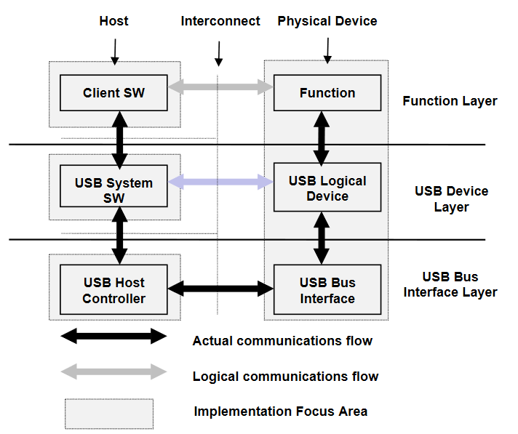

Figure 4‑4: Layers and entities of simple USB communication

### Bluetooth (BT) Communication

Bluetooth provides wireless technology over a short-range communication system with the goal of replacing cable(s) which connect portable and/or fixed electronic devices. The main components of the Bluetooth technology are robustness, minimal power consumption and minimal cost.

At the core of a Bluetooth system is a Host and one or more Controllers. The Host is considered a logical entity that encompasses all the layers below the non-core profiles and above the Host Controller interface (HCI). A Controller is also considered a logical entity that encompasses all the layers below HCI and can be defined as either a Primary Controller or a Secondary Controller.

Bluetooth technology comes in two forms of wireless systems: Basic Rate (BR) and Low Energy (LE). With both forms comes device discovery, connection establishment and connection mechanisms. Table 4-4 below summarizes the differences between the two forms.

|  |  |  |
| --- | --- | --- |
| Feature | Basic Rate (BR) | Low Energy (LE) |
| Device discovery | Available | Available |
| Connection establishment | Available | Available |
| Connection mechanisms | Available | Available |
| Enhanced Data Rate (EDR) | Available | Not Available |
| Alternate Media Access Control (MAC) | Available | Not Available |
| Physical (PHY) layer extensions | Available | Not Available |
| Synchronous connections | Available | Not Available |
| Asynchronous connections | Available | Not Available |
| Isochronous transmission | N/A | Available |
| Data rate | Up to 54 Mb/s | 2 Mb/s |

Table 4‑4: Summary of BR and LE BT systems

Some examples of implementing a Bluetooth Core system include only one Primary Controller which can be in one of the following configurations according to the Bluetooth Core Specification:

* a BR/EDR Controller including the Radio, Baseband, Link Manager and optionally HCI.
* an LE Controller including the LE PHY, Link Layer and optionally HCI.
* a combined BR/EDR Controller portion and LE Controller portion (as identified in the previous two bullets) into a single Controller.

We can see a visual representation of these three configurations in the following figure from the Bluetooth Core Specification:

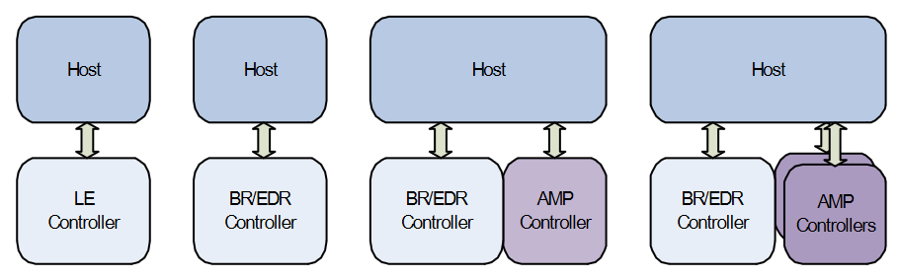

Figure 4‑5: Three example Bluetooth configurations

### Touch Screen

Touch screens are a combination of a touch panel and an electronic visual display which is usually an LCD or an OLED display. There are many types of touchscreen technologies including infrared and surface acoustic wave, but we mostly interact with resistive and capacitive touchscreens. Most of us are familiar with these touchscreen technologies because we use them in everyday devices like our smartphones, computers, grocery store checkouts, and even at an ATM. There are two different types of touchscreen technologies we will be considering for our Slate, capacitive and resistive touchscreens.

A resistive touchscreen as shown in Figure 4-6 below is made of two top transparent film panels and a bottom insulating glass panel. Both transparent film panels are coated with electrically conductive layers that are made of indium tin oxide.

The two film panels are separated by non-conductive spacers that creates some empty space between them, so the panels do not touch while not in use. The conducting sides are placed facing each other, so when you press your finger against the screen both the layers contact each other. Those layers always have current running through it so when the layers make contact, a change in resistance occurs (an increased in voltage) and a sensor layer logs this change by having a processor calculates the coordinates of the change to determine the position.

This type of touchscreen is found on devices like ATMs, self-checkout kiosks, and other devices that only need single finger and basic gesture support. Resistive screens are not as bright as capacitive screens but tend to be more durable and affordable.

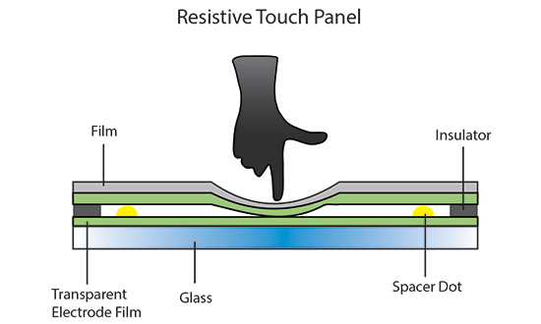

Figure 4‑6: Operation of a resistive touch screen.

Capacitive touch screens are a bit more complicated but also type of touchscreen we interact the most because those are the ones we find on modern computers, smartphones, and tablets (ex. iPad). As shown in Figure 4-7 below, capacitive screens are made up of multiple layers of plastic and glass, coated with a conductive material like indium tin oxide or copper.

The coated material responds when contacted by another electrical conductor, like a finger. A capacitive screen works by registering a change in an electrostatic field (touch event), this occurs when the coated material is contacted by another electrical conductor (in our case a finger). Once this "touch event" is registered by the touch sensor the control board signals the operating system prompting some response.

Capacitive screens are generally brighter and more sensitive than resistive screens. Unlike, a resistive touchscreen, most capacitive touchscreens cannot detect finger presses through electrically insulating material like gloves. This is a massive disadvantage because it affects usability of consumer electronics like a smartphone in cold weather when people are using gloves.

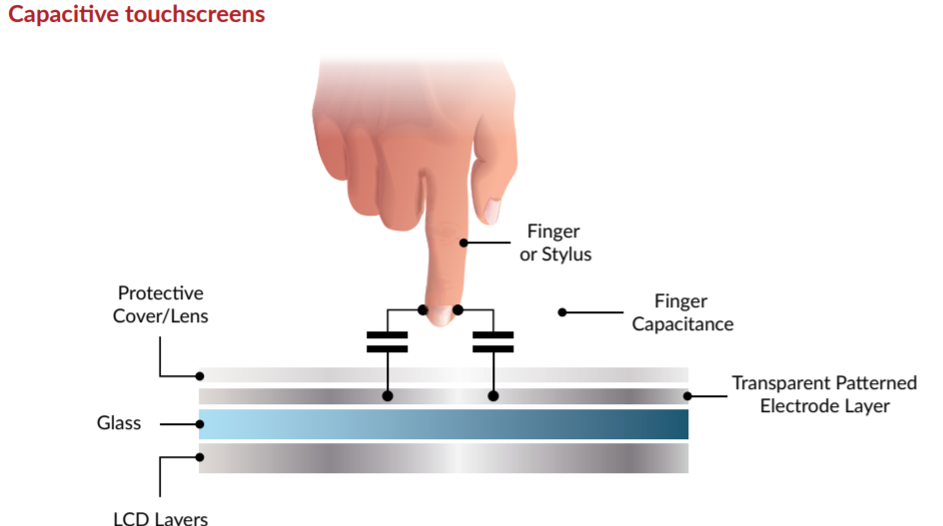

Figure 4‑7: Operation of a capacitive touchscreen

At this point in the design of Slate, the decision of what type of screen that will work best has not been made. There are advantages and disadvantages to both types and for the Slate. A main concern of the project is to minimize the cost while also supporting simple hand gestures. So, a resistive screen might be what we go for but if we want a higher resolution display that supports more complicated hand gestures, we will consider a capacitive touchscreen.

To aid in the design decision for the type of touchscreen to be used, the apparent advantages and disadvantages of both resistive and capacitive screens were identified. These advantages and disadvantages for resistive and capacitive screens are respectively shown in Table 4-5 and Table 4-6 below. Utilizing these tables, the best design decision for the type of screen that will be used by Slate can attempted to be made.

|  |  |
| --- | --- |
| Resistive Advantages | Resistive Disadvantages |
| Cost | No multi-touch support |
| Reduced accidental touch | Requires adequate pressure to register touch events |
| Higher sensor resolution | Display is less bright when compared to capacitive screens |
| Stylus can be used for input | Lower durability |

Table 4‑5: Resistive screen advantages and disadvantages

|  |  |
| --- | --- |
| Capacitive Advantages | Capacitive Disadvantages |
| Durability | Much more costly |
| Possibility of higher resolutions | Reduced viewing angles |
| Screen brightness |  |
| More sensitive input response |  |
| Gesture input support (multi-touch) |  |

Table 4‑6: Capacitive screen advantages and disadvantages

## Printed Circuit Board

Printed circuits boards or better known as PCBs (Printed Circuit Board) are the most common method of assembling electronic circuits today. The entire idea behind a PCB is to mechanically support and connect different electronic components together with the help of conductive tracks using made from copper sheets laminated onto a non-conductive substrate. Typically, the PCBs is composed of one or more insulating layers, one or more copper layers that have the designed signal traces, power, and ground layers. Nowadays PCBs usually consists of around 8 but more complex boards can have even more. The boards after design and etched have their components mounted on the top layer with either holes or on the surface. There are many manufactures that will take your Gerber files and print them out, some include E-TekNet, jlcpcb and many more. Typically, the cost per board depends on two factors size and the amount of layers that will be needed. It can range anywhere from a few dollars to a couple hundred.

### PCB composition

The PCB has alternating layers of different materials that are put together with the help of heat and an adhesive. The PCB is separated into the silkscreen, solder mask, copper, and the substrate (FR4). This separation is visualized in Figure 4-8 below. Prototype boards can be built using perfboard, which basically is a piece of paper and laminated with an FR-2 resign.

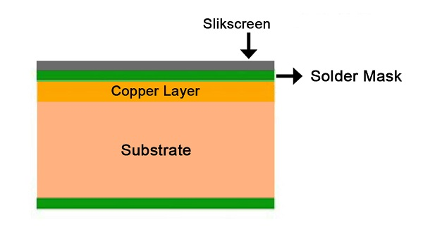

Figure 4‑8: Materials used in a PCB

#### Base Layer - Substrate

The substrate is the solid core that gives the PCB its structural integrity. Each substrate is given a grade FR-4 which is a composite material that is composed of woven fiberglass held together by epoxy resin. This layer is responsible for giving the OPCB its rigidity and helps prevent damage like accidental snapping. However, depending on the situation you can opt in for flexible PCBs which are made of plastic composites to create a curve and is resistant to high temperatures.

#### Copper foil/sheeting

The next layer up is the copper foil which is attached using adhesive and then heat fixed onto the substrate layer. Between the copper foil and sheeting layer is called prepreg which is a layer of pre-impregnated resin. It is bonded to the other layer by heat and pressure.

#### Solder mask

This typically determines the color of the board, usually the solder mask is green, but you are able to change the color depending on the manufactures. The main purpose of this layer is to keep the copper tracks and pads insulated from the other metal, pieces of solder or other conductive materials.

#### Silkscreen

Final layer where the white ink that holds all the information about the board lies. The markings help with assemble letting the assembler know what exactly goes into each section of the board. Typically, the information are numbers, letters and other symbols that can represent pins or LEDs.

### Design Recommendations

The PCB must be not only reliable but also long lasting to ensure that the product is a success. Each board is different in the sense that they all have their own unique design and purpose. However, certain procedures can ensure that the PCB can work at its full potential which can in turn improve performance and reliability of the system. The industry has developed techniques over the past years. Some of these techniques can help reduce the overall footprint of the PCB making the system much more compact. Table 4-7, which spans the next two page, describes some techniques and rules for PCB design.

Table 4‑7: PCB design techniques and rules

| **Technique/Rule** | **Description** |
| --- | --- |
| Keep traces as short and direct as possible. | Longer traces mean higher resistance and inductance in the board data and power lines. |
| Fine tune the components placement, group similar components together. | Keep all related components together because they are most likely connected to each other. Meaning keeping resistors/capacitors near each there since they do connect to each other in a circuit. This also helps in the testing phase. Keep all components similar in orientation to help with an efficient and error-free soldering process during assembly. |
| Use a power line to manage the power lines and ground. | With this its ensures that the power flows effectively with little to no impedance and power loss. It also ensures that the ground return path is adequate for the circuit. In typical design. |
| Orienting power and ground planes | It is always recommended to have the planes to be symmetrical and centered. With this it allows the board to not bend. Use common rails for each supply, have sold and wide traces, and avoid daisy chaining power lines from part to part. |
| Defining Net widths | It is recommended to provide a 0.010” width for low current and anything more than 0.3A should be wider. |
| Keep Thinds separate | Keep the digital and analog components in their respected areas. Keep power ground and control ground separate for each power supply stage. If the ground plane is the middle layer. Make sure to place a small impedance path to reduce the risk of any power circuit interference. |
| Combating heating issues | Set up the components that will dissipate the most heat through the board. Keep critical components away from high heat sources. If one or more components generate a large amount of heat keep them separated through the board. Use the ground plane as a large heat sink. Use teardrops where traces join pads to provide additional copper foil/metal support to reduce mechanical and thermal stress. |
| Checking your layout against your PCB design rules. | Always recheck your design to ensure there aren't any issues that can come up when the board is printed. Use the ERC and DRC to verify you have met all the constraints. Once that this error free check through all the routes of every signal and make sure you haven't missed anything. |
| Use decoupling capacitors wherever necessary | This helps shield your on-board IC from high frequency noise. |
| Use automatic signal routing with caution. | Any critical signal paths should be routed by hand to avoid undesired coupling or emissions. |
| Use silkscreens carefully | This is used to identify components, part numbers, and wiring symbols which helps people better understand the board. Ensure all fonts and orientation are consistent. |
| Generate the PCB manufacturing data and verify it before sending it out to be fabricated. | Create your own Gerber file before sending it to the manufacturer, this way any errors missed can be caught. |
| Place the mounting holes strategically  Table 4‑7: PCB design techniques and rules | Plan in the beginning and should be clear of tracks and components. Holes should be coated with dielectric materials, make them consistent to save cost. |

### PCB Design Software

Electronic design Automation or EDA for short are software that is needed to develop PCBs. Usually, these programs have a schematic editor for designing all the circuits of the board. Parts can be selected and connected together to form connections. The Sofware also allows for annotation and auto routing to automatically connect traces based on the constraints of your design. With all these features it allows for an easier time designing PCBs. The most popular EDAs are Eagle, DipTrace Starter, Altium, and ORCAD. The software when used for commercial application is expensive however ORCAD, Eagle, and DipTrace offer free versions with restrictions to how many layers can be used and must be for non-commercial use. Eagle is widely supported and has an extensive community with plenty of online tutorials and libraries which allows for ease of use. The only draw side is that it does not have the nicest user interface compared to the other software. With this in mind the team has elected to use Eagle for this project. Below is a table that shows all the pricing for all the Software's however, some versions may not be listed.

|  |  |  |
| --- | --- | --- |
| Software Package | Specs | Price |
| Eagle Standard | 99 sheets with unlimited layers | $820 |
| DipTrace Standard | 1000 pins with unlimited layers | $345 |
| Eagle Free Version | 16 layers maxed at 4” x 6” boards | Free |
| DipTrace Free Version | 2 layers with a max of 500 pins | Free |
| OrCAD Free Version | 2 layers with a max of 100 pins | Free |

Table 4‑8: Overview of PCB software

### Eagle Design

PCB design in Eagle is quite simple, it requires a two-step process. First to design a schematic which would be a .sch file, then creating a board layout in the “.brd” format based off that schematic. Once you have an error free schematic and board you can create a Gerber file which is sent to the PCB manufacturer for printing.

To start things off we must create a schematic, Eagle requires you to first start a new project. One that is done you can add your schematics to that directory to make it as organized as possible. To add parts Eagle, give an ADD tool which opens a library navigator with a list of pre-loaded libraries and gives you the option to add more later down the line. Once you select the desired part the design will automatically update with its schematic symbol. Once you have added and found all your parts you can start adding a frame to your design while this isn't necessary it is recommended because it will allow for a clean and organized schematic. After is when you should add your power and ground inputs.

After the schematic is designed and verified to be error free, it can be transferred to Eagles board designer to create the boards layout. This is where you will lay out all the components on the board and create their respected traces.

To begin the process, we must first generate/switch to board command. Once there the gold lines represent air wires, which should the require connection that is represented in your schematic. There will also be a faint, light gray outline surrounding all the components in your board. Organize the board to ensure that the parts do not overlap, and the tracks don’t cross to prevent any shorts. However, you can put tracks on the opposite side of the board if you need the traces to overlap for some reason. Vias can also be used if the trace needs to be moved to a different layer mid-way.

Once everything is finished, it is very important to run the Eagle Design Rule Check to make sure there aren't any error in the board layout. Annotations should be done as a final touch up. Once the design is final it is time to create the Gerber file to then be sent to the fabricator.

### Design Constraints for PCB

The PCB must fit the shape of the enclosure and must consider the space needed below the PCB so that components are not interfering with the optimal placement of the battery. Many of our controller considerations include an antenna design that requires PCB constraints to reliably receive and send wireless signals.

The constraint is to remove the ground plane beneath the surface area of the PCB that the antenna covers. The other option is to have the area of PCB below the antenna removed, but the former option would likely cost less to alter and allow for more flexibility in controller placement.

### PCB Manufacturers

Three possible PCB manufacturing services were investigated for the Slate project. Each manufacturer offers their own unique services, but they are all very similar at the core. The manufacturing of the PCB at this stage will only consider the development of prototypes. No considerations were made into the manufacturing of the PCB when bringing the product to market in which new plans for mass manufacturing may be required.

The main concern for manufacturing of Slate’s prototype PCB is price. Based on the current timeline of the project, we are not constrained by any extremely short turn-around time for the manufacturing. All three of the PCB board manufacturers offer similar material types. At this time, we are unable to request quotes from the manufacturers being investigated as we do not have a Gerber file or a completed bill of materials (BOM).

The project team will reach out to each of the possible manufacturers to inquire about the possibility of their financial support for the Slate project. Once we have a completed BOM and PCB design, we will contact each of the manufacturers in Table 4-10 below for their service quotes.

|  |  |  |  |
| --- | --- | --- | --- |
| Company | Location | Assembly Services | Financial Support |
| Saturn PCB Design, Inc. | Central Florida | Yes (and component purchasing) | Unknown |
| FermiTron, Inc. | Central Florida | Yes | Unknown |
| Quality Manufacturing Services | Central Florida | Yes | Unknown |

Table 4‑9: Summary of PCB manufacturers

## Keyboard Switches Considerations

Slate will be equipped with 10 switches that can be mapped to do whatever, the user desires. To choose the correct keyboard switches we must consider our environment, tactile preference, target hand size, strength, typing style, and the general purpose of the keyboard.

Slate is intended to be used inside, on the table next to the main keyboard. Different switch's carry different auditory feedback that some may prefer, some may like soft toned or distinct click with a high-pitched sound when pressed.

Tactile preference depends untimely on the user. The general rule of thumb is that for gaming linear switches are what should be bought since they are consider speed switches with a smooth and consistent keypress which helps with rapid movements. For general typing tactile and “clicky” switches are preferred because it provides great feedback which results in a pleasant user experience. If the desired feel is a hybrid of the both the keyboard itself can have a swapping feature which Slate will not. The following sections will further expand on the different types of switches.

### Mechanical Switches

Mechanical switches are the mechanisms underneath each key, which determine the activation of the keystroke. There are several different types of mechanical key switches which will be identified in subsequent sections. To provide an overview of what parts must be considered in the selection of a mechanical switch, an example of one is shown in Figure 4-9 on the next page.

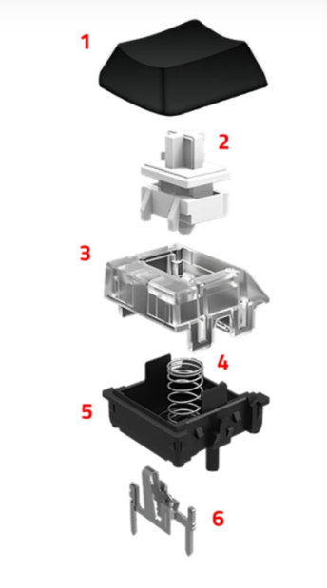

Figure 4‑9: Components of a mechanical keyboard switch

As can be seen in the figure above, each switch is composed of six parts, the keycap, the stem, upper housing, coil spring, base housing, and the cross-point contact. To properly investigate this key component of Slate, each of the parts that compose a keyboard switch must be known and understood. Table x-x below lists and describes each of these six components. Utilizing this information, the project team can more confidently decide to utilize this type of keyboard switch as Slate’s inputs, as well as make the decision between different manufacturers and models of these types of keyboard switches.

|  |  |  |
| --- | --- | --- |
|  | **Name** | **Description** |
| **1** | Keycap | The part the user sees and is partially responsible for the noise generated when the key is bottomed out. |
| **2** | Stem | Can vary in shape which affects the actuation and travel distance of the switch. It is responsible for the keystroke feel and determines the switch type. |
| **3** | Upper Housing | This part protects and guides the stem and is the part that the keycap hits when the key is pressed. |
| **4** | Coil Spring | The resistance of the coil spring determines the amount of pressure needed for the key to be pressed. It also helps guild the key back up to its original position. |
| **5** | Base Housing | This is where the upper housing is mounted. And is the piece that attaches and clips to the PCB |
| **6** | Crosspoint Cross | A tiny metal or gold piece where the electricity flows. It is responsible for rendering a key press when the switch is pressed by closing the switches current. |

Table 4‑10: Descriptions of the components of a keyboard switch

#### Types of Mechanical Switches

There are three types of switches linear, tactile, and clicky. Linear switches are the simplest they move up and down without any tactile feedback or clicking noise. They are smooth which allow for a more rapid actuation. Tactile switches provide a tactile feedback, they provide a noticeable bump in the middle of travel to let the user know that your key has been registered. Which means the user won't need to bottom out the key. Clicky switches work the same as tactile switches however, they provide a distinct click noise when the key is activated.

#### Characteristics of Mechanical Switches

There are five technical characteristics of a switch that must be considered when making the selection not only amongst the types of mechanical switches but the specific manufacturer and model of the component as well. As part of the technology investigation, these characteristics were identified and defined. The result of this investigation is shown in Table 4-12 below.

No one characteristic can be considered more important towards the application for Slate. The variety of use-cases for the product means that one user may find the operational force to be the most important of these characteristics, while another user may find the total drive distance to be of the upmost importance.

Based on our engineering requirements, none of these characteristics should be weighed more heavily than another. Slate needs to meet the all-around needs of many different users, so the most well-rounded option in respect to these characteristics is the one that will most likely be favored when deciding which switch to decide upon as the one for our project.

|  |  |  |
| --- | --- | --- |
|  | **Characteristics** | **Description** |
| **1** | Operation Force | How hard the user must press the key. It is measured in centinewton (cN) or gram-force (gf). |
| **2** | Activation Point | This is the point where the keypress in recognized by the keyboard and is measured in millimeters. |
| **3** | Total Travel Distance | The distance the keycap travels until it hits the upper housing of the switch. Which is the distance until you bottom out. Normally measured in millimeters. |
| **4** | Tactile Position | Is where you feel the bump on tactile and clicky switches. |
| **5** | Reset Point | Is the distance which the key is deactivated when released. |

Table 4‑11: Characteristics of mechanical switches

### Switch Considerations

There are several options to consider when it comes to make the selection for the switch that will be utilized in the design of Slate. Several of the switch options will now be considered. First, there are several different categories of switches. These categories are linear, clicky, tactile, and low-profile. Each of these types are geared to certain types of users. A summary of each of these key switch types is shown in Table 4-13 below.

|  |  |  |  |
| --- | --- | --- | --- |
| Key switch Type | Noise Level | Feel | Force Required |
| Linear | Quiet | Smooth | Varies |
| Clicky | Loud | Bumpy | Varies |
| Tactile | Moderate | Bumpy | Varies |
| Low-profile | Varies | Varies | Varies |

Table 4‑12: Summary of key switch types

There are several options available in each of these key switch types. The options that were explored and considered for Slate are visualized in Figure 4-10 and will be explored in the subsequent sections.

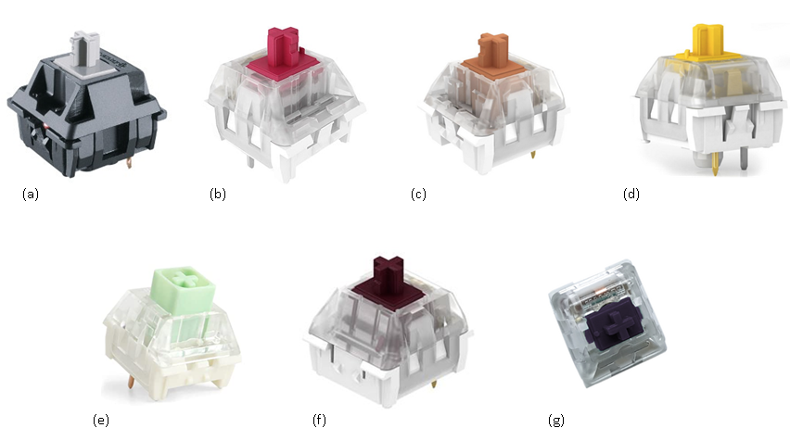

Figure 4‑10: Visualization of several keyboard switches

#### Linear

Two linear type switches are being considered for use with Slate. These two switches are the Speed Silver and the Burgundy Kalih. Stock images of these linear type switches are shown in Figure 4-10(a) and Figure 4-10(b) respectively. Some of the key characteristics were considered when investigating these components are those described in Table 4-12.

At the time of this investigation, Speed Silver cost approximately $15.00 USD for a set of ten switches. They are manufactured by Cherry MX, require an operating force of 45cN, have an activation point of 1.1mm, a travel distance of 3.5mm and a lifespan of 50M. There is no option for the backlighting of a Speed Silver.

The second consideration for linear type key switches was the Burgundy Kalih. This model of switch cost $28.00 for 70 pieces. This option for key switches requires an operating force of 50cN, have an activation point of 1.7mm, a travel distance of 3.6mm and a lifespan of 70M. Contrary to the Speed Silver, the other linear type of key switch investigated, they do have the ability to be backlit.

#### Clicky

Three clicky type switches are being considered for the design of Slate. These three switches are the Speed Bronze, the Speed Gold, and the Box Jade. Stock images of these three types of switches are shown in Figure 4-10(c), Figure 4-10(d), and Figure 4-10(e) respectively. As with the linear type switches, the key characteristics of clicky type key switches are those that were described in Table 4-12.

Speed Bronze switches are manufactured by Kalih. This model if clicky key switch costs $30.00 dollars for 70 switches. They require an operating force of 50cN, have an activation point of 1.1mm, a travel distance of 3.5, and a lifespan of 70M. Lastly, they do have the capability to be backlit.

Speed Gold switches are also manufactured by Kalih and cost $30.00 dollars for 70 switches. They require an operating force of 40cN, have an activation point of 1.4mm, a travel distance of 3.5mm, and a lifespan of 70M. Similar to the Speed Bronze of the same manufacturer, they have the ability to be backlit.

The last option in the clicky key switch category investigated were the Box Jade switches which are also manufactured by Kailh. These switches cost $10.00 for 10 switches. They have a 50cN operating force, 1.7mm activation point, 3.5mm travel distance, and have a 70M lifespan. In comparison to the other switches manufactured by Kalih, the box construction utilized by the Box Jade allows for greater stability on the keypress. The result of which is a more robust feel like that of a button as opposed to a typical switch whose feel is intended for rapid actuation.

#### Tactile

Two tactile type switches are being considered for the design of Slate. These two switches are the Speed Copper and the Plum. Stock images of these tactile type switches are shown in Figure 4-10(f) and Figure 4-10(g) respectively. Some of the key characteristics that were considered when investigating these components are those described in Table 4-12.

Speed Copper switches are manufactured by Kalih. This model of switches cost $30.00 for 70 switches. They require an operating force of 40cN, have an activation point of 1.1mm, a travel distance of 3.5mm, and 70M lifespan. Lastly, they do have the capability to be backlit.

Plum switches are manufactured by Kalih as well. This model switch costs $30.00 for 70 switches. They require an operating force of 70cN, have an activation point of 1.7mm, a travel distance of 3.6mm, and 70M lifespan. They also can be backlit similar to many of the other options from Kalih.

#### Low-Profile

In addition to the standard height mechanical key switch, there are also low-profile options that allow for a slimmer profile when mounted. These typically come in the same options of actuation characteristics as described above, but have reduced height and use shallower keycaps. One model of low-profile switches to consider are the Kailh Choc branded switches. These are available in clicky, tactile, and linear options.

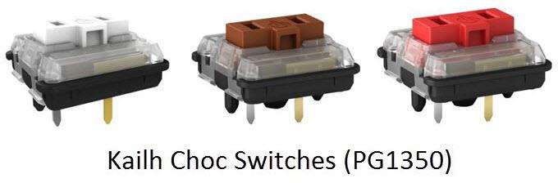

Figure 4‑11: Low-profile key switch visualization

#### Switch Consideration Summary

#### In summary, the components that were investigated for the keyboard switches were of various type. These types included linear, clicky, tactile and low profile. The important aspects that must be considered from the user’s perspective for any of these types of key switches are the loudness, the feel and the force required to register a key press event. Section 4.12 will provide an ultimate summary and selection for the key switch component of Slate.

## 3D Printer Filament Considerations

There are many different types of 3D printing filaments currently in the market ABS, Flexible, PLA, HIPS, PETG, Nylon, Carbon Fiber, ASA, Polycarbonate, Polypropylene, Metal filled, Wood filled, and PVA. Due to such a large selection of filament, we must remember our main design constraints for this project, which is to be as cost effective however, still have a durable and have a clean finish.

With that out of the way we must first address the type of printer that will be used because that will give us a better understanding of which filaments we can use. A Slate team member will be providing the 3D printer since this team member has one at their disposal. A secondary option, if by any means the team member is not able to provide these services, the team will be using the 3d printer provided to us in the TI lab.

The team member currently owns a *Creality 3* 3D Printer. This printer can print upwards of 300 degrees Celsius with a print volume of 220 x 220 x 250mm. The way we will rank these filaments is by using 5 tear scaling system. With the main categories being printability, strength, stiffness, durability, and cost. Printability is based off how easily the material is to print given the factors such as oozing, clogging, warping etc. Strength is calculated based on how much stress the material can withstand before breaking. Stiffness is measured by how difficult it is for the material to bend. Durability is based off how resistance the material is to heat, fatigue, UV, water, and chemical resistance. Price is of course measured based off how expensive the material is.

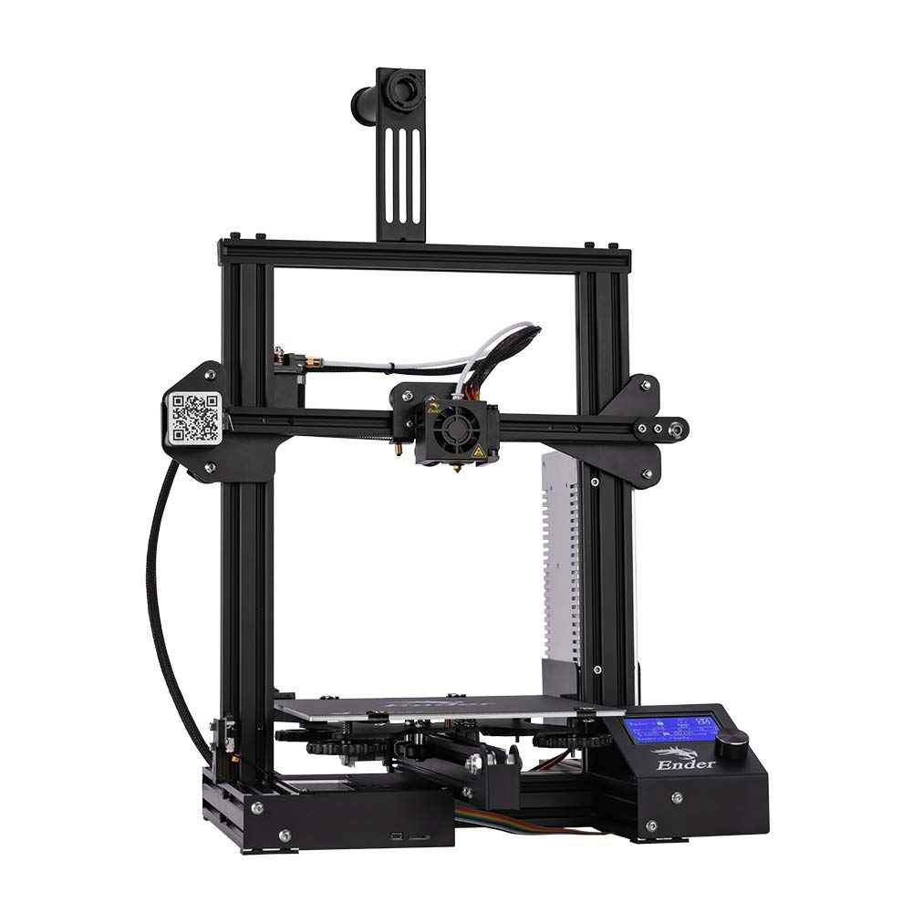

Figure 4‑12: 3D Printer example

The key selection that must be considered regarding 3D printing is the filament type that will be used. The filament is the actual material the product will be made up of and its selection will mostly be reliant on the engineering requirements that have been previously specified for Slate.

Several filament types were considered for the Slate project and these considerations include Polylactic acid (PLA), acrylonitrile butadiene styrene (ABS), flexible, High impact polystyrene (HIPS), glycol modified polyethylene terephylene (PETG), nylon, carbon fiber, acrylic styrene acrylonitrile (ASA), polycarbonate, polypropylene, metal filled, wood filled and polyvinyl alcohol (PVA). Examples of these filament types are shown in Figure 4-13 below and will be expounded upon in the subsequent sections.

Some of the important aspects of these filament types to consider are cost, print temperature, bed temperature, resulting texture, strength, stiffness, and durability. All of these aspects will be considered when selecting a filament and will be summarized at the conclusion of this section. The results of this investigation will lead the Slate team to a design decision on what type of filament to use for the housing of Slate’s components.

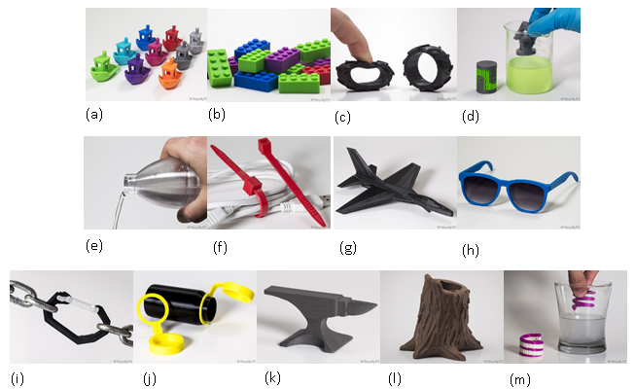

Figure 4‑13: Examples of 3D printer filaments

### PLA

PLA is a Polylactic acid, shown in Figure 4-10(a), which is the one of the most common accessible filaments for home desktop prints. It prints at a 190 – 220 degrees Celsius extruder temperature with a bed temperature of 45 – 60 degrees Celsius. It is both tough and easy to print with not requiring much preparation work. However, the prints degrade over time and the finish is rough in texture. It also is extremely poor when used in higher temperatures which means it is not suitable for outdoor use.

Usually, the price per kilogram comes up to 10 – 40 dollars. PLA ranks a 4.5 in printability, 3.5 in strength, 3.5 in stiffness, 2 in durability, and 2 in price.

### ABS

ABS is an acrylonitrile butadiene styrene is shown in Figure 4-10(b). It is best known for its low cost and good mechanical properties. ABS is very tough and has a high impact resistance which means it can see extra usage and wear which is why Legos are made of this material. However, it is a candidate for heavy warping, produces a pungent order while printing and parts tend to shrink when printing leading to dimensional inaccuracy. It prints at an extruder temperature of 220 – 250 degrees Celsius and a bed temperature of 95 – 110 degrees Celsius. Price per kilogram comes up to 10 – 40 dollars. ABS ranks a 4.5 in printability, 2 in strength, 2.5 in stiffness, 4.5 in durability, and a 2 in price.

### Flexible

Flexible filaments are made of Thermoplastic elastomers or TPE for short is shown in Figure 4-10(c). Thermoplastic polyurethane or better known as TPU is the most commonly used it offers flexibility, excellent vibration dampeners, and has good impact resistance. However, it is very difficult to print with making it very hard to work with and you will not always get a good print. Price per kilogram comes to 30 – 70 dollars. It prints at an extruder temperature of 225 – 245 degrees Celsius and a bed temperature of 45 – 60 degrees Celsius. Flexible filament ranks a 3 in printability, 2 in strength, 1/2 in stiffness, 4.5 in durability, and 3 in price.

### High impact polystyrene (HIPS)

HIPS or High impact polystyrene, is a dissolvable support material commonly used with ABS and is shown in Figure 4-10(d). Because it’s a support material it can be dissolved using d-Limonene leaving prints clean and free of any markings. Its low in cost, impact resistant, and lightweight. However, it is dissolvable using d-Limonene and requires special attachments on the 3d printer such as a heated chamber. Price per kilogram comes to 24 –32 dollars. It prints at an extruder temperature of 230 – 245 degrees Celsius and a bed temperature of 110 – 115 degrees Celsius with the help of a heated chamber. HIPS ranks a 3 in printability, 2 in strength, 5 in stiffness, 3.5 in durability, and 2 in price.

### PETG

PETG is a glycol modified version of polyethylene terephylene (PET) which is most commonly used to create water bottles and is shown in Figure 4-10(e). It is low in cost, is semi-rigid with good impact resistance, is order less when printing, has great thermal properties allowing the plastic to effectively cool and prevent any major warping in the material. and has a clean and smooth surface finish. Price per kilogram comes to 20 – 60 dollars. It prints at an extruder temperature of 230 – 250 degrees Celsius and a bed temperature of 75 – 90 degrees Celsius. PETG ranks a 4.5 in printability, 3 in strength, 2.5 in stiffness, 4 in durability, and 2 in cost.

### Nylon

Nylon or in better known as Polyamide is very popular with its high flexibility and overall strength of the material and an example is shown in Figure 4-10(f). It offers high impact resistance and is resistant to abrasion. However, the printing temperatures are close to or above 250 degrees Celsius which some printers cannot reach reliably. The biggest issue with nylon is that the filament is hydroscopic which means they readily absorb moisture from their surroundings. Which requires an airtight storage and is not suitable for moist and humid environments. Price per kilogram comes to 25 – 65 dollars. It prints at an extruder temperature of 225 – 265 degrees Celsius and a bed temperature of 70 – 90 degrees Celsius. Nylon ranks a 4 in printability, 3.5 in strength, 2.5 in stiffness, 5 in durability, and a 3 in price.

### Carbon Fiber

Carbon fiber filament, an example of which is shown in Figure 4-10(g), uses tiny fibers that are infused into the base material to improve the overall properties of the material. Any 3d filament can be infused with carbon fiber. The fibers give better strength and stiffness. This also allows for the object to be much lighter and more dimensionally stable. However, because of the fibrous component to the filament it is more likely to clog and can require special hardware to avoid damaging the printer. The cost per kilogram is 30 – 80 dollars. It requires a wear resistant hardened steel nozzle which prints at 200 – 230 degrees Celsius with a bed temperature of 45 – 60 degrees Celsius. Carbon fiber ranks a 4 in printability, 2.5 in strength, 5 in stiffness, 1.5 in durability, and 3 in price.

### ASA

ASA or also known as acrylic styrene acrylonitrile is very similar to ABS and an example is shown in Figure 4-10(h). It has better UV resistance by changing the type of rubber used in the formulation. ABS is also known for its high impact resistance, and higher temperature resistance. However, it a bit more expensive, requires a higher extruder temperature, and produces a potentially dangerous fume. Price per kilogram is 38 – 40 dollars. It prints at an extruder temperature of 220 – 245 degrees Celsius and a bed temperature of 90 – 110 degrees Celsius. ASA ranks a 3.5 in printability, 3.5 in strength, 2.5 in stiffness, 5 in durability, and 2 in price.

### Polycarbonate

Polycarbonate or PC, shown in Figure 4-10(i), is a high strength material used in tough environments. It has high heat deflection, and impact resistance. It also has a high glass transition temperature which simply means that it will maintain its structural integrity past 150 degrees Celsius and is bendable. However, it requires a very high print temperature, is prone to warping, and absorbs moisture from the air. Cost per kilogram is 40 – 75 dollars. It prints at an extruder temperature of 260 – 310 degrees Celsius and a bed temperature of 80 – 120 degrees Celsius. Polycarbonate ranks a 3 in printability, 4 in strength, 3 in stiffness, 3 in durability, and 3 in price.

### Polypropylene

Polypropylene, shown in Figure 4-10(j), is a semi-rigid and lightweight material that is commonly used in storage containers. This material has good impact and fatigue resistance while also holding its integrity in high heat. The print surface is smooth and clean. However, the filament is prone to heavy warping, has low strength, and it expensive. Price per kilogram is 60 – 120 dollars. It prints at an extruder temperature of 220 – 250 degrees Celsius and a bed temperature of 85 – 100 degrees Celsius. Polypropylene filament ranks a 2 in printability, 2 in strength, 2 in stiffness, 4.5 in durability, and 5 in price.

### Metal Filled

Metal filled filaments, an example of which is shown in Figure 4-10(k), contain very fine metal powders such as cooper, bronze, brass, and stainless steel depending on the case. Because it is metal it is much heavier than traditional filaments. It does not require high extruder temperatures, is heavier than most filaments, and gives off a nice metallic finish to the print. However, it requires wear resistant nozzle, printed parts are brittle, can cause clogs, and is very expensive. Cost per kilogram will depend on the metal being used but can range from 50 – 120 dollars. It prints at an extruder temperature of 190 – 220 degrees Celsius and a bed temperature of 45 – 60 degrees Celsius. Metal filled filaments rank a 3.5 in printability, 1.5 in strength, 5 in stiffness, 2 in durability, and 5 in price.

### Wood Filled

Wood filled filaments, shown in Figure 4-10(l), are composites between PLA as its base and wood materials such as wood dust, corks, and another other similar wood variants. The print will give off a wood like finish, does not need a wear resistant nozzle and gives off a pleasant smell. However, smaller nozzles can clog so it requires a much larger nozzle size. Price per kilogram is 25 – 55 dollars. It prints at an extruder temperature of 190 – 220 degrees Celsius and a bed temperature of 45 – 60 degrees Celsius. Wood filled filaments rank a 4 in printability, 2.5 in strength, 4 in stiffness, 1.5 in durability, and 2 in price.

### PVA

PVA or better known as Polyvinyl alcohol is shown in Figure 4-10(m) is a soft and biodegradable polymer that is highly sensitive to moisture. It is great as supports since it is dissolvable in water and does not require an additional hardware or any special solvents. However, it is moisture sensitive, requires an airtight container, greater chance to clog the nozzle, and is expensive. Price per kilogram is 40 – 110 dollars. It prints at an extruder temperature of 185 – 200 degrees Celsius and a bed temperature of 45 – 60 degrees Celsius. PVA ranks a 2.5 in printability, 4.5 in strength, 1.5 in stiffness, 3.5 in durability, and 4 in price.

### 3D Filament Summary

In the previous sections, 13 options for 3D printer filament material were investigated. Several key aspects of these filament options were of the most importance. These aspects were printability, strength, stiffness, durability and price. After review of the many options available, we utilized SIMPLIFY3D’s website to create the table below, which summarizes the key aspects of each of the filament types [6].

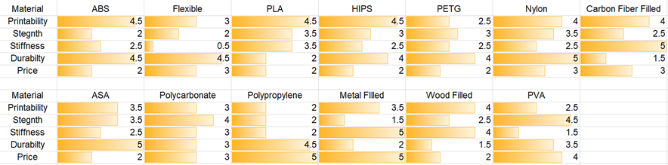

Table 4‑13: Summary of 3D filaments

## Controller Considerations

Several microcontroller units (MCU) were considered during the selection phase of product development. Each vendor’s model of a MCU is developed with a wide possibility of applications in mind. Factors like power consumption, clock speed, and memory size all vary among different MCUs. All the major components of Slate will directly interact with the MCU, so it is vital that this component is investigated thoroughly.

The initial selection for consideration was generated based upon the functional needs of Slate. The MCU will be required to process user inputs from the touch screen device and analog input keys. It will also be required to provide the communication link between Slate and the device being utilized. The MCU will also process what outputs are displayed on Slate’s screen and store any of the user’s configuration options.

We investigated three MCU options: Espressif ESP32, Atmel ATmega32U4 and Nordic nRF52840. Stock photographs of several MCU options are shown in Figure x-x on the next page. We will now provide the key findings of our investigations into these three options.

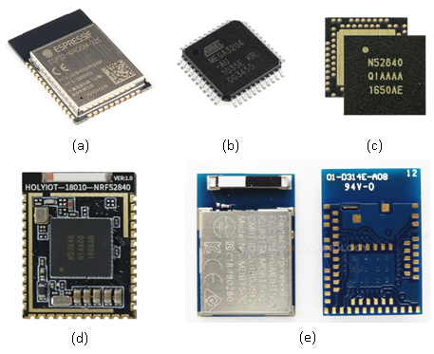

Figure 4‑14: Stock images of MCU options

### Espressif ESP32 Series

According to the manufacturer, the ESP32 Series, shown in Figure 4-14(a), provides an entire system on the chip and is primarily designed for mobile, wearable electronics and Internet-of-Things (IoT) applications. It is meant to be a complete integration solution that occupies minimal printed circuit board (PCB) area. The system includes Wi-Fi (2.4 GHz band), Bluetooth, one or two high performance 32-bit CPU cores, an ultra-low power co-processor and multiple peripherals.

Some of the key features provided by the ESP32 series’ Bluetooth are: 1) BT v4.2 BR/EDR and BLE specification compliance, 2) Class-1, class-2 and class-3 transmitter without external power amplifier, and 3) UART HCI up to 4 Mbps.

The applicable specifications of the MCU and some of the advanced features of the system are: single/dual core 32-bit LX6 microprocessor(s), 448 KB ROM, 520 KB SRAM, 34 x programmable GPIOs, 10 x touch sensors, ULP co-processor, and additional peripheral components.

The modules we would consider are manufactured directly from Espressif, or an additional company called WeMos.

### Atmel ATmega32U4

The Atmel ATmega32U4, shown in Figure 4-14(b), is an extremely popular choice among keyboard-related hardware projects due to its compact size, power efficiency, and affordability. The ATmega32U4 features an 8/16Mhz 8-bit AVR RISC-based processor, onboard full-speed USB module, 16/32KB of Self-Programmable Flash, 1.25/2.5KB SRAM, and 512B/1KB EEPROM. It does not include onboard Bluetooth or 2.4Ghz Wi-Fi capability.

Since the ATmega32U4 has minimal passive component requirements to operate, it is generally only offered as the chip itself, or designed-into a development board. Since we are required to utilize our own circuit design, the ATmega32U4 would require us to add these passive components since we cannot use a development board in our final design. The ATmega32U4 is readily available in the US.

### Nordic Semiconductor nRF52840

The Nordic Semiconductor nRF52840 is a relatively new microcontroller, appearing on the market in early 2018. Many of the newest/ongoing keyboard-related hardware projects are using this chip due to its onboard wireless capability, powerful processor, and sizeable memory space. The nRF52840 features a 64Mhz 32-bit ARM Cortex M4F processor, 1MB of flash memory, 256KB RAM, built-in Bluetooth 5 and 2.4Ghz Wi-Fi, native full-speed (12Mbps) USB support, NFC Tag-A capability, and on-chip DC-DC buck converter. Due to its ample 1MB of flash storage, this microcontroller is compatible with higher-level programming languages like CircuitPython.

#### Standalone Package

Using the nRF52840 as a standalone chip, displayed in Figure 4-14(c), would require the additional design of coupling capacitors, timing crystal, and antenna design. This option is suitable for very compact boards that need custom routing to fit all required components.

#### Modularized Package – HolyIoT 18010

This module from HolyIoT, shown in Figure 4-14(d), provides the necessary passive components to interface the nRF52840 with other peripherals. Unique to this design is the inclusion of castellated solder holes, which allow for easier soldering to custom PCB – it can be done by hand or in a reflow oven.

#### Modularized Package – Raytac MDBT50Q

This module from Raytac, shown in Figure 4-14(e), is similar in function to the HolyIoT, although it appears there is more documentation available, it is more readily available in the US, and is slightly more expensive per-unit. It uses standard surface-mount solder pads on the bottom of the unit, so would require reflow oven to attach to custom PCB.

## Screen Considerations

Five touchscreen displays were considered throughout the selection phase. The important factors that were of concern for the Slate project were power consumption, internal memory, brightness level, serial communication type, and touchscreen type were the major components when selecting display candidates for Slate.

The five touchscreens considered were the Adafruit TFT Featherwing, EastRising TFT LCD touchscreen, Focus LCD’s TFT E35RG73248LW6M250-C, and the Focus LCD’s TFT E35RG13248LW2M450-CA. Stock photographs for each of the five touchscreens investigated are shown in Figure 4-15 below. Each of the screens considered will be expounded upon in the subsequent sections.

It should be noted that the touchscreens using capacitive technology will only be considered if it is decided to make the Slate’s user interface more complex by adding multi-touch hand gestures support, which is only possible with capacitive touchscreens.

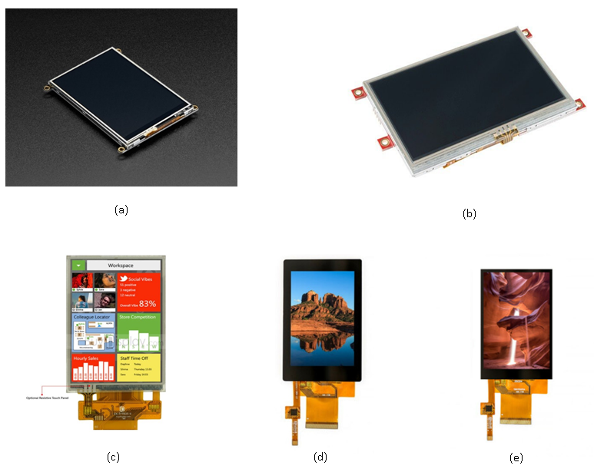

Figure 4‑15: Stock photos of screens considered

### Adafruit TFT FeatherWing

The Adafruit TFT FeatherWing, shown in Figure 4-15(a), is a 3.5" LCD resistive touchscreen with individual 16-bit color pixel depth control. It’s a combination of a 3.5” TFT breakout and a STMPE610 resistive touchscreen controller. The display comes with a *resistive* touchscreen attached to it and an optional SD card socket which can be used to store images.

Given by its large 480x320 display, it works well with faster boards that have at least 48MHz. This display uses dual SPI or UART interfaces as its serial-communication protocol which means both the nRF52840 and the ESP32 series microcontrollers that we are considering for the Slate can be used given they are quite fast MCUs that support a 32MHz QSPI interface.

### 4D System uLCD-43PT

The Resistive Touch version of the 4D System uLCD-43 display is shown in Figure 4-15(b). The uLCD-43PT is a TFT intelligent Display Module that is powered by a PICASO graphics processor optimized with a virtual core engine called an EVE. This display is a combination of a 4.3” 480x272 pixel 65k True color LCD screen, audio amplifier and speaker and a micro-SD card socket.

Unlike the previous display mentioned this display utilizes $I^{2}C$ and UART as its serial communication protocol. This screen features 14KB of flash memory for user code storage and 14KB of SRAM for user variables. It also has 13x General Purpose I/O pins, which supports fast 8-bit parallel data transfer. The display’s brightness is up to 400 NITS on the TN version and 510 NITS (128 DPI/PPI) on the newer IPS version, so it is the brightest of the three options but also the most expensive.

### EastRising TFT LCD touchscreen

This EastRising TFT LCD touchscreen display is shown in Figure 4-15(c). This display is a 3.5” Resistive touchscreen with a ILI9488 controller. It supports 8-bit, 9-bit, 16-bit, parallel, 3-wire, and 4-wire serial SPI interface. Like the last two displays mentioned the display format is 320x480 but the brightness level is only up to 280 NITS making it the dimmest screen of the three.

The reason we considered using this touchscreen is because it is the most cost-effective display that meets our specifications. If we decide that we do not need a brighter display that has internal RAM, we will consider choosing this display.

### Focus LCD’s TFT E35RG73248LW6M250-C

The capacitive touchscreen shown in Figure 4-15(d) is the older 3.5-inch TFT LCD display with a ILI9488 LCD controller and a FT6236 IC controller attach to it. It has an enhanced MCU in the CTP controller which also includes 32KB internal flash memory and 4KB SRAM data memory. Like the previous displays considered this display packs a 320x480 LCD screen with up to 250 NITS and 345KB of GRAM. It operates at 3.3V and supports 3/SPI/4SPI+16bit/18bit RGB interfaces. While this is a lower end capacitive touchscreen and is not the brightest of the displays, it is the most cost-effective capacitive touchscreen out of the ones currently available.

### Focus LCD’s TFT E35RG13248LW2M450-CA

This capacitive touchscreen shown in the figure below is the new version of the E35RG touchscreen from Focus. Like its predecessor it has a 320x480 display but has a wider viewing area. It also uses the ILI9488 LCD controller but differs in the CTP controller it is using, which is the FT6336G. The display now has up to 450 NITS which is almost twice as bright as the last version. It operates at 3.3V and supports 3/SPI/4SPI+16bit/18bit RGB interfaces. The main differences come from the FT6336G which comes with an upgraded 48KB of flash memory and 5KB of SRAM.

## Battery Management IC Considerations

The following section identifies several potential integrated circuits that are utilized for dynamic power management. Many of the requirement categories were considered during this search to include sustainability and performance. As other key components for Slate were not decided upon yet, several assumptions were made regarding the voltage requirements for these key components while considering several different battery management ICs.

Four battery management ICs were investigated prior to selection. The four battery management ICs considered were Texas Instruments BQ24179, Maxim Integrated MAX77757, Linear Technology LTC4085 and Microchip MCP73831/2. These four ICs were initially identified by using electronic component provider’s search utilities while specifying some broad requirements power requirements that were assumed to match engineering requirements for Slate. The results of this investigation are expounded upon in the following sections.

The power flowchart shown in Figure 4-19 on the next page, is a more specific version of Slate’s initial battery management flowchart from Section 2.6.2. It visualizes the key assumptions that were made prior to the battery management IC consideration process and subsequent component selection.

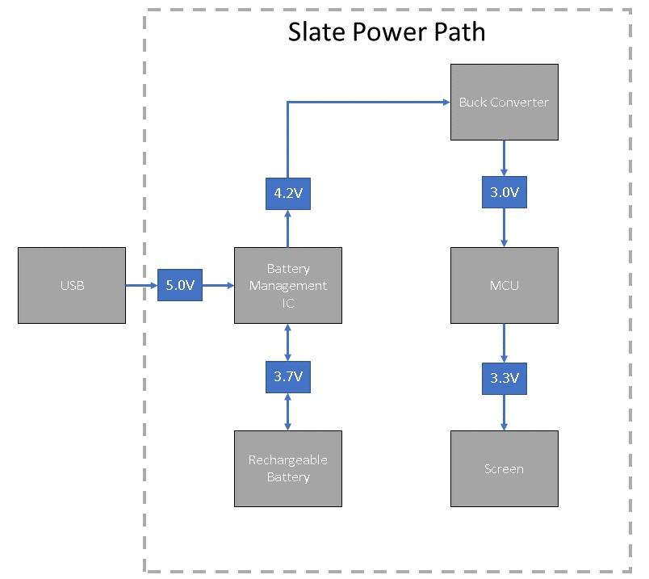

Figure 4‑16: Power path flowchart used for power management IC considerations.

### Texas Instruments BQ24179

The BQ24179 from Texas Instruments is an I2C controlled battery charger that will allow a system to continue operation even when the battery is completely discharged or removed. The typical applications for this IC are smartphones, tablets, drones, digital cameras, mobile printers, etc. It supports 1- to 4-cell batteries with a fully integrated switch-mode buck-boost charger and any Universal Serial Bus Power Delivery 3.0 profile. The IC supports Li-ion and Li-polymer batteries with charging current sensing circuits. A simplified example schematic is shown in Figure 4-20 on the next page.

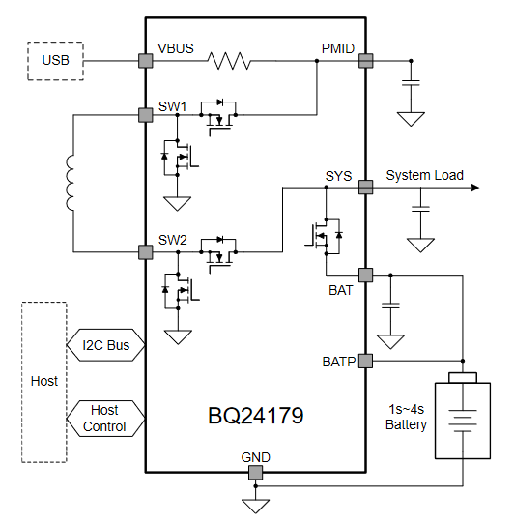

Figure 4‑17: Texas Instruments BQ24179 example schematic

Some of the key characteristics from the datasheet for the BQ24179 are summarized in the table below and will be used to make design decisions.

|  |  |
| --- | --- |
| Characteristic | Value |
| Price (Single IC) | $6.36 |
| Body Size (nominal) | 2.90 mm x 3.30 mm |
| Input Adapter | USB 3.0 |
| Input Source Range | 3.6-V to 24-V |
| System Output Range | 2.5-V to 19.4-V |
| Battery | 1s to 4s Li-Ion |

### Maxim Integrated MAX77757

The MAX77757 from Maxim Integrated is a standalone 3.15A charger with integrated USB Type-C® CC detection. The typical applications for this IC are listed as portable medical devices, wireless headphones, mobile routers, etc. It supports single-cell or parallel cell Li-ion, Li-poly or LiFePO4 batteries. A simplified example block diagram is shown in the following figure.

The MAX77757 is significantly cheaper than TI’s BQ24179 and also provides USB Type-C connectivity. Based on the example block diagrams provided by the manufacturers, more components may be required to fully utilize the MAX77757.

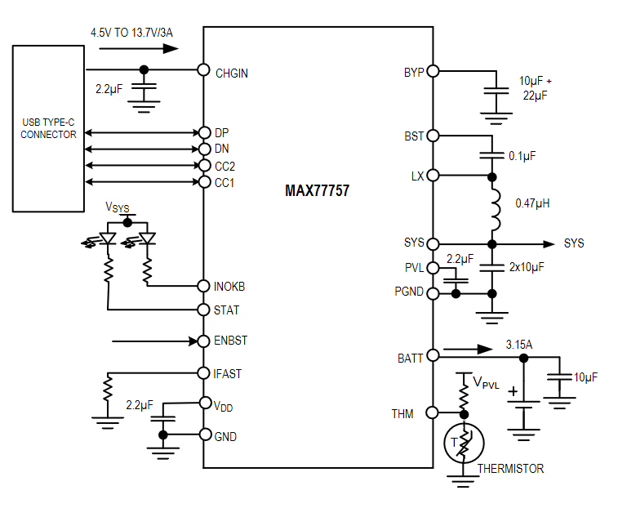

Figure 4‑18: Maxim Integrated MAX77757 block diagram

Some of the key characteristics from the datasheet for the MAX77757 are summarized in Table 4-15 below. These key characteristics aided in some of the design decisions related to the realization of Slate.

|  |  |
| --- | --- |
| **Characteristic** | **Value** |
| Price (Single IC) | $2.86 |
| Body Size (nominal) | 3.0 mm x 3.0 mm |
| Input Adapter | USB Type-C Connector |
| Input Source Range | 4.5-V to 13.7-V |
| System Output Range | 3.6-V, 4.1-V to 4.5-V |
| Battery | 1s or parallel 1s Li-Ion |

Table 4‑14: MAX77757 key characteristics

### Linear Technology LTC4085

The LTC4085 from Linear Technology is USB power manager and Li-Ion battery charger that. The typical applications for this IC are portable battery-powered applications like Cameras and MP3 Players. It supports 1-cell batteries for which the current is programmable between 100-mA to 500-mA.

This IC automatically controls battery charge current, so the sum of the load current and charge current does not go above the programmed input current limit. An example of a typical application is shown in Figure 4-19 below.

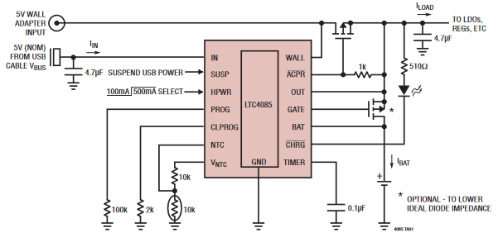

Figure 4‑19: LTC4085 typical application

Some of the key characteristics from the datasheet for the LTC4085 are summarized in Table 4-16 below.

|  |  |
| --- | --- |
| Characteristic | Value |
| Price (Single IC) | $4.41 |
| Body Size (nominal) | 4.0 mm x 3.0 mm |
| Input Adapter | USB or 5-V Wall Adapter |
| Input Source Range | 4.35-V to 5.5-V |
| System Output Range | 5-V |
| Battery | 1s Li-Ion |

Table 4‑15: LTC4085 key characteristics

### Microchip MCP73831/2

The MCP73831/2 from Microchip is an advanced linear charge management controller that is meant for use in space limited applications due to its small physical size. It supports both Li-Ion and Li-Poly battery charging with four voltage regulation options and a programmable charge current between 15-500 mA. A typical application is shown Figure 4-20 below.

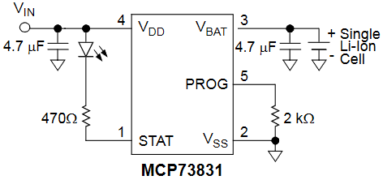

Figure 4‑20: MCP73831 typical application

Some of the key characteristics from the datasheet for the MCP73831/2 are summarized in Table 4-17 below.

|  |  |
| --- | --- |
| Characteristic | Value |
| Price (Single IC) | $0.66 |
| Body Size (nominal) | 2.0 mm x 3.0 mm |
| Input Adapter | USB or 5-V Wall Adapter |
| Input Source Range | 3.75-V to 6-V |
| System Output Range | 4.20-V, 4.35-V, 4.40-V, 4.50-V |
| Battery | 1s Li-Ion |

Table 4‑16: MCP7381 key characteristics

## Software Considerations

In addition to hardware considerations, the availability and support of various open-source software is just as important to consider. While some software is created for wide compatibility, others have a short list of microcontrollers they are compatible with. Below lists our considerations for open-source software that would be applicable to our project.

### QMK

QMK is an open-source keyboard firmware for Atmel AVR and Arm USB families of microprocessors. The code for QMK is hosted on Github and maintained by its founder Jack Humbert along with contributions from the community. Of the software considered, it is the longest-running and most popular keyboard firmware.

There is a large amount of documentation and tools for its usage. It is primarily focused on projects that are intended to be used as standard wired keyboards. While it supports macros and rotary encoders, it does not support screens or touchscreens, and has limited Bluetooth support (only AVR chips, and BT 2.1).

### ZMK

ZMK Firmware is an open-source keyboard firmware built on the Zephyr Project RTOS. ZMK’s stated goal is “to provide a modern, wireless, and powerful firmware free of licensing issues.” The code for ZMK is hosted on GitHub and maintained by various contributors.

When compared to QMK, ZMK generally provides the same features and more, including much better support for Bluetooth, support for more Arm-based controllers, and battery reporting. It does not support AVR/8-bit chips, however. It doesn’t have as extensive documentation and tools as QMK but has active development on GitHub.

### CircuitPython

CircuitPython is an open-source derivative of MicroPython which is a software implementation of a programming language which resembles Python 3, designed and optimized to run on a microcontroller. It is one of the popular solutions for programming microcontrollers and small handheld devices and is designed to simplify experimenting on low-cost microcontrollers.

The code for CircuitPython is hosted on GitHub and is maintained by many contributors including Adafruit which is the main development sponsor. Adafruit makes it easy for beginners to use CircuitPython by providing good documentation and libraries on their website for each compatible device. The reason we are considering CircuitPython is because it allows programmers to drag-and-drop code onto the device instead of flashing, which means development is a lot easier for us. It also has libraries for Bluetooth keyboard functionality, macros and for utilizing touchscreens.

### KMK

KMK is an open-source firmware that uses CircuitPython as its base, with libraries written specifically for keyboard functionality using CircuitPython. KMK includes functions written to make CircuitPython easier to program in a keyboard project, however it is limited by its currently implemented features. KMK is hosted on GitHub and maintained by members of its community including Adafruit employees, however KMK is not an official Adafruit project.

## Battery Considerations

Several types of batteries were considered for use with Slate. These include 18650 Lithium-ion, Lithium-Polymer and the common “AA”. As reference, examples of these are respectively shown in Figure 4-21(a), Figure 4-21(b) and Figure 4-21(c) below.

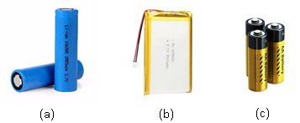

Figure 4‑21: Types of batteries considered for Slate

### 18650 Lithium-ion Cell Battery

The 18650 Li-ion Battery is a popular choice for rechargeable, battery-operated hardware designs. The cells are robust and are capable of a large amount of current output. Their standardized size means they hold a predictable amount of energy and greater battery life can be obtained by putting multiple in parallel. Their nominal voltage per cell is 3.7V. The diameter of 18650 cells may be too large for this project, as our rather compact and slim design would require extra space to be allocated to fit one or two of these cells.

### Lithium-Polymer (Li-Po) Battery with JST-connector

Lithium-Polymer batteries are not as robust as Lithium-ion and are more prone to environmental factors if not adequately protected. The benefit however is that Li-Po batteries can be designed into a thin, sheet-like design while maintaining decent capacity and power-output. They are just as easy to find as 18650 batteries, but slightly more expensive. Most come with a compact JST connector, which allows for easy plugging and unplugging to the main board and would also be more compatible with development boards we are considering for our prototype. The nominal voltage for a single Li-Po is 3.7V.

### “AA” Alkaline Non-Rechargeable Battery

If we decide to not include a rechargeable battery as a feature, we could resort to the ubiquitous “AA” battery instead. These are widely known and available, relatively compact, and would likely require no more than 4 AA batteries total.

While this may reduce complexity in the hardware design, we may avoid this option if possible since a target user for this device would likely have ample ability to charge the device since it would often be used where USB connection (and subsequently charging) is likely to be available. The nominal voltage for a single AA battery is 1.5V.

## Rotary Encoder Considerations

A rotary encoder is an analog knob that continuously turns in either direction. Typically, its functionality in a computer setting is for actions that involve zooming, scrubbing, volume control, or other motions that benefit from fine-tuned rotational input. Depending on cost, size, and complexity of integration, Slate will include - at most - two rotary encoders that can be programmed to the user’s requirements. The rotary encoders considered for use with Slate are visualized in Figure-22 below and will be expounded upon in subsequent sections.

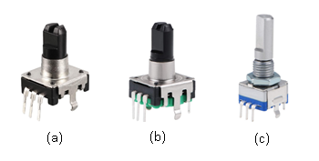

Figure 4‑22: Rotary encoders considered for use with Slate

### Small Rotary Encoder – 12.5mm Shaft Height, 6mm Shaft Diameter

This rotary encoder, shown as reference in Figure 4-22(a), has a small footprint and short shaft height that is useful in designs where a small encoder knob is desired. It has 24 pulses/positions, three working pins, two mounting pins, uses a D-type shaft, and is rated at 5V. It can also be pushed down as a button for extra functionality. Total dimensions are 14.5mm x 12.7mm x 21mm.

### Medium Rotary Encoder – 14.3mm Shaft Height, 6mm Shaft Diameter

Same in functionality as the Small Rotary Encoder, but with an extra 1.8mm of height to the shaft and slight footprint size increase. Total dimensions are 15mm x 13mm x 24mm.

### Large Rotary Encoder – 20mm Shaft Height, 6mm Shaft Diameter

This rotary encoder uses a metal shaft instead of plastic as seen in the small and medium models. It has 20 pulses/positions, five working pins, two mounting pins, uses a D-type shaft, and is rated at 5V. It can also be pushed down as a button for extra functionality. Total dimensions are 15mm x 12.5mm x 30mm.

## Joystick Considerations

A joystick is an analog component that allows the user to input movement in an X-Y plane. In a computer setting, joysticks are often used for directional input, an alternative for mouse movement, replicating arrow keys, and other fine-tuned directional control. Typically, only gamepads include two joysticks, in any other scenario – one joystick is present otherwise it would be too cumbersome to control. For this reason, Slate will include one joystick.

The types of joysticks being considered for Slate are shown in Figure 4-23 below. Relevant information about these options for the joystick will be discussed in the subsequent sections.

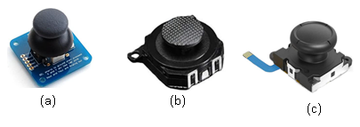

Figure 4‑23: Types of joysticks being considered for use with Slate

### “PS2”-Style Joystick

This style of joystick, shown in Figure 4-23(a), operates on orbital movement and has an ample-sized knob for operation. It uses five pins: VCC, XOUT, YOUT, SEL, and GND. XOUT and YOUT are the pins used to determine X-Y positioning using potentiometers. SEL is for when the joystick is pressed, down which acts as a button for additional functionality. The resolution of the X-Y axis must be considered and tested if chosen, since it can vary from unit-to-unit. The model shown below is in breakout form, but easily be de-soldered and mounted to our own PCB.

### “PSP”-Style Joystick

This model of joystick, shown in Figure 4-23(b), is much slimmer than the “PS2”-style model. It is surface mounted with pads on the underside of the component. Instead of fully orbital movement, the “PSP”-style joystick moves on a shallower orbit due to its shorter stem and wide knob area. It uses 4 pins: X, GND, Y, and VCC. Functionality is the same as the “PS2”-style joystick except this one does not include button functionality – it cannot be pressed.

### “Switch”-Style Joystick

This model of joystick, shown in Figure 4-23(c), is actually a replacement joystick for a “Joy-Con” controller manufactured by Nintendo. Since this joystick uses a ribbon cable, a specific connector would need to also be considered and designed into our PCB in order for it to function. This joystick is similar in size and functionality to the “PSP”-style joystick but includes button functionality when pressed down. It uses five pins.

## Strategic Components and Part Selections

In the previous selections, we thoroughly investigated several options for the key components and design aspects of Slate. The key components and aspects of our design included the PCB (design software and material), keyboard switches, 3D printed material filament types, logic controllers, touchscreens, battery management ICs, software libraries, batteries, rotary encoders, and joysticks. The subsequent sections provide a summarized comparison between the parts investigated along with the selected one.

### PCB Design Software Selection

For our PCB Design software, we will be using the free version of Eagle. This gives us the most flexibility in terms of max layers and size out of all the free options, and Eagle is by-far the most commonly used design software among the resources we’ve encountered while researching for this project. All members of the team are at least somewhat familiar with Eagle since it is the same software used in Junior Design.

### Battery Management IC Comparison and Selection

After careful consideration of several different battery management ICs, the selected IC was the *Microchip MCP73831/2*. The primary considerations that led to this design decision were the price, footprint, and package. We found the greatest weakness of our selection to be the small charge current which will lead to longer battery charge time but found this tradeoff acceptable. Table 4-17 on the next page summarizes key aspects for each battery management IC that went into our design decision for this part.

|  |  |  |  |  |
| --- | --- | --- | --- | --- |
| Consideration | MCP73831/2 | BQ24179 | MAX77757 | LTC4085 |
| Manufacturer | Microchip | Texas Instruments | Maxim Integrated | Linear Technologies |
| Availability | Available | Available | Available | Available |
| Price (1 unit) | $0.66 | $6.36 | $2.86 | $4.41 |
| Footprint | 2.0 x 3.0 mm | 2.90 x 3.30 mm | 3.0 x 3.0 mm | 4.0 x 3.0 mm |
| Package | DFN or SOT-34 | WCSP | FC2QFN | DFN |
| Charge Current | 15-500 mA | Up to 3.3 A | Up to 3.15 A | Up to 1.5 A |
| Thermal Feedback | Available | Available | Available | Available |

Table 4‑17: Key considerations for battery management IC selection

### Battery Selection

The selection for battery came down to several key aspects of the battery types. These aspects were the nominal voltage per cell, shape, and the capacity range per cell. The results of this comparison are shown in Table 4-18 below.

|  |  |  |  |
| --- | --- | --- | --- |
| Battery | Nominal Voltage per cell | Shape | Capacity Range per cell |
| Lithium-Ion | 3.7 V | Cylindrical | 1800mAh – 3500mAh |
| Lithium-Polymer | 3.7 V | Flat Rectangular | Depends on shape, 200mAh – 5000mAh |
| AA | 1.5 V | Cylindrical | 2500mAh |

Table 4‑18: Key considerations for battery selection

After reviewing the battery options for consideration, the choice for Slate will be to use a Lithium-Polymer (Li-Po) battery. Li-Po batteries have a much greater range of sizes and capacities which give us more options for the battery life of our project. Its flat, rectangular construction also bodes well to our design, as it can easily fit in the slim area below the PCB within the enclosure. A Li-Po battery will be sufficient to meet power requirements and comes preconfigured with a JST-PH connector which is easy to implement into our board design and is used by many development boards as well.

Beyond battery type, we also must determine a capacity and size that works well for our device. We can do math considering the maximum power draw we’d expect to see with our design to determine a target capacity that meets or exceeds our battery life requirements. There is not much documentation on the max power consumption of the screen module, however the third-party consensus is about 90mA at 5V = 0.45W. For the nRF52840, looking at the datasheet from Nordic Semiconductor, they give typical current values for different scenarios. If we combine the typical current at highest CPU mode and typical current at max Bluetooth radio output, it's about 16.4mA + 6.3mA = 22.7mA at 3.3V ≈ 0.075W. If we add both these power figures and round up to the nearest hundredth of a watt to cover all other low power component draw, we get 0.45 + 0.075 = 0.525, round up to 0.53W max power draw. We then take the Wh figure for each battery size we are considering and divide by max power draw to get number of power-on hours.

2500mAh, dimensions 80 x 52 x 4mm: 12.5Wh / 0.53W = 23.58 hours

3000mAh, dimensions 79 x 59 x 4.7mm: 15Wh / 0.53W = 28.30 hours

3200mAh, dimensions 81 x 63 x 4.6mm: 16Wh / 0.53W = 30.19 hours

Clearly all three of these options meet our battery life requirements, and we’ve determined that all three sizes could easily be fit into our enclosure. So, any choice works for our project, and since all three only differ by a range of approximately $5.00, we’ll go with the highest capacity option of 3200mAh.

### Microcontroller Selection

The selection the controller unit came down to several key aspects of the controller types. These aspects were the processor type, the processor speed, flash memory available, RAM size and the number of GPIO pins. Table 4-20 shown below summarizes these considerations.

|  |  |  |  |  |  |
| --- | --- | --- | --- | --- | --- |
| Controller | Processor | Speed | Flash | RAM | GPIO |
| ATMega32U4 | AVR 8-bit | 16Mhz | 32 KB | 2.5 KB | 25 |
| ESP32 | Xtensa LX6 | Up to 240Mhz | 4MB | 320 KB | 34 |
| nRF52840 | Arm M4F | 64Mhz | 1 MB | 256 KB | 48 |

Table 4‑19: Key considerations for microcontroller selection

Other aspects of the microcontroller selection could not necessarily be accomplished with quantitative values like those in Table 4-19. These other aspects that were considered were features provided by each of the board and are summarized in Table 4-20 below.

|  |  |  |  |  |  |  |
| --- | --- | --- | --- | --- | --- | --- |
| Controller | Native USB | Native Wireless | Fast Processor ( $≥$ 32 MHz) | Large Flash Memory ( $≥$ 1 MB) | $≥$ 25 GPIO pins | CircuitPython Support |
| ATMega32U4 | ✓ |  |  |  | ✓ |  |
| ESP32 |  | ✓ | ✓ | ✓ | ✓ | Only ESP32-S2 |
| nRF52840 | ✓ | ✓ | ✓ | ✓ | ✓ | ✓ |

Table 4‑20: Qualitative considerations for microcontroller selection

After reviewing the microcontrollers for consideration, our choice will be the Nordic Semiconductor nRF52840. It’s support for both native USB and Bluetooth will cut down on development time and complexity, plus it has all the speed needed to run this project and ample GPIO pins for our inputs.

As for which module of nRF52840 we intend to use, we find it easiest to select the same module used by the development board we chose. Our choice of development board is the Adafruit Feather nRF52840 Express. It uses the MDBT50Q-1MV2 module from Raytac, the details of which are listed in section 4.5.3.3.

### Software Selection

After reviewing the software considerations, our choice will be to use CircuitPython and the libraries provided by Adafruit for USB and Bluetooth HID emulation. The use of CircuitPython over C/C++-based software stacks will reduce complexity, development time and allows for better readability.

CircuitPython is also being maintained and advanced by a much larger group of developers than the other options and would allow us to have as much flexibility as possible without limiting ourselves to the small libraries and functionalities of the smaller software stacks. There is a chance some of the code and functionality of KMK can be ported into our project, but the feasibility of doing so is still being researched.

### Touchscreen Selection

After listing six different possible displays we decided to narrow our results to just the resistive touchscreen types because while capacitive touchscreens are easier to use and support more complicated features, the Slate would not take advantage of these features and the price was well above our budget.

Out of the remaining displays we saw advantages to using the Adafruit TFT displays because Adafruit provides well documented data sheets with adequate testing boards for development purposes. From there, we saw two possible LCD TFT displays from Adafruit that could be consider for the Slate, the 3.5” TFT FeatherWing and the 3.5” TFT Breakout.

Table 4-21 on the next page compares specifications and features for both displays. The important of these being brightness level, serial communication type, resolution, operating power, and type of touchscreen controller included.

|  |  |  |  |  |  |
| --- | --- | --- | --- | --- | --- |
| Display Module | Brightness level | Serial Comm. Type | Resolution | Operating Power | Dedicated Touchscreen Controller |
| FeatherWing | * 400 NITS | * SPI | * 480x320 | * 3.3 V logic / 5 V backlight | * STMPE811 |
| Breakout | * 400 NITS | * SPI * Fast 8-bit parallel | * 480x320 | * 3.3V /5.0V | * N/A |

Table 4‑21: Specifications and features comparison for displays

Both LCD modules from Adafruit use the same driver chip (HX8357) but the FeatherWing LCD has a dedicated touchscreen controller (STMPE811) that piggybacks on the SPI interface to reduce pins needed for the touch panel to just one. On the Breakout LCD module, four analog pins are needed for the touchscreen and must be accounted for in code. So, while configuring the breakout LCD module might be more complex to set up, it does support a faster 8-bit parallel data transfer interface which the FeatherWing does not. They also both have an internal GRAM buffer that can be written on to offload display draw to the display IC.

#### Touchscreen – Final Selection

After reviewing the touchscreen options for consideration, we’ve decided on the Adafruit 3.5” TFT FeatherWing screen module. The FeatherWing includes circuitry and components that assist in its operation and reduce number of pins required by the controller. The FeatherWing is also a good choice for development, which means we won’t have to change screen models from prototype to final design.

Any of the Adafruit Feather development boards can slot easily into the headers of the FeatherWing, which means no soldering to start developing the touchscreen software. Once we transition to final design, we can design male headers into our board that will allow the FeatherWing to slot in without soldering while still being plenty secure.

### Switch Selection

The selection for switch after comparing specifications and features was finalized after investigation into the possible selections. The selection came down to several key aspects of their features which were discussed in the technology investigation section. The aspects considered for direct comparison amongst the key switch options were color, profile, action type, action force, action point, travel distance and lifespan. The comparison is summarized in Table 4-22 on the next page.

|  |  |  |  |  |  |  |  |
| --- | --- | --- | --- | --- | --- | --- | --- |
| Brand | Color | Profile | Act. Type | Act. Force | Act. Point | Travel Distance | Lifespan |
| Cherry | Speed Silver | Standard | Linear | 45cN | 1.1mm | 3.5mm | 50M |
| Kailh | Burgundy | Standard | Linear | 50cN | 1.7mm | 3.5mm | 70M |
| Kailh | Speed Bronze | Standard | Clicky | 50cN | 1.1mm | 3.5mm | 70M |
| Kailh | Speed Gold | Standard | Clicky | 40cN | 1.4mm | 3.5mm | 70M |
| Kailh | Box Jade | Standard Box | Clicky | 50cN | 1.7mm | 3.5mm | 70M |
| Kailh | Speed Copper | Standard | Tactile | 40cN | 1.1mm | 3.5mm | 70M |
| Kailh | Plum | Standard | Tactile | 70cN | 1.7mm | 3.6mm | 70M |
| Kailh | Choc Red | Low-Profile | Linear | 50cN | 1.5mm | 3.0mm | 70M |
| Kailh | Choc White | Low-Profile | Clicky | 60cN | 1.5mm | 3.0mm | 70M |
| Kailh | Choc Brown | Low-Profile | Tactile | 60cN | 1.5mm | 3.0mm | 70M |

Table 4‑22: Key switch feature and trait comparison

After reviewing all the switch models for consideration, our choice of switch for the final design is the Kailh Box Jade switch. A clicky actuation type was desired to help assist the end-user in feedback for when the macro button is pressed, and the robust action of the Box Jade switch will help the keys from accidental nudges and provide a more confident key stroke for macro usage.

To keep development costs low, we ordered a breakout kit for switches that included tactile brown switches, so we will use those for the prototype. We’ve also decided to cut down the number of switches in the prototype from 10 to 8, this change may carry over to the final design as well.

### Rotary Encoder Selection

The selection for rotary encoder was decided upon after comparing the notable specifications and features that were targeted as having the most weight on meeting the engineering requirements for Slate. The aspects considered for selection were encoder size, shaft type, shaft length, shaft diameter, total dimensions and whether or not the encoder included a switch.

Those key features for the three encoder options are shown in Table 4-23 on the next page.

|  |  |  |  |  |  |
| --- | --- | --- | --- | --- | --- |
| Encoder | Shaft Type | Shaft Length | Shaft Diameter | Total Dimensions | Switch? |
| Small | D | 12.5mm | 6mm | 14.5x12.7x21mm | Yes |
| Medium | D | 14.3mm | 6mm | 15x13x24mm | Yes |
| Large | D | 20mm | 6mm | 15x12.5x30mm | Yes |

Table 4‑23: Key features of encoders used for final selection

Our first protype is currently using a large rotary encoder and we found that we need a rotary encoder that provides a slimmer profile (shorter shaft) but a wider knob. After some investigating, we found that when installing this wider knob on the large rotary encoder, it became way too high for our liking. So currently we are looking to use a medium size Encoder for the final prototype design.

After reviewing all the rotary encoder models for consideration, our choice for the final design will be the medium 20mm rotary encoder.

### Joystick Selection

The selection for joystick was made after comparing specifications and features of the options investigated. Those features that were identified as having the most impact on the final design of Slate so that the design could meet the engineering requirements were the number of pins, the profile, whether a connector was required or not, and whether the joystick could act as a switch. Those features are summarized in Table 4-24 below.

|  |  |  |  |  |
| --- | --- | --- | --- | --- |
| Joystick | Pins | Profile | Connector Required? | Switch? |
| PS2-Style | 5 | Full | No | Yes |
| PSP-Style | 4 | Slim | No | No |
| Switch-Style | 5 | Slim | Yes | Yes |

Table 4‑24: Key features of joysticks used for final selection

Our first protype used the PS2-Style Joystick because it was the cheapest and came with a development package, the team received after purchase from Adafruit. After testing three different units, we saw that the accuracy was lacking on this Joystick. We found that the slimmer PSP Joystick that we later purchased provided higher accuracy but with the tradeoff that it lacked the button functionality.

After reviewing the joystick models for consideration, our choice for the final design will be the PSP-Style Joystick because in our testing it had great accuracy, a slimmer profile and did not require a connector.

### 3D Printing Filament

The selection for 3D printing filament after comparing their natural properties.

#### 3D Printing Filament – Final Selection

The enclosure of Slate will be 3D printed using Creality Ender 3 Pro that will be provided by a Slate team member. Choosing the correct material defines the structural integrity, strength, durability, and stiffness of Slate. The goal of Slate is to make it as ergonomic and accessible as possible, which already eliminate a good portion of 3D filaments on the market. Table 4-25 below is a summary of all the final scores given to each filament.



Table 4‑25: Key 3D printer filament features used for final selection

After careful consideration, our choice for the final design will be PLA but could change to ABS later down depending on how the 1st iteration of Slate turns out. Another reason we are choosing these two are because this filament type is already owned by a team member and these rolls are accessible from the team members previous projects. The filament is already procured and at no added cost to the development budget, so it is the clear choice at this phase of the project.

## Possible Designs and Related Diagrams

As all key components for the design of Slate have been selected, initial investigation into how the hardware will be designed is ready to begin. To begin, more thorough studying of all manufacture provided datasheets and diagrams were completed by Slate team members. The most notable of these components being the microcontroller unit, the screen, and the three different types of physical inputs.

After the thorough studying of these component’s datasheets, and other related designs that utilized these components, a diagram was developed to aid in the net connections that would be used in Eagle. In Figure 4-24 on the next page, we can see this diagram with color coded lines showing the now known connections between all these key components. The diagram in the figure was mainly based on the prototype parts that were being tested by the Slate team prior to the initial schematic design.

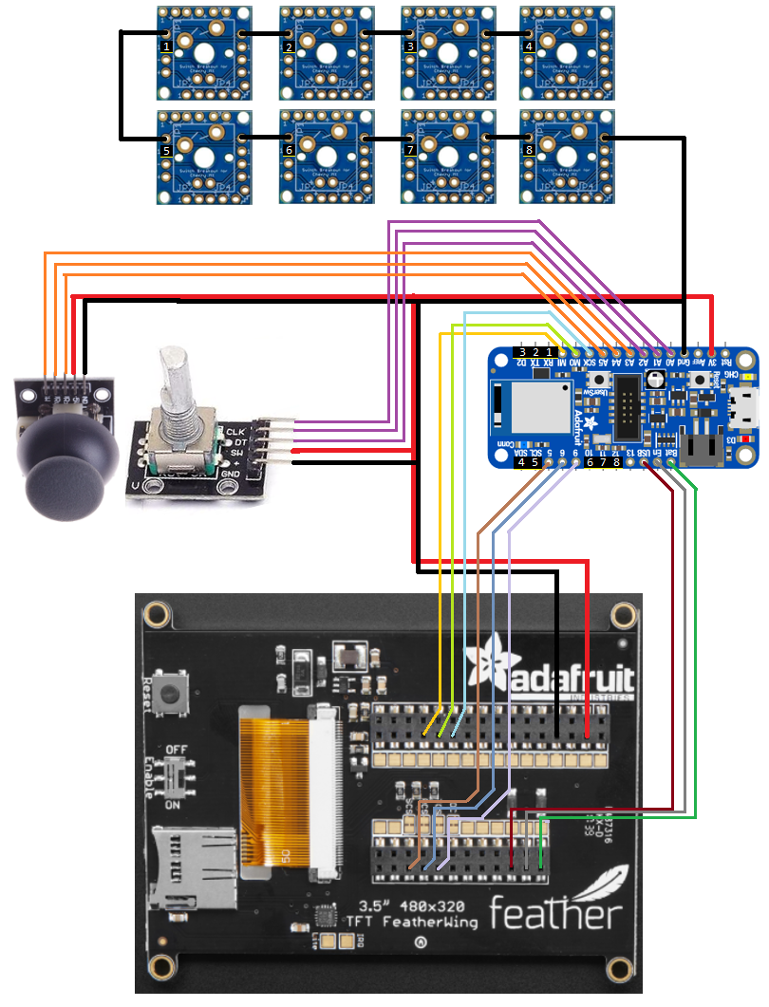

Figure 4‑24:Pinout for Slate prototype

## Parts Selection Overview

After our main component selections were accomplished, the team began procuring and constructing what would be necessary to aid in designing the final PCB, software development and testing. Table 4-26 below summarizes what prototype components were purchased after the parts selection process was compared.

These components would not only be referenced when designing Slate’s schematic, but also during these initial stages of Slate’s development. Having these parts on-hand helped answer important design questions as more decisions came to light as the project’s design began to form.

The table displaying the components used for prototyping after selection should not be thought of as a BOM. A BOM will be developed after the schematic for Slate is finalized. The items in the table were used from a prototyping standpoint alone and should be attributed to the development budget, not the budget for manufacturing of the final protype.

|  |  |  |  |
| --- | --- | --- | --- |
| Part Name | Manufacturer | Model | Price |
| MCU | Adafruit | Feather nRF52840 Express | $24.95 |
| JTAG/SWD Debugger | SEGGER | J-Link EDU Mini | $19.95 |
| Touchscreen | Adafruit | FeatherWing – 3.5” | $39.95 |
| PCB Ruler | Adafruit | V2 – 6” | $4.95 |
| Fine tip curved tweezers | - | ESD safe – 120mm | $3.95 |
| Perfboard Plates (10) | Bakelite | - | $4.95 |
| Breadboard PCB | Adafruit | Perma-Proto Half-sized | $4.50 |
| Rotary Encoder (5) | Cylewet | 15x16.5mm | $9.29 |
| Switch Breakout | Treedix | Black Switches with R2 Keycap (5 pins) | $11.99 |
| Wire Stripper/Cutter | IRWIN | 6-inch | $10.99 |
| Vertical Slide Switch (10) | Cylewet | 1P2T (3 pins) | $5.69 |
| Jumper Wire Kit | QSU | 140 Piece | $5.99 |
| Li-Po Battery | AKZYTUE | 3.7V 3200mAh with JST Connector | $14.09 |
| USB 2.0 A-Male to Micro B Cable | Amazon Basics | 3 feet | $5.26 |

Table 4‑26: Initial prototype part selection overview

# Hardware Design Details

During our design, we categorized sections of the schematic based on the primary functions. The designed schematics for these main functions will be reviewed in the subsequent sections. All schematics were created using EAGLE Version 9.6.2.

## Power and Filtering

Seen below, Figure 5-1 shows the design for the power and filtering circuit. The diode labeled ‘D1’ will allow for the circuit to choose whether to use USB (VBUS) or the battery (VBAT) as its voltage source. A pull-up resistor is used on the ENABLE pin of the IC to activate voltage regulation. The result of the circuit is a regulated 3.3V output that is used to provide voltage to the rest of the system.

This circuit’s main component is an IC utilized for low dropout and linear regulation. At the time of this design, the Slate team is still deciding on how Slate will be powered on/off. If the design leads us to a simple switch/button to power on/off the product, the enable pin on the low drop linear regulator will be utilized to accomplish this.

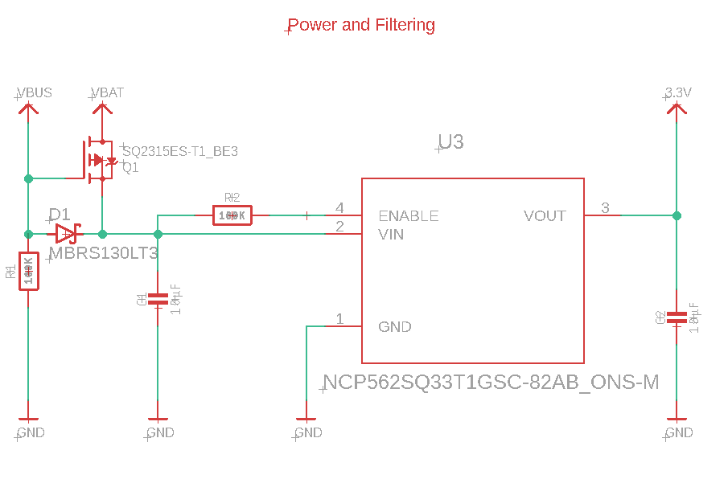

Figure 5‑1: Slate’s power and filtering circuit

The portion of the schematic shown in Figure 5-2 below includes the design for both the Micro USB and JST connector that interfaces with the battery. Included are test points coming directly off the D+ and D- pins of the USB connector to aid with troubleshooting. Slate will be utilizing a USB 2.0 Micro connector to provide data transfer and power when it is connected. When the battery is the only power source, the LIPO monitoring circuit in the next section will automatically switch from the 5.0V USB input from VBUS to the voltage provided by VBAT.

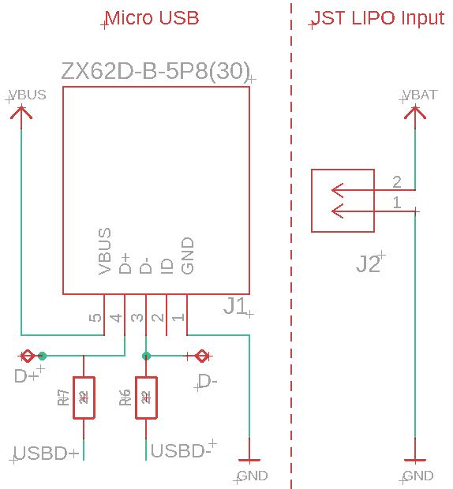

Figure 5‑2: USB and JST connector schematic design

## LIPO Charging and Monitoring

The circuits responsible for the LIPO battery charging and monitoring are shown in Figure 5-3 below. The STAT pin of the LIPO charger is left disconnected as there will be no LED indicator on the final PCB design of Slate.

The LIPO monitoring circuit’s voltage divider will be connected to a GPIO pin of the MCU to monitor the battery percentage. The possibility of displaying the current battery charge percentage on Slate’s user interface will be explored as software is further developed as the design of Slate continues.

From the datasheet of the MCP73831 LIPO charging IC, we know that VDD needs to be between 3.75V and 6.0V, which is satisfied by the provided voltage from USB (VBUS). The temperature range of the LIPO charging IC easily fall within the range of operating temperatures specified by the engineering requirements for Slate. Testing will be necessary to ensure the temperature within Slate’s enclosure falls within these temperatures even during times of heavy load.

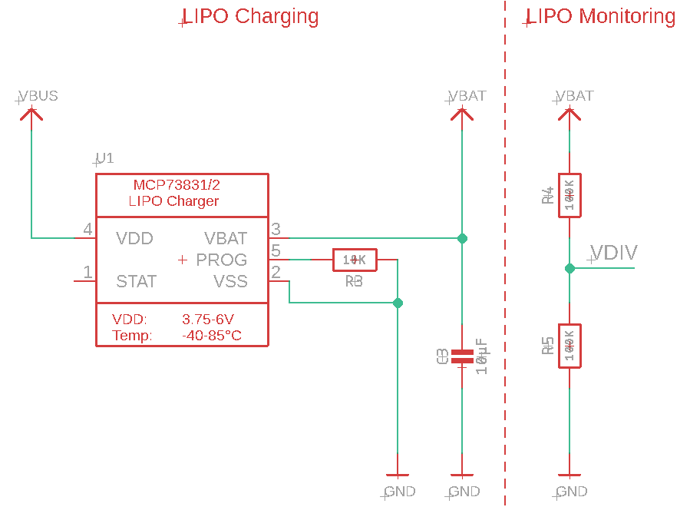

Figure 5‑3: LIPO charging and schematic design

## MCU/BT Module, Debugging, and Flash Memory

The design for the MCU/BT module is shown in Figure 5-4 below. Test points are included on the MCU to aid in tracking down any potential problems that may arise during initial design. The naming convention used for the nets that are connected to GPIO pins was discussed and agreed upon by members of the project team. The datasheet and similar designs that incorporate the MDBT50 from Raytac were referenced heavily to aid in the development of this portion of the schematic.

Some examples of the naming conventions used for the nets included in the overall schematic are *SW_ENC* and *SW_JOY*. These nets are associated with the switches for both the encoder circuit and the joystick circuit respectively. Similarly, the nets that begin with *QSPI* are those that need to be connected to the memory module that utilizes QSPI for serial communication.

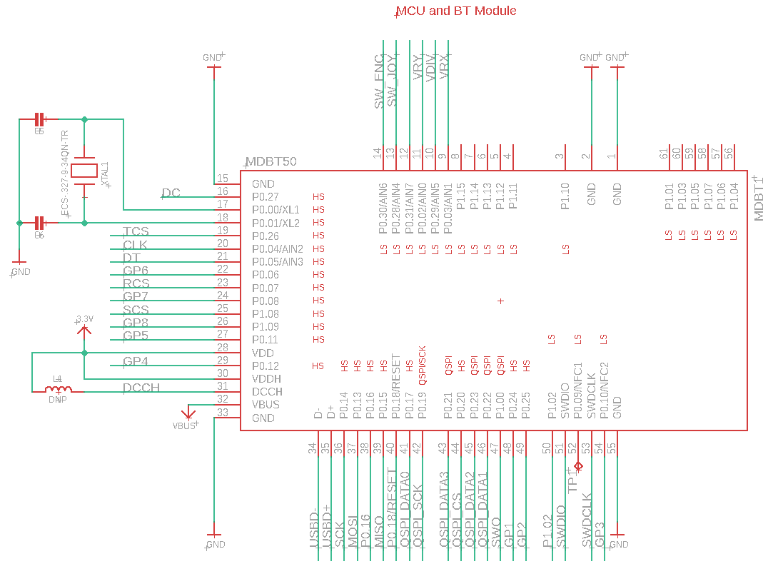

Figure 5‑4: MCU/BT module schematic design

The schematic design for the SWD debugging interface and the flash memory is shown in Figure 5-5 below. Test points are included on the debugging circuit, like those found on the MCU schematic, that will aid in any necessary debugging of the PCB design. The SWD circuit is a standardized connector that will be necessary to flash the MCU with the required bootloader after delivery of the designed PCB for the Slate project.

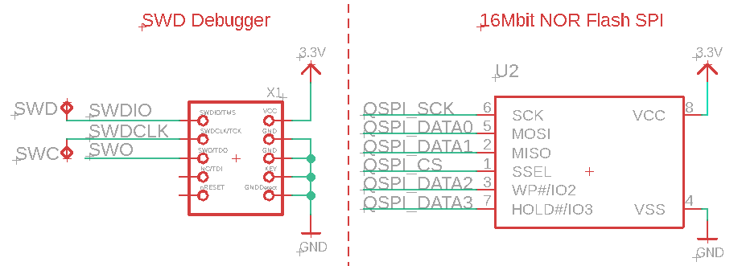

Figure 5‑5: SWD debugger and flash memory schematic designs

## Decoupling Capacitors

Several capacitors are used and placed near the ICs that are included in our design. These capacitors act as shunts against noise caused by the other components in the design. The points protected against noise are shown in the following schematic.

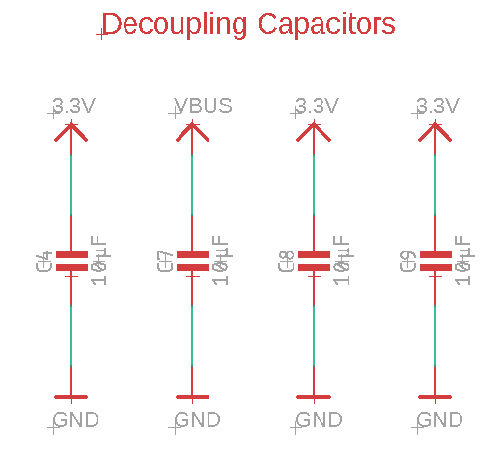

Figure 5‑6: Schematic design of the decoupling capacitors

## Screen Headers

Two pin headers placed parallel to each other are planned to be utilized to connect the screen to the MCU and power nets of the rest of the PCB. As shown in Figure 5-7 below, not all pins on the connectors of the screen are utilized. Those pins that are unnecessary are left without any nets connecting to them.

The aspects of this portion of the design were heavily influenced by the layout of the selected screen. If Slate is ever to be mass-produced, this design aspect will need to be revisited. The current design solution is not the most cost-effective or user friendly, as a damaged screen results in many possibly working parts unable to be salvaged.

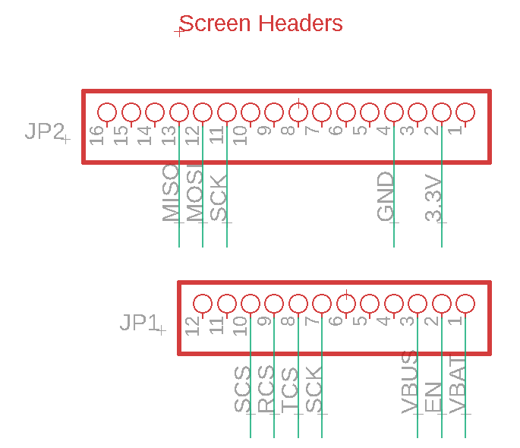

Figure 5‑7: Schematic design of the screen headers

## MX Switches

The Slate prototype will use eight MX switches as a 2X4 matrix which is shown in Figure 5-8 below. The nets connecting to pin 1 of the switches corresponds to a GPIO pin on the MCU.

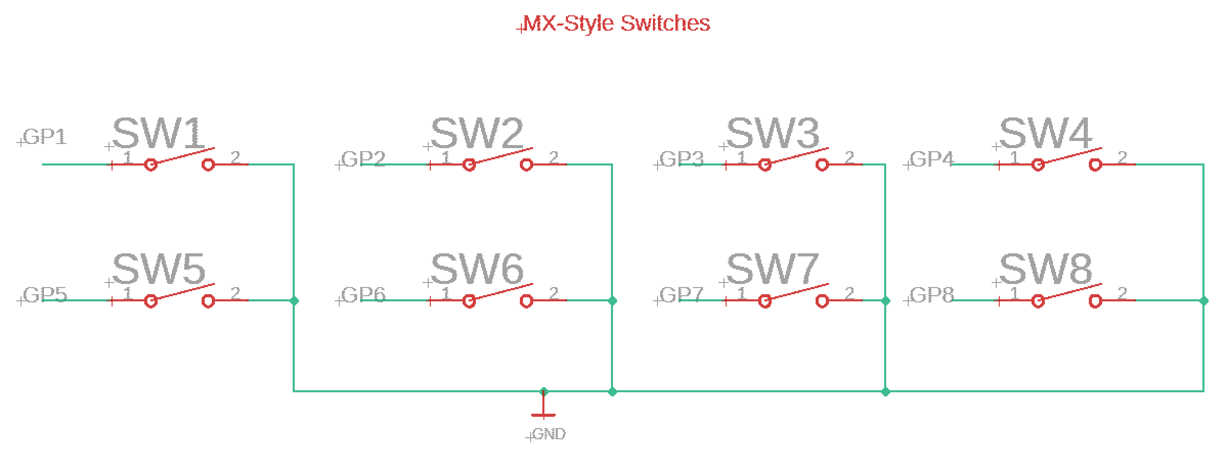

Figure 5‑8: Schematic design of the MX switches

## Rotary Encoder

The design for the rotary encoder is shown in Figure 5-9 below.

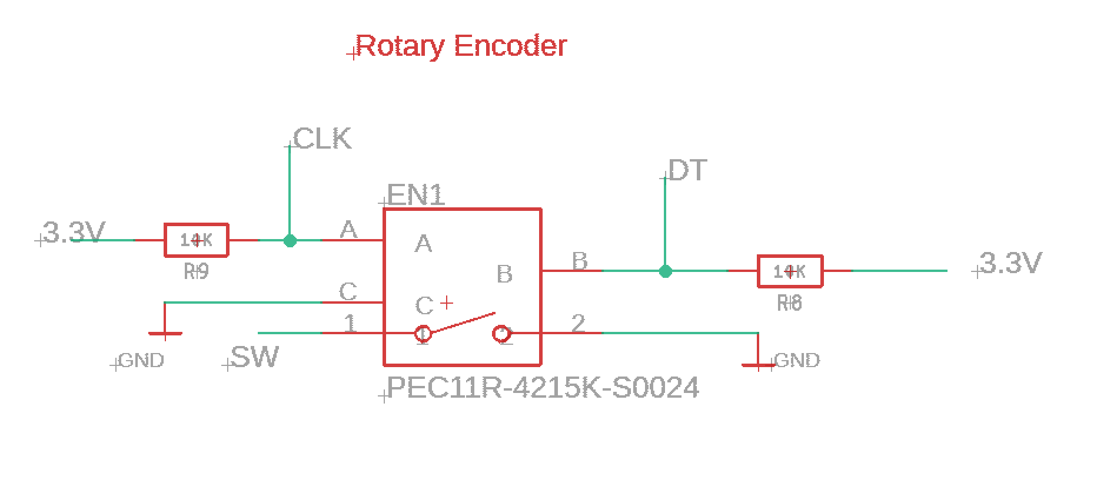

Figure 5‑9: Rotary encoder schematic design

## Joystick

The schematic design for the Playstation style joystick is given in Figure 5-10 below.

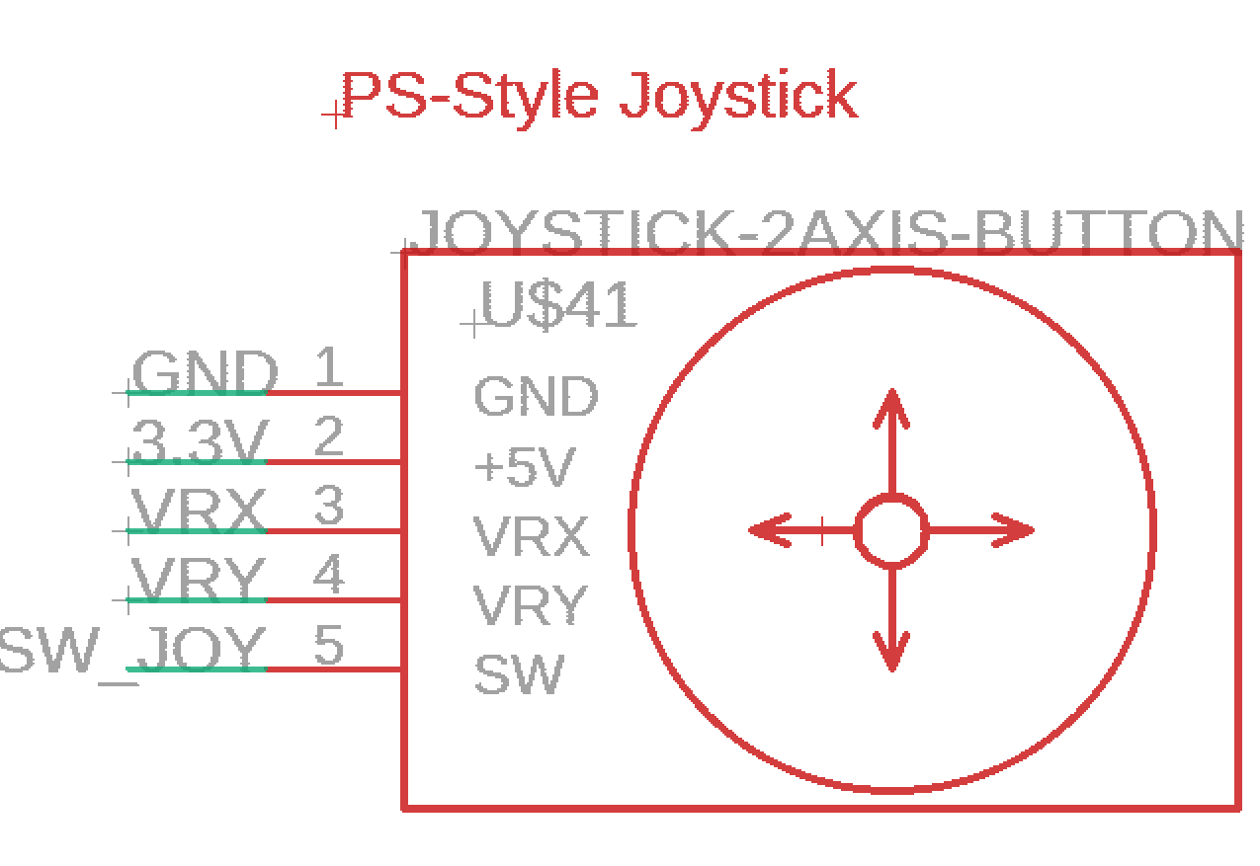

Figure 5‑10: Schematic design for the PS style joystick

## PCB Bill of Materials (BOM)

The major components selected for final PCB design are displayed in Table 5-1 below. This list is not exhaustive, as it was directed not to include minor components like resistors and capacitors by Slate’s project coordinators.

|  |  |  |  |  |
| --- | --- | --- | --- | --- |
| Component | Model | Manufacturer | Source | Price |
| MCU/BT | MDBT50Q-1MV2 | RAYTAC | [Digi-Key](https://www.digikey.com/en/products/detail/raytac/MDBT50Q-1MV2/13677591) | $9.94 |
| 32.678 KHz Crystal | ECS-.327-9-34QN-TR | ECS, Inc. | [Mouser](https://www.mouser.com/ProductDetail/ECS/ECS-327-9-34QN-TR?qs=%2Fha2pyFaduh4WVcjWR3%252B1X7YAR6C4mBRai1QL3f4XAgXwbvmcMaPXw%3D%3D&utm_source=octopart&utm_medium=aggregator&utm_campaign=520-.327-9-34QNT&utm_content=ECS) | $0.90 |
| 16Mbit FLASH SPI | AT45DB161E-SHF-B | Adesto | [Mouser](https://www.mouser.com/ProductDetail/Adesto-Technologies/AT45DB161E-SHF-B?qs=sz9oxq9AnY9g5UQKu3m6Vw%3D%3D) | $2.41 |
| LIPO Charging IC | MCP73831T-2ATI/OT | Microchip | [Mouser](https://www.mouser.com/ProductDetail/Microchip-Technology/MCP73831T-2ATI-OT?qs=yUQqVecv4qsZbioEUu%252B83g%3D%3D) | $0.59 |
| Low dropout linear regulator | NCP562SQ33T1G | ON Semiconductor | [Digi-Key](https://www.digikey.com/en/products/detail/NCP562SQ33T1G/488-NCP562SQ33T1GCT-ND/2121577?utm_campaign=buynow&utm_medium=aggregator&curr=usd&utm_source=octopart) | $0.67 |
| MOSFET for Power | SQ2315ES-T1_BE3 | Vishay / Siliconix | [Mouser](https://www.mouser.com/ProductDetail/Vishay-Siliconix/SQ2315ES-T1_BE3?qs=TiOZkKH1s2RTOcBqWhNNKA%3D%3D) | $0.57 |
| Schottky Power Rectifier | PMEG2010EH,115 | Nexperia USA Inc. | [Digi-Key](https://www.digikey.com/en/products/detail/nexperia-usa-inc/PMEG2010EH-115/1589929) | $0.38 |
| JST-PH 2-Pin Connector | 1769 | Adafruit Industries | [Mouser](https://www.mouser.com/ProductDetail/Adafruit/1769?qs=%2Fha2pyFadujTTjkHKg6gwTQ%2FgVw8P9Ka%252B0n%2FJcQN4g0%3D&utm_source=octopart&utm_medium=aggregator&utm_campaign=485-1769&utm_content=Adafruit) | $0.75 |
| Micro USB Connector | ZX62D-B-5P8(30) | Hirose Electric Co | Mouser | $0.96 |
| SWD Interface Connector | 752 | Adafruit Industries | [Mouser](https://www.mouser.com/ProductDetail/Adafruit/752?qs=%2Fha2pyFaduj%252BEQoCDpJSxkEYwBKwLVtySljFsPefVOc%3D&utm_source=octopart&utm_medium=aggregator&utm_campaign=485-752&utm_content=Adafruit) | $1.50 |

Table 5‑1: Limited BOM for Slate’s PCB design

# Software Design Details

Aspects of the software design required for Slate will now be discussed.

## Software Functionality and Block Diagrams

The block diagram shown in Figure 6-1 below shows the basic operation flow for the software that runs on Slate. Initially Slate will display the current time and the total battery percentage on the user interface. It will also set its generic profile as default at boot; once the user creates a profile the user can then change the default boot profile to any of the created profiles.

While the Slate is idle, it waits for the user to perform an action and/or for the configurator app to send an update file. If the desktop configurator app sends an update the Slate is rebooted and loads the updated profiles. If the user attempts to use a macro and an error occurs, an error message will come up on the screen, if the macro is instead executed successfully, the Slate reverts to back idle state after the macro is performed. If the user selects a different profile, then the Slate loads the selected profile and updates the macros to the settings on that profile.

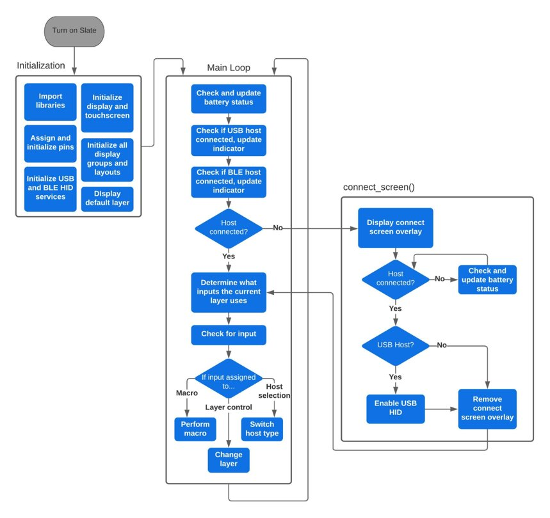

Figure 6‑1: Slate’s software block diagram

A separate block diagram is shown in Figure 6-2 below for the desktop configurator application that is used to modify the macros and update the Slate. Initially when the Slate is connected to the application, it reads all the profiles stored on the Slate and displays them as a list on the application user interface. Here the user can create a new profile or select one of the profiles on the list to modify or delete.

When modifying a profile, you can configure a physical macro or a touchscreen macro to your desired function. It lists nine physical and nine digital macros for the user to modify. When the user clicks done, it saves the profile you selected or created with specified macro settings on the list and goes back to the main interface.

The app allows the user to either load the entire list of profiles back to the Slate or for the user to select one specific profile and load it onto the Slate. The user can also set one of the listed profiles as the default profile, which then will be used as the initial boot profile when the Slate is turned on. The program then overwrites the Slate’s defaulted profile but not the generic profile used when the Slate is first initialized.

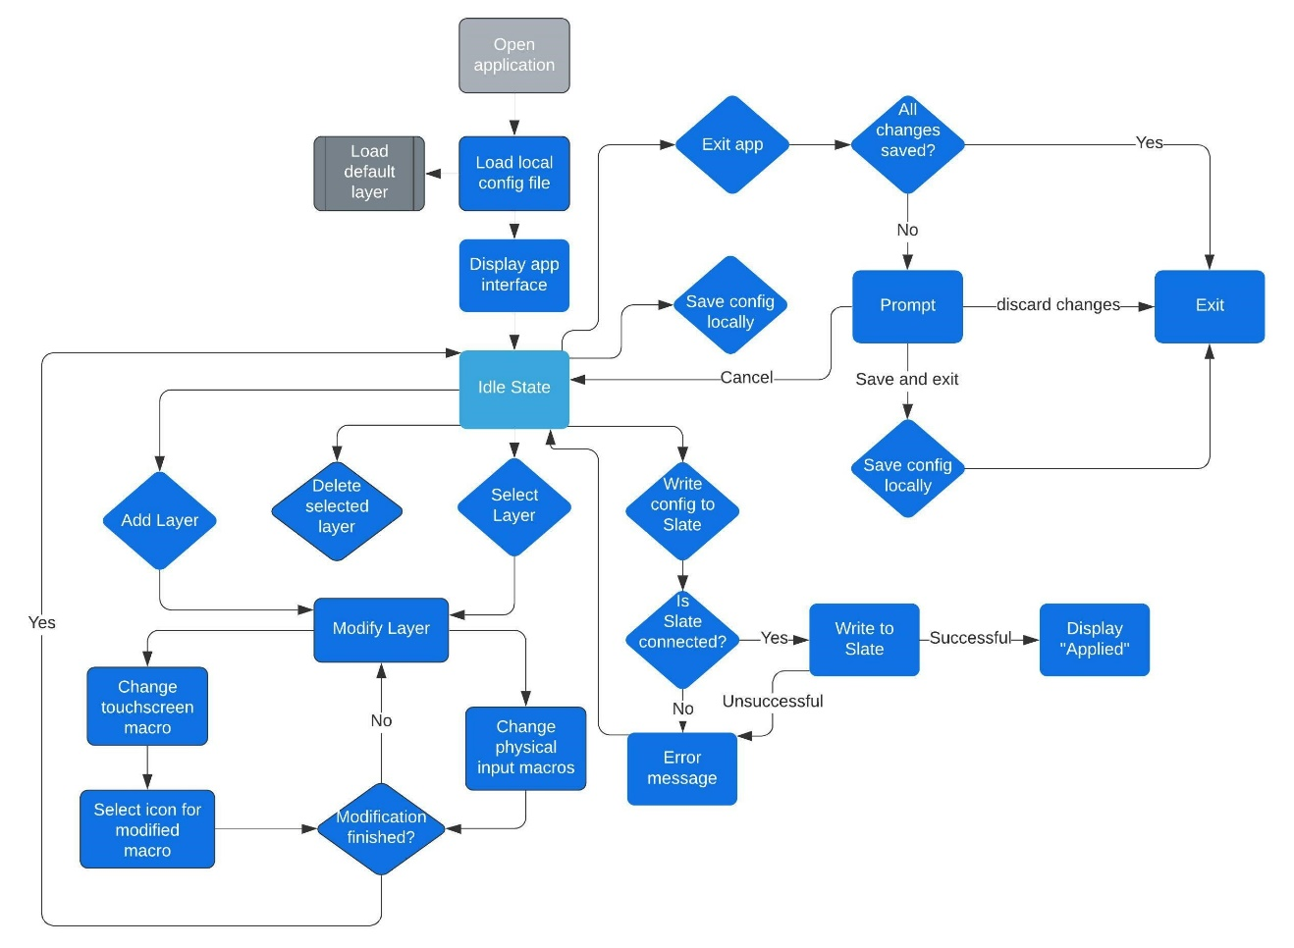

Figure 6‑2:Slate’s desktop configurator software block diagram

## Software Tools

### Documentation and Communication

Communication and documentation are key components for successfully and effectively working in any team design project. The following software tools were used for the purposes of establishing reliable communication, organized file sharing, and group task management.

#### OneDrive

After investigating a few different tools that could be used as our main method of editing and file sharing the document report, we found that OneDrive met and exceeded all our needs. With any UCF Knights email, Office365 is available for free. Through Office365 we can access OneDrive, so the group all had access to it which was convenient. OneDrive is a cloud-based file hosting service that allowed for real time collaboration on any document. Not only does it allow any stored document to be browser accessible, making it easy to work on with almost any device with access to the internet, but it also has the capability for any device with Microsoft Word to edit and update the document in real time which made team collaboration very convenient and efficient.

#### Discord

We chose to use Discord as our general communication tool. Discord is an open-source software that offers server-based voice and text chats that make it easy to communicate with each other. Discord servers are organized into topic-based channels where users can collaborate, share and talk to one another. A server was created for our team where we made multiple channels based on different topics to organize the information that was posted by each member of the team, for example we have a GitHub channel that automatically updates us when someone makes a new commit to our app repository. Which made it easy to check up on any changes made to the application. We also had a power path management, schematic and resource channel where each of us could post general information we investigated on each topic or post questions we may have had on those topics. Discord also was a mobile application available on any mobile OS which allowed us to communicate with each other even when we are not home. Discord was also used to host our weekly meetings

#### Trello

Group task management is very important to keep up with development deadlines for each deliverable. Trello was another important collaboration tool that was used to manage and assign tasks to each member using a virtual task board. A project manager creates a virtual task board and invites the team to access their tasks where each member can create cards that represent task that need to complete. These cards can be stored in a collection of lists that will keep track of how far along each member is with their assigned tasks. This tool was chosen because it allowed us to organize a list of tasks that needed to be done before a deadline which kept us from slacking off.

### Development Tools

Through the development phase we utilized many different tools to aid us with writing code, collaboration management, version control, GUI development and many other needs we encountered along the way. Table 6-1 below details each software that was used and provide a small description of how they were utilized.

|  |  |
| --- | --- |
| **Software Tool** | **Description** |
| **J-Link Software** | Flash programming |
| **Mu** | Programming Microcontroller |
| **VsCode** | Programming Web Application |
| **Git** | Version control |
| **GitHub** | Code collaboration tool that allowed us to efficiently work on the same code and provide peer review for each commit. |
| **CircuitPython** | Programming language based on Python that made coding the MCU easier. |
| **Eagle** | PCB design |
| **Fusion360** | 3D Modeling |
| **PyQt** | GUI development |
| **TKinter** | GUI development |
| **PySimpleGUI** | GUI development |

Table 6‑1: List of software tools utilized for development

#### Mu editor

Mu is a simple code editor that work with Adafruit's CircuitPython boards. Adafruit recommends using this editor for beginners that want to utilize CircuitPython and do some embedded programming. It is written in Python and works on Linux, Windows, and MacOS.

The serial console is built in the editor so you can get immediate feedback from any board's serial output. In Figure 6-3 below, an example of the feedback received when utilizing the dir function of Python with an input of the board module.

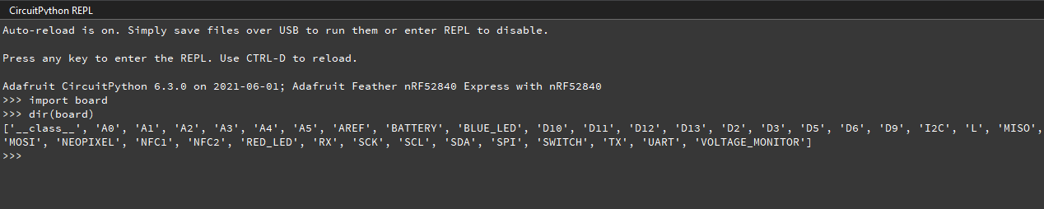

Figure 6‑3: Listing of pins available via CircuitPython

#### GitHub

GitHub was used in our project as a tool that provided efficient code collaboration between our team. It provides a version control system by using branches and allows for easy peer review for each commit that is made by each user. We created a repository for our team where we all have access to the Slate software and can work on different aspects of the software by creating new branches. Once one of us are done making changes we simply can merge our changes to the branch and ultimately merge to the main branch if no bugs are found. Below is Figure 6-4 which shows the repository we are currently using for the Slate.

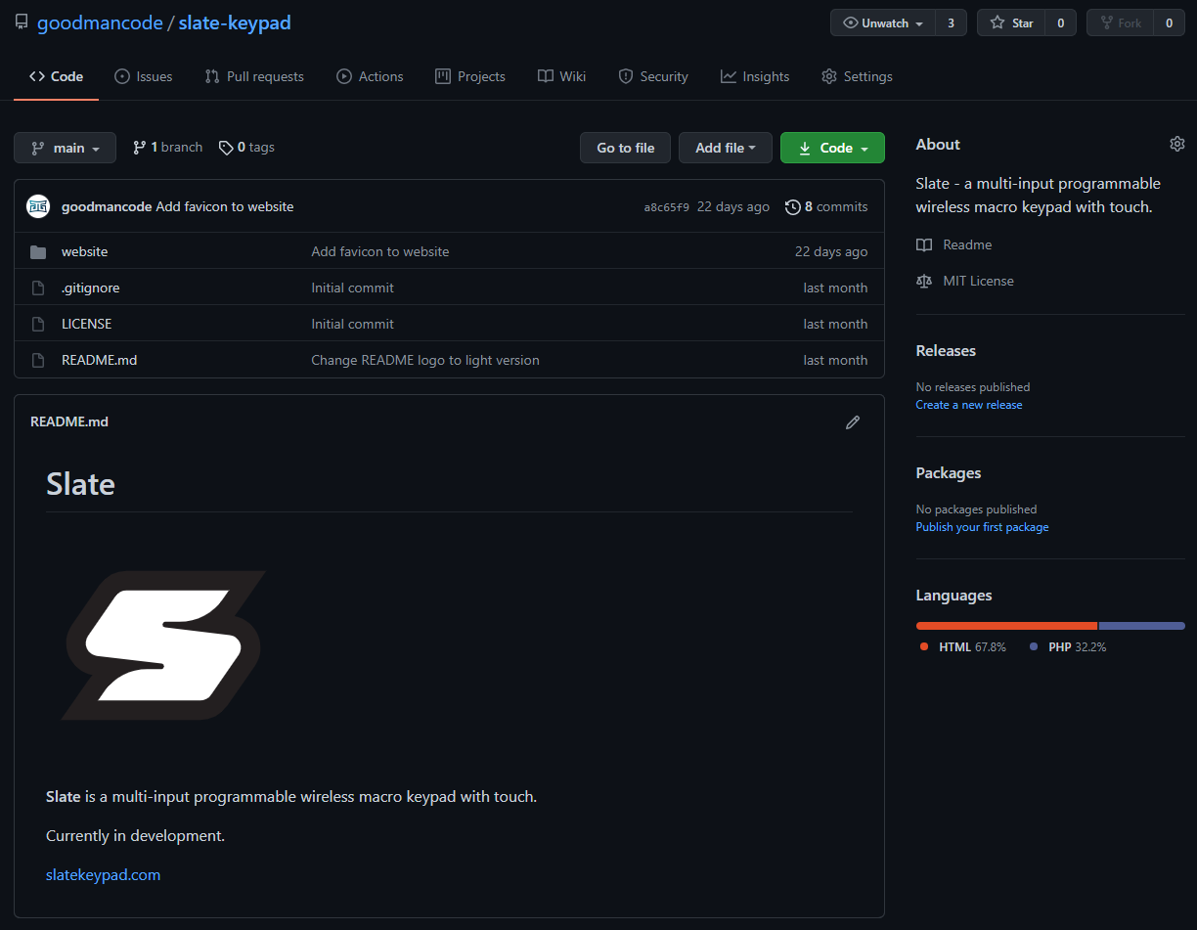

Figure 6‑4: Image of Slate’s code repository on GitHub

## Software Development

### GUI Tools

Since our software design for Slate will be centered around CircuitPython, it makes sense to use Python to develop our desktop configuration application. Three options that exist for easier GUI development in Python include PyQt, Tkinter, and PySimpleGUI. These libraries differ in complexity and flexibility, with PyQt being more complex to develop but having wide visual options, and PySimpleGUI being the simplest to implement with limited visual features. Tkinter provides a decent trade-off between simplicity and features, and there is ample documentation for its development.

### “Touch Deck” Demo Code Analysis

Adafruit has developed code using multiple of their existing open-source libraries that resembles the functionality we wish to have on the touchscreen of our final design. Since we are able to install and run this demo directly on our development board and screen module, we’ve decided to base our own code on this demo with additional functionality added down the line for physical inputs and potentially Bluetooth operation.

The demo code utilizes two Python files along with libraries and bitmap assets to function. The two Python files are **code.py** and **layers.py**. In the main operation of the demo is all within **code.py** which is the file ran by default by the CircuitPython interpreter. The **layers.py** file is simply a configuration file that holds all the user-defined mappings of buttons including their icon, macro functionality, and text label. Our intention is to add some additional mappings to the layers file for the physical inputs, while adding extra functions to the existing library to go beyond the basic three macros of key-press, multi-key-press, and type string.

The code file consists of the following sections and processes. First the necessary libraries are imported from the flash memory as needed by the program. Then, the program initializes the screen using the appropriate functions, and initializes the HID device library. After this, some variables are added with default values including the default layer number, cooldown time between button presses, and layer index values. The large section after this establishes the on-screen GUI by forming visual groups that hold cells and subsequently the macro buttons and icons.

The program then defines a function called **load_layer** that takes in a layer index value as an input, flashes a loading screen to the display, reads the layer config, builds a GUI structure to be written to the screen buffer, and then sends the established layer to the display. At this point all of the static definitions, variable declarations and functions have been defined, and the main loop begins. This main loop is a “while True” loop that does not end until the program is terminated via power-off or uncaught error.

This loop continuously checks for touchscreen position and whether the user has touched a point on-screen. If the user has pushed the home layer icon, the default layer is loaded using the previously mentioned function. If one of the next layer icons are pressed, then the layer index +1 or -1 from the current layer is loaded. If a specific on-screen button is pressed, that button’s function or macro is performed with minimal latency.

All the functionality in the current demo is performed over a USB connection and USB-HID communication. Part of our development will include determining the feasibility of porting functionality over to Bluetooth-HID, along with handling the move from USB power and communication to Bluetooth communication and battery power.

# Prototyping

Now that the initial hardware and software designs for Slate have been completed, prototyping will be utilized to identify potential areas that can be improved upon. During the prototyping stage, the team will also prepare for the initial custom PCB design to be manufactured and assembled along with the initial software that will be utilized on the final version of the PCB.

Throughout this section, the aspects related to prototyping Slate will be reviewed, and any potential design problems that can be identified will be noted. If any hardware or software design problems are identified through this prototype, the related schematic and software designs will be updated to reflect these changes.

### Prototype Progression

In this section we detail the stages of the prototype from part arrival to finished prototype. Any creative decisions, setbacks, testing, are shown here to document progress and hands-on development.

#### Part Arrival

Figure 7-1 below is used as a reference showing the condition and appearance of each individual component we received for the prototype.

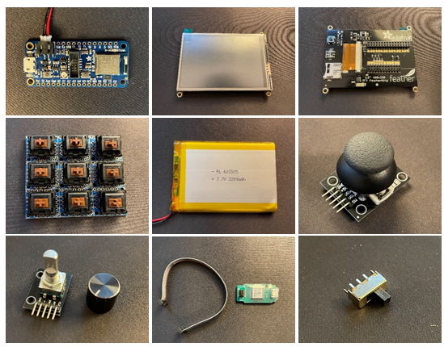

Figure 7‑1:Initial condition of prototype components

#### Initial Boot of nRF52840 Feather Express

Upon initial boot of the Adafruit nRF52840 Feather Express, shown in Figure 7-2 below, the board is confirmed to be functional and has a default UF2 bootloader installed for use with Arduino. The operating system chosen for development is Microsoft Windows, and no manual steps were necessary for the Feather Express to be recognized.

Following the primary guide for the board at Adafruit’s website, we checked what firmware version the board was running out of box. The board was using an out of date bootloader which released in 2018. To remedy this issue, we followed the steps for flashing the latest bootloader (v0.6.0)which was released 19 June 2021.

When attaching the battery with USB attached, the charge LED is lit and the board remains functional. When USB is removed with battery attached, the board continues to function without power-loss or reset.

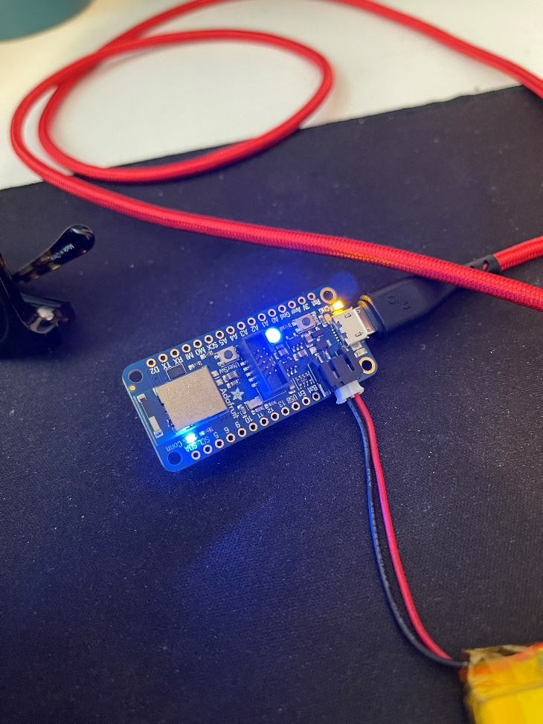

Figure 7‑2: The initial booting of the Feather Express prototype component

#### Installing CircuitPython to nRF52840 Feather Express

As stated, the development board ships with firmware capable of being recognized and programmed for Arduino. Since we intend to use CircuitPython, we’ll install it onto our board using a guide provided by Adafruit.

The latest stable release of CircuitPython for our board is 6.3.0. We download the uf2 file for version 6.3.0 and proceed with installation. Installation is simple, first we plug in our development board via USB, then double press the RESET switch on the development board to enter installation mode, locate the newly recognized disk drive “FTHR840BOOT”, and finally drag the new uf2 file into the drive. The board automatically recognizes this uf2 file and proceeds with installation. Once finished, the disk drive is now labelled “CIRCUITPY” and CircuitPython installation is complete.

#### Basic REPL Commands and Serial Monitor Output

With CircuitPython is installed, we opened the Mu editor to run some commands that would be executed by the Python interpreter running on the prototype MCU. The feedback from running the test code snippets was used for initial testing. By comparing the received feedback from the board with that which was expected according to the CircuitPython documentation, we successfully were able to test the CircuitPython installation and get a better understanding of how code will be executed by Slate’s MCU.

#### Soldering Headers on to Development Board

The nRF52840 Feather Express ships with headers unattached. In order to interface with the Feather Wing 3.5” TFT in a suitable manner, two rows of male header pins must be attached to the breakout pins of the Feather Express.

As a team member had received the parts and owned the necessary tools to solder the headers, the soldering required to attach the FeatherWing more steadily to the Feather Express was accomplished. The results of this work are shown in Figure 7-3 below. Testing using a voltage meter was conducted to ensure adequate connection in each of the headers, along with eliminating the possibly of shorted connections.

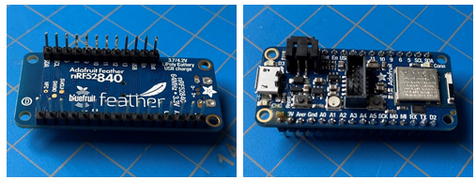

Figure 7‑3: Header pins attached to the prototype breakout board

#### Attaching Feather to FeatherWing

After the pins are soldered to the Feather, it is as simple as plugging the Feather into the FeatherWing in the correct orientation. The FeatherWing has female headers specifically in the layout of the Feather, so no jumpers are needed. In Figure 7-4 below, we can see the FeatherExpress and the FeatherWing as separate pieces (left) and when they are connected (right).

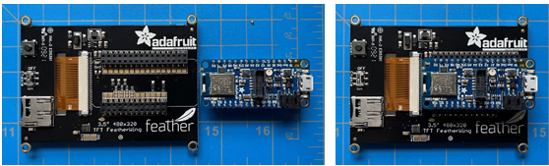

Figure 7‑4: Attachment of Feather and FeatherWing

#### Running the Example Project Code “Touch Deck” from Adafruit

Adafruit provides a guide and sample code to run a UI similar to what we are trying to achieve in terms of touchscreen functionality. The guide is written for combinations of any Feather and FeatherWing 3.5” TFT, so no modification should be needed to get the code to be functional with our parts.

When the necessary libraries and bitmap icons are written to the 2MB QSPI Flash (which shows up as removable storage CIRCUITPY in Windows), the main example code is also written (code.py) along with a config file for profiles/layers (touch_deck_layers.py). On initial run of the example code we received the error shown in Figure 7-5 below.

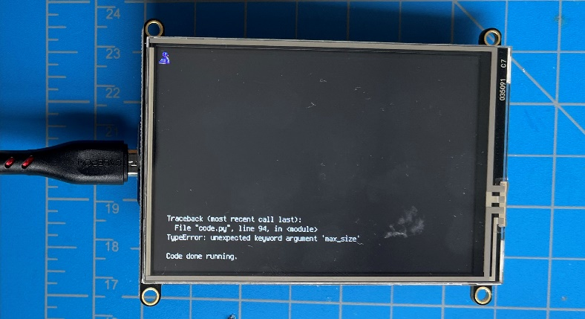

Figure 7‑5: Error upon initial running of test code for prototype screen

Upon investigation in the GitHub issues section for Adafruit libraries, it seems this “max_size” argument is deprecated for where it is used in the example code, so upon removing the arguments and reloading the code we are greeted with the screen shown in Figure 7-6 (left) below, which is the output to be expected for the code that was executed.The example is working and the user can select between layers with the on-screen buttons along the right side.

The default layer is for YouTube media controls. We confirmed all of these functions do indeed work on a test video. Adafruit includes some additional layers which can all be configured in the config file, including adding new layers. To show proof of concept for this config file, we created our own layer, which is the symbol for the Slate project. A new bitmap icon of this logo was added and it was simple to add each button with the correct icon and function by typing the string “Slate Keypad” in Windows. We confirmed this function works, and does indeed type the customized string. This example scenario is displayed in Figure 7-6 (right).

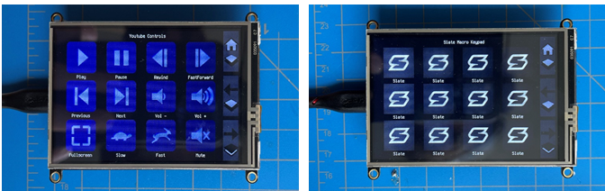

Figure 7‑6: Expected output for CircuitPython screen libraries

#### Mock Layout with Functional Screen and MCU

Figure 7-7 below displays a rough estimate of where our parts will be placed for the prototype. Our intention is to mount all these components to a perfboard during the prototyping stage for a more solid construction when compared to a breadboard prototype. The result is also a more reliable connection between traces and ports. This mock layout can then be used for several aspects of testing for both software and hardware designs.

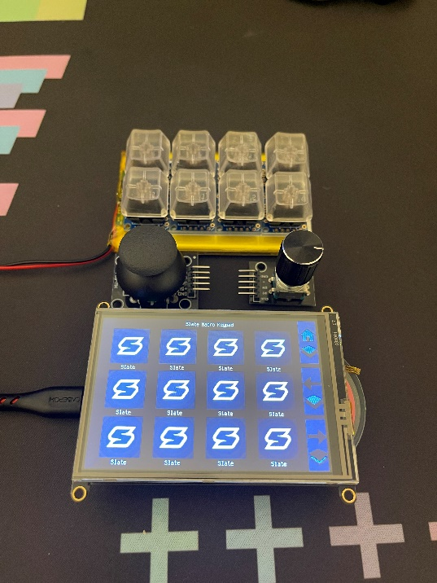

Figure 7‑7: Mock layout for initial Slate prototype

#### Protoboard Soldering and Component Assembly

To ease in the troubleshooting of the prototype, all components should be socketed into female headers soldered onto a final protoboard. This way they can be replaced, inspected, or otherwise mounted in a way that is not time consuming to remove.

Originally the prototype was to use two or three 7x9cm single-sided perfboard, since it was what the group already had on hand. The layout chosen to fit all components was the one shown below.

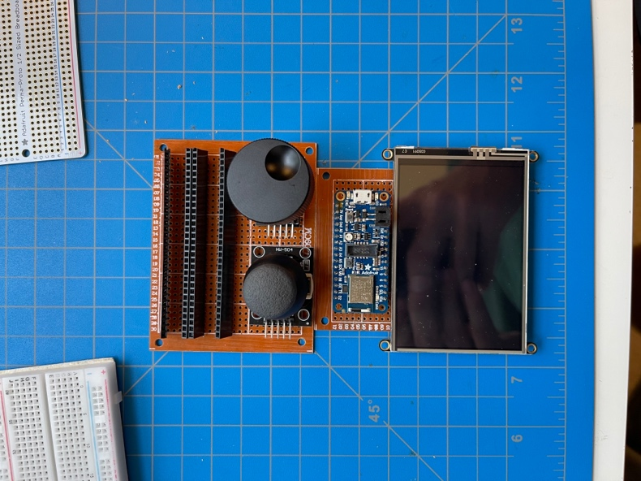

Figure 7‑8: Mock layout on two 7x9cm perfboards

To mount the eight switches, four female header rows are soldered to the top perfboard which the switch breakout boards slot into once pins are added. Those pins are soldered like so:

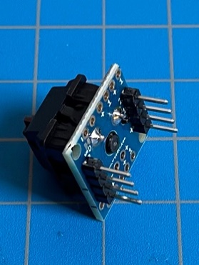

Figure 7‑9: Modular key switch breakout with pins attached

Once all the soldering is done for the female headers and the switches are soldered to their respective breakout boards, the switches can be added to the perfboard.

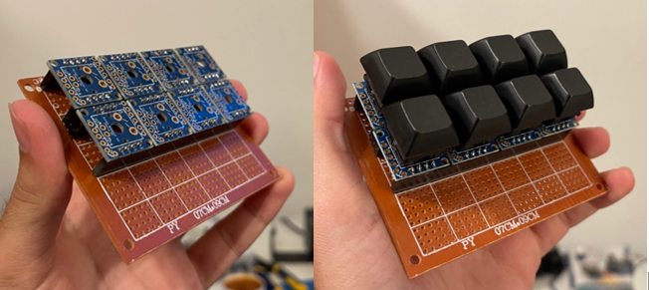

Figure 7‑10: Eight modular switches mounted to perfboard

At this point we are going to pivot to a single, higher-quality protoboard with double-sided solder pads. This will reduce the fragile nature of connecting two separate perfboards with wiring, and allow better density with component placement so that the prototype is closer to the final intended footprint of the Slate keypad. Along with this change and added space, female headers for switches were reduced to just the amount necessary for stability of each switch, and the switches were rotated to the correct orientation as-per footprint for final design.

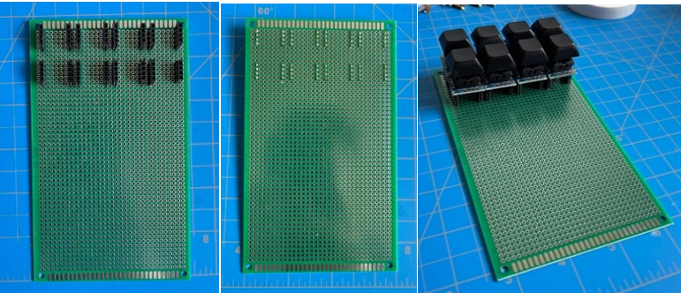

Figure 7‑11: Soldering progress of switch headers on new protoboard

Similarly, female headers for the rest of the components including the development board, screen, joystick and encoder were added in similar positions to our mockup render, which leaves only the underside wiring of data lines and power to each component.

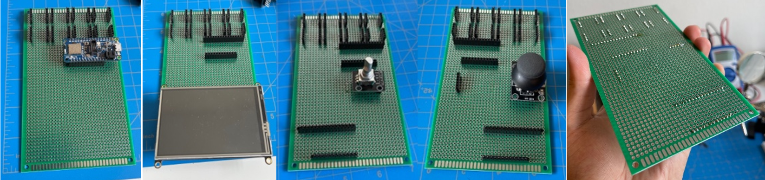

Figure 7‑12: Soldering progress of remaining component headers

To connect all the components to the development board neatly, wires will be kept below the protoboard PCB, with the components themselves just needing to be placed in their correct sockets. The screen is wired up first, which involves 11 wires for power delivery and data transmission.

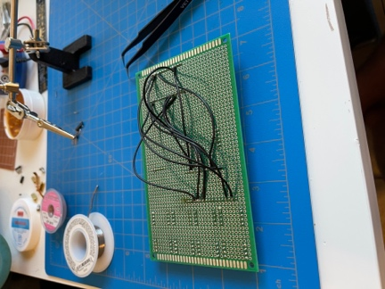

Figure 7‑13: Wiring assembly for screen

To ensure wires are connected correctly, a test boot is performed to show no shorts or data corruption/degradation is present.

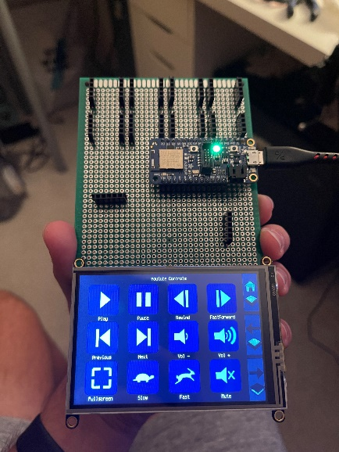

Figure 7‑14: Power-on test after wiring screen

To stabilize the PCB and provide a flat bottom surface, a section of MDF particleboard was cut to 10x16cm that we will later drill and mount the PCB to with M3 standoffs. This will also provide space for the battery below the PCB if needed.

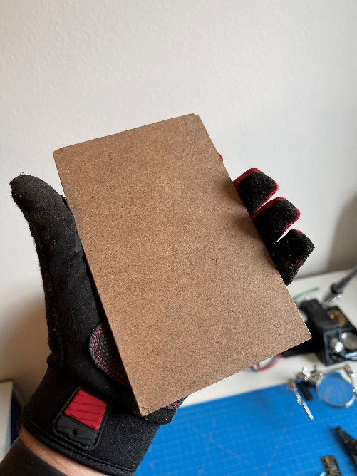

Figure 7‑15: Custom cut 10x16cm MDF base

Additional holes were drilled through the PCB for M3 standoffs, providing support for the rotary encoder and joystick modules. After inserting each component into their respective headers and placing on MDF base, this is our prototype powered on:

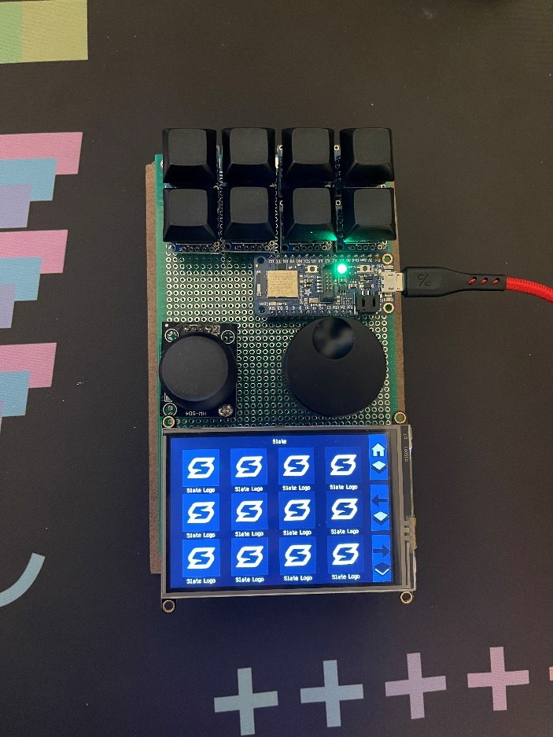

Figure 7‑16: Final prototype assembly

By using protoboard and wiring components by hand, we have demonstrated our prototype in a size and shape similar to our desired final design. This allows us to tweak positioning of components via user interaction, and gives us an opportunity to start developing an enclosure knowing approximate physical specifications and z-height based on the prototype.

### PCB

The finished schematic and board layout will be completed within the first couple of weeks of senior design two, or possibly sooner depending on scheduling of the team members responsible for the PCB design. The PCB board fabrication is quite expensive if done professionally however, since our design mainly consists of through hole switches, jumpers for the microcontroller and touchscreen. To limit the need for a stencil we will use standard size resistors and capacitors however, our backup plan if we aren't able to fit them in an ergonomic box the design will be transferred to SMD components. Diagnosing problems with a board usually tends to be an incredibly time-consuming task and are unacceptable at such a late part of the project. The plan for fabrication are detailed in this section.

#### PCB Design

As mentioned before our design will try to use standard resistors and capacitors, currently the only components that require some sort of resisters and capacitors are the encoders. Other than that, everything are just traces to the microcontroller, touchscreen, and other components. Previously we mentioned that Eagle will be our primary program for designing, building, and laying out Slates board. Once the board layout is completed Eagle has a built-in method to export a certain number of files called GERBERs which lay out all the specifications for board manufactures to fabricate the printed circuit board.

The images below show the prototype PCB using the protoboard to lay out the traces for each component.

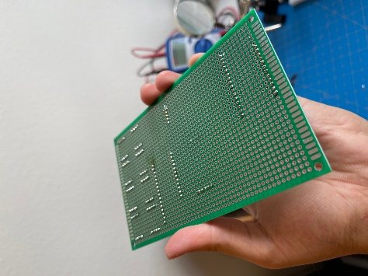

Figure 7‑17: Trace and wiring examples

The following sections is a quick overview of each layer of the PCB for our design.

##### Copper Top and Bottom (.cmp and .sol)

These two files lay out all the copper features or better known as traces for the board. In eagle these are usually the top and bottom layers and are simply conductive paths or planes.

##### Top Solder mask and Bottom Solder mask (.stc and .sts)

These thin layers made of polymer are applied to the expose copper, to prevent both oxidation and prevent unintentional shorts due to soldering. Usually there is no solder mask on the bottom unless components are place there however, for our board there won't be any parts on the bottom of the board to keep the overall complexity down.

##### Top Silkscreen and Bottom Silkscreen (.plc and .pls)

When the board is created in Eagle, it is very important to have labels for each part so that when we make the bill of materials, we can link each component to a label for example R1, R2, S1, S2, E1, E2 etc. for each resistor, switch, and encoder. To keep track of everything on the board. It also helps to place in the microcontroller and touchscreen onto the board since each trace needs to be going to a specific pin on the microcontroller and touchscreen.

##### Drill Legend (.drd)

The board will have various drill location for various components. The most common and likely for our case is for mounting into the case and vias. The vias are small features used to get a copper trace from the top layer to the bottom layer or any layer that needs to be reached and are typically 0.012 inches in size. The board will have mounting holes that will help secure the PCB on the enclosure. Complex boards can have internal layer with their own circuitry, but for our case we won't have that. Typically, vias are less reliable then traces since they are exposed to the environment and have the potential of becoming corroded over time.

#### PCB Fabrication

This section explains the process of getting the components onto the PCB, currently we will try to solder the components ourselves however, this is subject to change depending on the passive components we chose to use.

##### Contacting

Once the GERBER files are generated, we have two potential options to contract. In order to print the PCB, the stencil must be created to properly distribute the solder across the board, and the actual board will be sourced by a manufacture that have been mentioned in an earlier section. Currently we expect the total cost of PCB to be around 100 dollars.

##### Stenciling

The stenciling is a pretty simple procedure however, this will contribute to the majority of the cost if we decide to use SMD components. Usually, the price of a stencil can be up to $220. A stencil is nothing more than a thin metal sheet with various cut outs for the solder paste. Because we are using the microcontroller and Bluetooth module where it has a small pitch, it will require the stencil to have tight to tolerance which untimely brings up the price.

##### Solder Pasting

The solder paste distribution machine takes the stencil, locks it into a fixed position over the printed circuit board, and apply the solder paste. The machine takes two passes in order to be certain that the board is properly covered.

##### Soldering

Since we are using some through hole components like the switches and potentially passive components. We must solder them to the traces, this is done by taking soldering wire with the use of a soldering iron to apply the solder onto the printed circuit board.

##### Pick and Place Machine

This is the most complicated part of the production line of the PCB. This has the highest chance of failure if done incorrectly. It must be done within a time frame from the previous step of applying the solder paste, this is to prevent the solder paste from hardening prematurely. The .csv file will be produced; it will contain the x and y position of each material as well as their orientation to populate the board with the component.

##### Baking

The final step of the process, if not done correctly it could result in improper seating or conductivity issues. The oven is usually long, and on a dolly that pushes it through the oven to be heated, then air cooled at the end. The following image shows the Kester reflow profile and the heating procedure for the PCB.

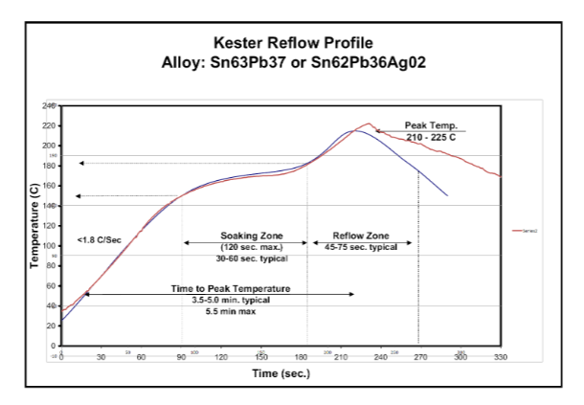

Figure 7‑18: Reflow time & temperature profile chart

##### DIY

The above section is the process if done professionally however, this entire process can be done entirely on your own. The stencil can be bought as well as the solder paste. Once aligned the solder paste can be applied to the board and the components can be place in their respected location with the help of tweezers. Once completed you can apply hot air to melt the solder and attach the component to the PCB. To prevent part from getting removed during installation of the other components flux is used. After all the small components have been attached the through hole components can be placed, this process is quite simple. It done with soldering wire and a soldering iron at the proper temperature to not melt the board or detach any of the surround components.

#### PCB Schematic

The image below shows our prototype PCB schematic and is subject to change later in Senior design 2.

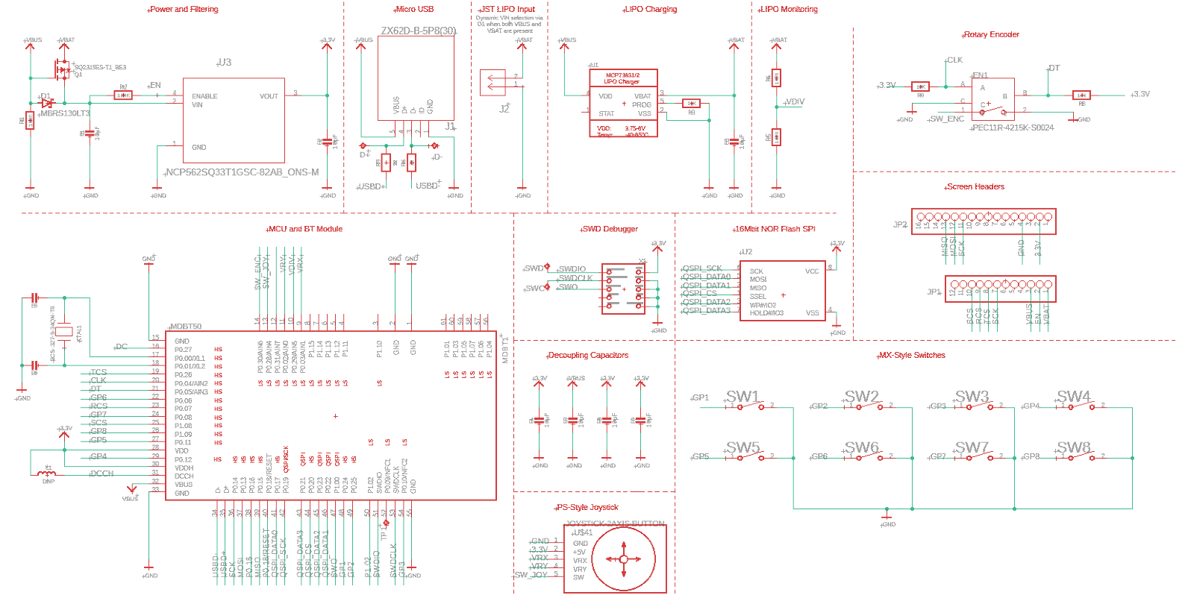

Figure 7‑19: PCB Schematic

### Prototype Expectations

This section will mention possible points of failure and any way of coupled with a plan of action to prevent any issues during the live span of this project. Since Slate is on a strict timeline, it is extremely important to go over any possible issues and have a way to solve or avoid them.

#### Potential Hardware Issues

The following table shows possible hardware issues along with its a solution plan of action.

|  |  |  |
| --- | --- | --- |
|  | **Issue** | **Solution** |
| **1** | The most common issue when working on a project especially during Covid means that time to receive parts are delayed and manufactures are in short supply. Some products can take many weeks to arrive, which will lead to delays in the production line of Slate. Time is very important since we only have the summer and fall semester to plan and build a product. | This issue can be avoided by ensuring that nothing is dependent on one component. As for Slate most of the parts are generic and can easily be replaced with a substitute if worst case come. |
| **2** | Ordering parts that turn out to non-operational, or damaging parts when soldering them onto the printed circuit board. | Oder more than what we expect to use. |
| **3** | When going through the Design process for the PCB, something is overlooked and costing hundreds of dollars. Since manufacturing and getting a stencil is so expensive. | Take time to third check the design before sending it out to ensure there are no mistakes in the design. Make sure every trace layout in eagle is correct. Each plane, vias, components are placed where it best fits. Because the company is doing exactly what it on the files, they aren't responsible for our mistakes. |
| **4** | Damaging the printed circuit board, by incorrect handling of the board. When soldering small pitch devices such as microcontroller and Bluetooth module pins can merge and short both the PCB and the component. | Order a few back up just in case any damage occurs to one, because getting another one made will take time that we do not have. Use a pick and place machine or when soldering use a macro lens to check for merged pins. |
| **5** | When designing the PCB, the most common issue is an incorrect ranking of nested planes, for example a vcc and ground plane. If they are on top of each other, you will have the risk of shorting and damaging the board. | Typically, eagle is quite good at catching these mistakes however, it is always a good idea to double check layer ranking. |
| **6** | Stranded wire near the board which can happen when mishandling the board. If that stranded wire strips and makes, contact with the board could cause shorts and damage the board. | Use compressed air before powering the PCB to blow off any bits of wire without damaging the board. |
| **7** | The mounts of the PCB could be conductive in the design (Slate wont but still should be considered) should be insulated if not it could cause a short. | Use rubber spacers in between the PCB and enclosure. |

Table 7‑1: Potential hardware issues

#### Potential Software Issues

The following table shows possible software issues along with its a solution plan of action.

|  |  |  |
| --- | --- | --- |
|  | **Issue** | **Solution** |
| **1** | Incorrect syntax when compiling CircuitPython. | Use IDE linter to correct syntax. |
| **2** | Software fails to write to nRF52840 module. | Check what mode nRF52840 is in, recover from safe mode or reflash with J-Link if necessary. |
| **3** | Desktop configurator cannot write config file to nRF52840. | Check that program has write permission and nRF52840 not in safe mode. |
| **4** | Unrealistic or Mismanaged timelines | Setting realistic goals for the software, work on key features and add more later. |
| **5** | Feature Overload | Keep the implementation simple, keep to the initial plan and don’t get carried away. |
| **7** | Compile errors | Go over the code and check for syntax errors and any logic that my cause a problem. |

Table 7‑2: Potential software issues

#### Prototype Constraints

In this section we detail constraints regarding the prototype. One constraint is the size of protoboard/perf-board we have on hand. Our perf-board cannot fit all prototype components on a single board, so two boards will need to be used and jumped or otherwise mounted next to each other. To mitigate this, we may purchase a larger double-sided protoboard that can accommodate all the components without splitting into multiple boards. Our limited timeframe means that we may have to keep the prototype to USB only and use the time in SD2 to develop the Bluetooth functionality. We made sure that our prototype uses parts that are breadboard friendly, but in general we will not be able to surface-mount any components for our prototype.

### Parts Acquisition and Bill of Materials

The following table shows the parts used for the prototype of Slate.

|  |  |  |  |  |  |
| --- | --- | --- | --- | --- | --- |
| Part Name | Model | Manufacturer | Source | Price | Quantity |
| Rotary Encoder Module | KY-040 | Cylewet | Amazon | 9.29 | 1 |
| Switch breakout prototype PCB board | 9 set PCB | Treefix | Amazon | 11.99 | 1 |
| Wire stripping tool | 2078316 | Irwin | Amazon | 10.99 | 1 |
| Vertical Slide switches | CYT1016 | Cylewet | Amazon | 5.69 | 1 |
| Jumper wire Kit |  | QSU | Amazon | 5.99 | 1 |
| Lipo-Battery 3.7v 3200mAh | 605585 | AKZYTUE | Amazon | 14.09 | 1 |
| Feather Express Dev Board | nFR52840 | Adafruit | Adafruit | 24.95 | 1 |
| JTAG/SWB Debugger | J-link EDU Mini | Segger | Adafruit | 19.95 | 1 |
| FeatherWing | TFT | Adafruit | Adafruit | 39.95 | 1 |
| nRF52840 SMD Module | MDBT50Q-1MV2 | Adafruit | Adafruit | 12.95 | 1 |
| PCB Ruler v2 |  | Adafruit | Adafruit | 4.95 | 1 |
| Fine tip curved tweezers |  | Adafruit | Adafruit | 3.95 | 1 |
| Perfboard Plates |  | Bakelite | Adafruit | 4.95 | 1 |
| Breadboard PCB | Perma-proto-Half | Adafruit | Adafruit | 4.50 | 1 |
| PS2 Joystick | Arceli | Arceli | Amazon | 7.99 | 1 |
| Pin Headers |  | Depepe | Amazon | 5 | 1 |
| Turning Knob |  |  | Amazon | 8.99 | 1 |

Table 7‑3: Parts acquisition table

The following table shows the Bill of materials.

|  |  |  |  |
| --- | --- | --- | --- |
| Cost Area | Price (USD) | Quantity | Total (USD) |
| Rotary Encoder Module | 9.29 | 1 | 9.29 |
| Switch breakout prototype PCB board | 11.99 | 1 | 11.99 |
| Wire stripping tool | 10.99 | 1 | 10.99 |
| Vertical Slide switches | 5.69 | 1 | 5.69 |
| Jumper wire Kit | 5.99 | 1 | 5.99 |
| Lipo-Battery 3.7v 3200mAh | 14.09 | 1 | 14.09 |
| Feather Express Dev Board | 24.95 | 1 | 24.95 |
| JTAG/SWB Debugger | 19.95 | 1 | 19.95 |
| FeatherWing | 39.95 | 1 | 39.95 |
| nRF52840 SMD Module | 12.95 | 1 | 12.95 |
| PCB Ruler v2 | 4.95 | 1 | 4.95 |
| Fine tip curved tweezers | 3.95 | 1 | 3.95 |
| Perfboard Plates | 4.95 | 1 | 4.95 |
| Breadboard PCB | 4.50 | 1 | 4.50 |
| PS2 Joystick | 7.99 | 1 | 7.99 |
| Pin Headers | 5 | 1 | 5 |
| Turning Knob | 8.99 | 1 | 8.99 |
| Shipping + Taxes | 16.43 | 1 | 16.43 |
| Total |  |  | 212.6 |

Table 7‑4: Bill of materials

# Integration & Testing

## Prototype Testing

To prototype our project, we will be using the Adafruit Feather nRF52840 Express development board that utilizes an nRF52840 microcontroller and includes components we intend to replicate in our design. This includes a USB plug, battery charging and protection circuitry, reset switch, and a SWD port for flashing the Arm Cortex M7F processor. We’ll also use the Adafruit 3.5” TFT FeatherWing Touchscreen that works natively with the development board, to allow us to get started on the software programming of the screen and it’s multi-profile macro feature.

### Enclosure Testing

The electrical housing for the electrical components must undergo a basic set of testing to ensure its security. The following is the testing protocol:

|  |  |
| --- | --- |
| **Testing process** | **Procedure** |
| **Step 1** | Ensure that the electrical components inside the ensure fit comfortable and don’t interfere with each other during use. |
| **Step 2** | Shake the enclosure to verify that the parts inside do not move out of place to prevent damage to any of the components. |
| **Step 3** | Drop the enclosure to the ground to test for stiffness and overall drop protection to prevent major damage. |
| **Step 4** | Check if the lid and openings in the enclosure line up and do not bind with any component such as the switches, encoder or lcd screen. |
| **Step 5** | Close the enclosure and check if all openings are visible and nothing is being crushed. |

Table 8‑1: Enclosure testing steps

#### 3D Printed Case Design

The case will be printed using PLA filament using a 3D printer. The design will undergo a variety of tests to ensure structural integrity for any scenario that it will encounter. Slate will live on a desk. The design must be ergonomic and user friendly the image below shows a very possible design for Slate however, this is likely to change moving into Senior Design 2 to take account of the internal components that will be used. The enclosure will consist of a top and bottom section with hardware holding them together. With perforations for the encoders, joystick, buttons, screen, and usb interface. Internally, the PCB will be house with mounting locations and an elevated design to fit the battery underneath the PCB. The orientation of the components as well as their position on Slate could also change later in the manufacturing/design process where we see best fit for our ergonomic and user-friendly requirements.



Figure 8‑1: Render mockup for case design reference

## Power Testing

### Initial Calculations

Due to our engineering requirements and constraints, the Slate project is heavily concerned with battery life. To calculate the expected battery life, we first calculated the expected Wh for both 2500 mAh and 3000 mAh batteries.

2500mAh = 2.5Ah --> 2.5Ah * 5V = 12.5Wh

3000mAh = 3.0Ah --> 3.0Ah * 5V = 15Wh

Next, the datasheet for the nRF52 MCU contains the typical values for current at the MCU’s highest CPU mode and the typical current with the BT radio output set to a maximum. From these values on the datasheet, we calculated the following:

16.4mA + 6.3mA = 22.7mA --> 22.7mA * 3.3V ≈ 0.075W.

Other resources on the internet state that the max power consumption of other components to be:

90mA * 5V = 0.45W.

We then add both of those and round up to the nearest hundredth of a watt to account for all other component power draw:

0.45 + 0.075 = 0.525 --> 0.53W max power draw.

Finally, we take the Wh number for each battery and divide by max power draw to get # of power-on hours:

2500mAh: 12.5Wh / 0.53W = 23.58 hours

3000mAh: 15Wh / 0.53W = 28.30 hours

### Battery Analysis

Software was written to analyze Slate’s battery subsystem. The software takes continuous samples of voltage and current from pin 10 of the MCU which is connected to the battery voltage via a voltage divider circuit. The results of the battery analysis are shown below.

## Hardware Testing

The following section describes the physical testing each of the components mounted on enclosure and testing procedures for the microcontroller. To ensure that the components are not binding with one another and preventing the device from working how it was intended to. The microcontroller is the most important in order for Slate to function properly, and if it is not wired correctly that can result in inaccurate button presses, encoder signals, touchscreen touches, or joystick inputs.

### Component Testing

The electrical components must undergo a basic set of testing to ensure it is operating at its best performance. The following is the testing protocol:

|  |  |
| --- | --- |
| **Testing process** | **Procedure** |
| **Step 1** | Check if the lid and openings in the enclosure line up and do not bind with any component. |
| **Step 2** | Press each switch to determine if one is either binding or damaged. |
| **Step 3** | Rotate the encoder to see if it is binding with the enclosure. |
| **Step 4** | Move the joystick around to ensure is has its full range of motion and is not getting caught with the enclosure. |
| **Step 5** | Plug the USB cable in the device and make sure the cable does not get stuck in any sort of way. |
| **Step 6** | Turn the screen on and check if the touchscreen is responsive and working as intended. |
| **Step 7** | Use a multimeter on each component to test for conductivity and to ensure all components are working. |

Table 8‑2: General component testing steps

#### Microcontroller and Bluetooth module

These two components will not undergo an immense amount of testing from a hardware point of view unless we encounter a noticeable problem. We will assume that both components are operational, and the manufacture quality tested the components. As far as the software testing of these modules it will be further talked about in the microcontroller testing section.

#### Passive Components

These components can easily be tested with the use of a multimeter. The multimeter has the ability to test both resisters and capacitors, while more advance one can test inductors. Because of the simplicity we will assume these parts to be operational however, if we need to, we can double check each component to ensure we received working parts from the distributor.

### Microcontroller Testing

The microcontroller will be looked over for any improper soldering points, all traces are connected and not shorted, and vias are not damaged. In order to test the logic of the microcontroller and see if the signals we are sending and receiving are adequate and sufficient for our needs we will use an Oscilloscope to test if the required voltages and currents are to what the manufactures recommends for the microcontroller. In order for development to go without problems the team will test the microcontroller with the following procedure to ensure the microcontroller is working as intended.

|  |  |
| --- | --- |
| **Testing process** | **Procedure** |
| **Step 1** | Use an Oscilloscope from the TI Lab, which can help supply the required 5v/3.3v needed for Slate to operate and the functions that an Oscilloscope has to test signals. |
| **Step 2** | Upload the code onto the board making sure the code complies successfully and uploads with no errors. |
| **Step 3** | The code will contain a test for each pin testing if it is able to trigger either a low and high single for a second. Once all pins are tested a final test of turning all the pins to high and low simultaneously. |
| **Step 4** | Connected a logic analyzer to see if all the pins are doing what the code tells it to do. To do this the code must be uploaded and connected to the logic analyzer. Each pin has its own cable. |
| **Step 5** | Once the test is done the team member will mark off that everything works as intended. |

Table 8‑3: Microcontroller testing steps

### Touchscreen Testing

In order to test the touchscreen, we will perform the following procedures to ensure the touchscreen is working to its full potential.

|  |  |
| --- | --- |
| **Testing process** | **Procedure** |
| **Step 1** | Ensure all connections points are made and aren't being interfered by anything. Also check the PCB traces to make sure all links are made. |
| **Step 2** | Check if all pins are connected to the corresponding pins layout in the schematic. |
| **Step 3** | Using a library from adafruit, we will upload a basic graphic test program that will populate the screen with icons that can be touch and print out a hex value to the serial window in the program. To ensure the touch screen is working as intended. |

Table 8‑4: Touchscreen testing steps

## Software Testing

Testing the systems software is critical to ensuring all system actions works correctly and performs to our expectations. The system must be able to turn on correctly, be able to read input from our sensors, buttons, encoders, and LCD. The feather MCU will need to be able to accurately display icons that the user sets up. It will also need to accurately determine what key is pressed and what program is currently running or know what preset each key is bound to.

# Project Operation

This user manual is designed to help the user successfully and properly set up Slate, safety precautions and general troubleshooting solutions to common issues. Below you will find all the necessary information mentioned in the above statement.

## Safety Precautions

The purpose of Slate is to be used at home and the overall design is safe however to reduce foreseeable safety risks, read the following safety precautions below before turning on the deice or applying any sort of power to it.

1. Keep Slate away from water or any foreign substance that is conductive in nature to prevent any damage to the device.
2. Make sure that no wires are expose or being crushed by the ensure. Check if any exposed wire is covered with insulations or a jacket to prevent an electrical shook to the user or prevent a short in the device.
3. Check for the electrical connections and do not turn on the device if there are any loose or torn cables or wires.
4. If unsure whether the device has been shorted test the battery or input voltage with a multimeter to ensure in is receiving voltage.
5. If the device must for whatever reason be opened, ensure power is off and wait a few minutes for the circuit to discharge.
6. Wear the proper safety equipment when dealing with electric components to ensure you are safe and the component is safe from any damage.

## General Information

Slate is intended to assist the user with an additional interface of “one-push” macros. The device is a mixture of a programmable touchscreen, physical switches, and rotary encoders. The programmable touchscreen would provide mainly application-specific macros, with the user able to select from multiple pages and profiles of digital “buttons” that execute a programmed macro or routine function. Physical switches can be customized in functionality but ideally remain the same between applications, serving as generalized macros across the OS. Rotary encoders assist the user in level, timeline, and scaling-based tasks, such as adjusting volume, scrolling the video timeline in editing software, or zooming in and out on a photo.

### Using Slate

The device follows a routine set of instruction to ensure the device is running and operating how it was intended. For an enjoyable user experience, please follow the following instructions to get full potential of Slate. This section addresses possible issues that can occur when using Slate and will be developed further as more testing of prototype units occur.

## Troubleshooting Tips

If you require assistance in using the Slate device, the following tables will list possible solutions that can be utilized in solving or diagnosing any issues.

|  |  |
| --- | --- |
| Problem | Solution |
| The device will not turn on. | If using it plugged in make sure the device is properly connected, ensure the micro-USB plug isn't damaged or the female portion is not damaged or filled with a foreign substance. Check for any loose connections. Measure the voltage across the battery to ensure you are getting close to voltage the device is rated for. |
| The Buttons are not pressing down. | Ensure the enclosure is not rubbing against the switches. Take the lid off of Slate and check if there isn't any foreign substance underneath the switches. Take the keycap off and see if the spring is jamming the shaft of the switch from going down. |
| The device turns on but is not responsive. | Check for any lose connections. Ensure the computer is recognizing the device. Reconfigure the device in the software. |
| Computer is not able to connect to the device. | Ensure all connection aren't lose. Reconfigure the device. Disconnect from the computer and wait 15 seconds before reconnecting or turning back on your device. |
| Touchscreen is not responsive. | Make sure Slate is clean and does not contain any foreign substance on the screen. Ensure all connection underneath the display are connected and the jumpers are not removed. Restart Slate. |
| Encoder is not responsive. | Clean Slate and ensure nothing is blocking the encoder from rotating. Check connections and reconfigure Slate in the software. Reset Slate. |

Table 9‑1: Slate troubleshooting tips

# Administrative Content

This section will give an insight to how well the team members contributed their time and the overall budget that is expected for Slate. The project is divided into two main sections the first reserved for researching and prototyping, and the second is acquiring final components, building and testing. Once all the research is done, the entire team will agree on which components will best suit Slate. After that the team will divide the cost among each other. Once the prototype is complete the team must reevaluate Slate and optimize it accordingly, with addition parts that can be ordered. The appropriate date and times for each milestone will be spread out form the initial document to the final presentation in senior design 2.

## Milestones

The following Gantt chart shows our expected milestones throughout senior design 1 and 2.

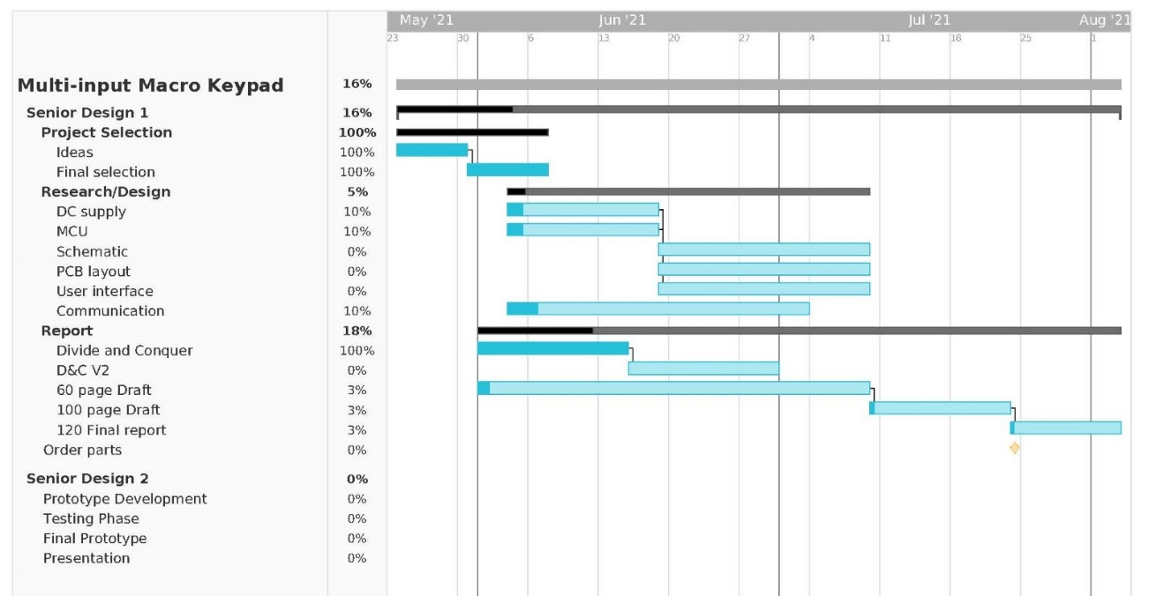

Figure 10‑1: Gantt chart for expected milestones

The majority of June and July will be spent documenting our technology investigations and meeting the report requirements. By the end of July, the protype will start been developed and tested, and our group will start ordering the parts for the definitive version of the Slate.

In SD2 the Slate will go through the final production sequences and begin an extensive testing phase. When the final workable prototype is built and tested, preparations for the demonstration will begin.

## Budget Analysis

The costs associated with this project will be self-funded. The budget currently is set at a couple hundred dollars in which will split equally among the four project members. Currently, no equipment has been acquired, besides what is already in each team member’s possession. The initial components required for prototyping this project plan to be obtained by August 1, 2021. This target date allows for enough lead time to research the required components in their entirety and enough lag time to prototype, test, and build a finished product.

We identified several of the main cost areas that will be necessary for the realization of Slate. These main cost areas are the Microcontroller Unit, the Power System, the USB Communication System, the Bluetooth Communication System, the User Interface, the hardware enclosure, and the cost of manufacturing. Many of these cost areas overlap, i.e., the Power System and the USB Communication system, but the prices associated with our budget in Table 1 were identified independently of one another. We chose this approach because we would rather overbudget than underbudget so any unforeseen costs that may arise throughout the development of our project can be mitigated.

### Development Budget

An initial development budget was created to help predict what the overall cost of the project would be. This allowed us to identify how many prototype units we could afford.

|  |  |  |  |
| --- | --- | --- | --- |
| Cost Area | Price (USD) | Quantity | Total (USD) |
| Development Board | $25 | 1 | $25 |
| Development 3.5” Touchscreen | $40 | 1 | $40 |
| 3000mAh 3.7V Lithium Battery | $14 | 1 | $14 |
| Total |  |  | $79 |

Table 10‑1: Initial development budget for Slate

The budget in Table 10-1 was created very early on in the project life cycle. After our investigation of various components and parts throughout the design process, Table 10-1 is not an accurate representation of what our design budget should be, and is more accurately described by Table 4-26

### Single Unit Bill of Materials (BOM)

At the onset of our project, we created an approximate single unit bill of materials (BOM). This would help identify if we could be competitive in the current market compared to similar products. The original BOM is shown in Table 10-2 on the next page.

|  |  |  |  |
| --- | --- | --- | --- |
| Cost Area | Price (USD) | Quantity | Total (USD) |
| Microcontroller Unit | $15 | 1 | $15 |
| Power Components | $13.50 | 1 | $13.50 |
| Battery | $14 | 1 | $14 |
| USB-C Connector | $5 | 1 | $5 |
| MX-Style Key Switch | ~$0.65 | 10 | $6.50 |
| PS2-Style Joystick | ~$2 | 1 | $2 |
| Rotary Encoder | ~$1.75 | 2 | $3.50 |
| 3.5” Touchscreen | $25 | 1 | $25 |
| Hardware Enclosure | $10 | 1 | $10 |
| Manufacturing/Shipping Fees | $10 | n/a | $10 |
| Total |  |  | $ 104.50 |

Table 10‑2: Predicted single unit bill of materials for Slate.

### Budget Analysis Summary

Two budgets were developed over the life cycle of project design and realization. These two budgets had to do with the development/prototype budget, and the budget regarding the final PCB to include all the necessary components, along with the costs for manufacturing and assembly. During the initial phase of specifying the project’s engineering requirements and constraints, dollar values were decided upon for both aspects.

#### Development Budget Analysis

After limited investigation, the identified engineering requirements for the development of a prototype was set at $1000.00. From Table 4-26, we can see that our development costs for a prototype system fell well below the budget set at the initial stages of our project. The cost of manufacturing possibly multiple amount PCBs may bring the Slate projects development costs much closer or even exceed the original $1,000.00.

## Project Design Problems

Slate must be ergonomic and compacted to not only look natural on the desk but also flow nicely with other keyboards. The main problem with Slate as far as its design is concerned is that the enclosure should not surpass our expected size limit of 6’’ x 6’’ x 2’’ and should exceed the projected weight limit of 120oz. With this is mind we opted in using a 3D printer with the help of ABS filament.

|  |  |
| --- | --- |
| Design Problem | Description |
| Margin of error from 3D space to real life. | When transferring the object from 3D space to the real world that, the margin of error is quite high and its accurately transferred over through the 3D printer because of the inconsistency of the machine. It could cause a fraction of a mm off which can result in the PCB or our components to not fit how they were intended. |
| 3D models not lining up to the actual components. | The 3D model could be off and the perforation on the case wouldn’t match to the holes designed for the USB plug, switches, screen, encoder, and joystick. |
| Prototype board perf board is weak and can break apart. | During the prototyping phase the initial board used failed resulting in us using a double-sided proto board to strengthen the integrity of the PCB. |

Table 10‑3: Project design problems

# Project Summary and Conclusion

In conclusion, this documentation provides insights into all aspects of the design process. Throughout the design, several issues needed to be overcome and all team members did their best to contribute and develop possible solutions. The end result was that we successfully were able to devise a system that will be utilized to address the issue of many users being required to accomplish a multitude of tasks in a short amount of time.

After identifying the issue, we wanted to solve, the team brainstormed and compiled a list of objectives for our engineering project that would solve the issue initially identified at the onset of this project. These issues would be the seed from which specific requirements would grow. These specific engineering requirements were further synthesized into initial design ideas and would lead to the identification of necessary components.

After the identification of necessary components, the team was then able to analyze potential options for these identified components that would be used in the final hardware design of the project. This analysis was accomplished through a thorough technological investigation, followed by research into specific components that would be required for any possible designs. Similar analysis was accomplished for the facets of the software design that would be necessary to accomplish the project goals.

These initial hardware and software designs and component selections lead us to the development of a functional prototype. This prototype was used to aid in the construction of a custom PCB, along with writing the software that would eventually be executed on the MCU included on said PCB.

After the groundwork for the construction of this custom PCB was laid, different facets of the project that would require to be tested were identified. Evaluation procedures were developed so that each of the engineering requirements could be objectively tested. If the result of these evaluations showed that the engineering requirements were not being satisfied, the designs of the project were revisited in an attempt.

As our project ends, we hope that our final design has the potential to regain some of those precious moments that may be missed by humans across the globe due to inefficient technology interfaces.

# References

|  |  |
| --- | --- |
| [1] | R. Ford and C. Coulston, "The Requirements Specification," in *Design for Electrical and Computer Engineers*, McGraw-Hill Education, 2007, pp. 35-62. |
| [2] | IEEE, "IEEE: Standard for Local and Metropolitan Area Networks: Overview and Architecture," 2014. |
| [3] | M. Diaz-Corrada, "Dynamic Power-Path Management and Dynamic Power Management," Texas Instruments, Dallas, 2018. |
| [4] | USB Implementers Forum, Inc., "Universal Serial Bus Power Delivery Specification," 2021. |
| [5] | USB Implementers Forum, Inc., "Universal Serial Bus Specification Revision 2.0," 2000. |
| [6] | Simplify3D, "Filament Properties Table," [Online]. Available: https://www.simplify3d.com/support/materials-guide/properties-table/. [Accessed June 2021]. |